Dr. Derek McLachlin Topics 7 – 21

Topic 7

Lipids and biological membranes
Readings: p.54-55, p.70-71, p.363-372

All cells are enclosed by a membrane composed of lipids, proteins and carbohydrates. Eucaryotic cells also have internal membranes that divide the cell into different compartments (Fig 11-3, p.366). Biological membranes have several important functions:
- They separate the contents of a cell or organelle from the surrounding environment.
- They control import and export of molecules (e.g., nutrients, waste, ions) into and out of the cell or organelle, using proteins that span the membrane.
- They contain sensors or receptors that allow the cell to respond to external stimuli including communications from other cells.
- They are involved in cell movement.

Biological membranes are based on lipid molecules. Lipids are biological molecules that have little or no solubility in water, but are soluble in organic solvents. In addition to being structural components of biological membranes, lipids also function as energy storage molecules (see Topic 16), enzyme cofactors, signalling molecules, and pigments. Structurally, lipids may be divided into several different classes, some of which are described below (see Panel 2-4, p.70).
Fatty acids: Hydrocarbon chains ending in a carboxylic acid group (Movie 2.2). Fatty acids usually contain an even number of carbon atoms, and range in length from 4 to 36 carbons. If the hydrocarbon chain has no double bonds, it is called saturated. If it has one double bond, it is called monounsaturated (e.g., oleic acid in Panel 2-4, p.70). If it has two or more double bonds, it is called polyunsaturated. The first C-C double bond in unsaturated fatty acids is usually between C9 and C10, counting from the COOH end; it is almost always cis, forming a kink in the chain. Any additional double bonds are usually at every third carbon.
Triacylglycerols: Glycerol is a three-carbon molecule with hydroxyl groups at each carbon (see figure). Triacylglycerols are obtained by attaching a fatty acid to each hydroxyl via an ester linkage (see Panel 2-4, p.70). Most triacylglycerol molecules contain two or three different types of fatty acids. Triacylglycerol is used to store fatty acids as energy reservoirs in adipocytes.
Glycerophospholipids: These are like triacylglycerols, except that one of the outside fatty acids is replaced with phosphate (Fig. 11-10B, p.367). The phosphate group is often conjugated to a polar alcohol like ethanolamine (to make phosphatidylethanolamine, Fig 11-10B, p.367), serine (to make phosphatidylserine, Fig 11-7, p.366) or choline (to make phosphatidylcholine, Fig 11-6, p.366).

Sphingolipids: These are based on sphingosine (see figure). If a fatty acid is attached to the nitrogen of sphingosine via an amide linkage, the molecule is called a ceramide. The terminal hydroxyl group can be modified with phosphoethanolamine or phosphocholine to make sphingomyelins (found in the myelin sheath of nerve cells), or with carbohydrates to make glycosphingolipids (e.g., the third lipid in Fig 11-7, p.366).
Steroids: Steroids are based on a system of four fused rings, three with six carbons and one with five; the ring system is almost planar. Testosterone (see figure) is an example of a steroid. Steroids that have a hydroxyl group at C3 are called sterols (e.g., cholesterol, Fig 11-7, p.366).
Other lipids: Some lipids have structures that do not fit into the other classes. For example, retinol, or vitamin A (see figure), is a polyisoprenoid (Panel 2-4, p.71) that our bodies convert to retinal, which is a photoreceptor in the rod cells of the retina. 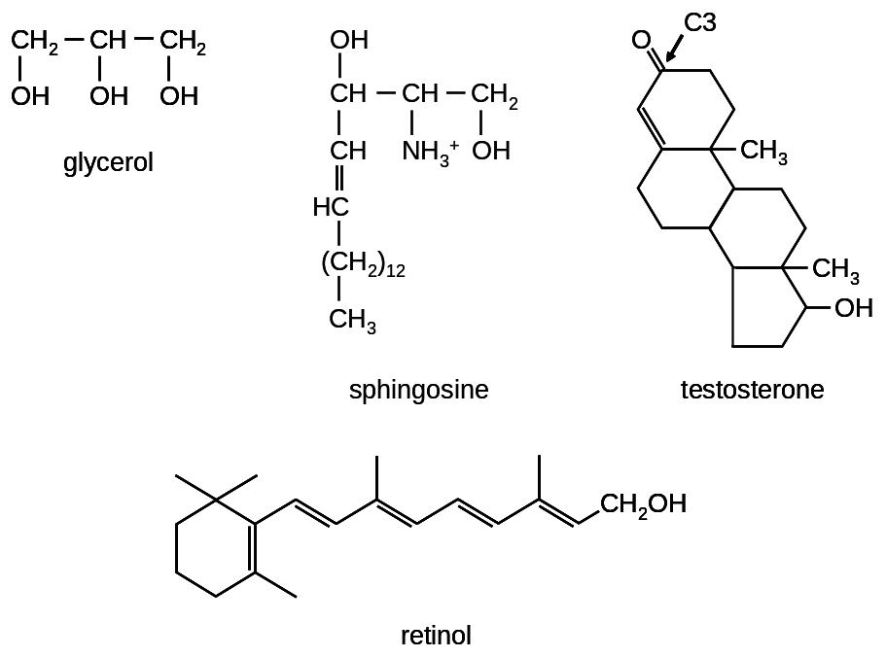
Glycerophospholipids, sphingolipids and the steroid cholesterol are amphipathic: one part of the molecule is hydrophobic and the other is hydrophilic (Figs 11-5, 11-7, p.365-366). Because of their amphipathic nature, these lipid molecules are well suited to be the basic structural components of biological membranes. In water, glycerophospholipids and ceramides spontaneously assemble into bilayers to hide or protect the hydrophobic groups from the polar solvent. The hydrophilic “head” groups are on the outside of the bilayer, next to the solvent, while the hydrophobic “tail” groups form the interior of the bilayer (Fig 2-20, p.55; Fig 11-11, p.368, Movie 11.2). Lipid bilayers are about 50 Å (5 nm) thick. Because they are composed of many individual molecules, lipid bilayer sheets are flexible (Movie 11.1). This flexibility allows them to protect their hydrophobic edges by spontaneously closing to form spherical vesicles or liposomes (Fig 11-12, 11-13, p.368-369).
Individual lipid molecules can move and diffuse within the plane of the bilayer (Fig. 11-15, p.370). The rate of diffusion is determined by the bilayer’s fluidity. At constant temperature, fluidity is determined by three main factors:
- The proportion of unsaturated fatty acyl chains within the glycerophospholipids and sphingolipids. Cis double bonds impede tight packing of the fatty acyl chains, increasing fluidity.
- The length of fatty acyl chains present in the glycerophospholipids and sphingolipids. Shorter chains mean more mobility and fluidity.
- The amount of cholesterol in the bilayer. At 37°C and higher temperatures, increasing the amount of cholesterol in the membrane reduces the fluidity of the bilayer. Cholesterol fills gaps created by unsaturated fatty acyl chains (Fig. 11-16B, p.370) and restricts the motion of other lipid molecules. At low temperatures, cholesterol increases the fluidity of the bilayer by interfering with orderly packing of other lipids.
Biological lipid bilayers are asymmetrical. That is, the lipid composition of one half or surface of the bilayer is different than the composition of the other half. For example, in human erythrocyte membranes, sphingomyelin and phosphatidylcholine are mostly found on the outer half, and phosphatidylethanolamine and phosphatidylserine are mostly found on the inner half (Fig 11-17, p.371). Lipids with attached carbohydrates are called glycolipids; these are not usually found on the cytosolic face of the membrane. However, cholesterol is evenly distributed on both halves.
Spontaneous “flip-flop” of a lipid from one side of the bilayer to the other occurs only rarely. The cell moves lipids from one side to the other using two classes of proteins: flippases and phospholipid translocases.
Topic 7 Review Questions
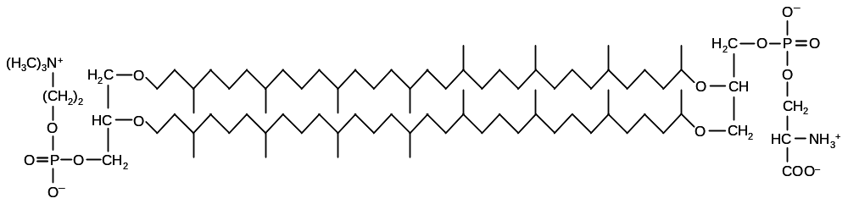
7-1. List similarities and differences between the molecule shown below and glycerophospholipids. Do you think this molecule could form the basis of a biological membrane? Justify your answer.

7-2. Question 11-11 in the textbook (p.385).

Topic 8

Membrane proteins
Readings: p.372-385
Proteins make up about 50% of the mass of typical biological membranes (Fig 11-4, p.367). Behaviour of proteins within the lipid bilayer is described by the fluid mosaic model, which states that proteins are free to diffuse laterally within the bilayer, unless their movement is restricted by cellular components (Fig. 11-33, p.380).
Functions of membrane proteins (Fig. 11-20, p.372):
- Transporters: Ions and polar molecules cannot cross the hydrophobic membrane. Transport proteins are required to move ions and polar molecules between compartments of the cell, or between the inside and outside. Most transporter proteins are specific for a particular substrate or a small set of substrates. For example, most cells have potassium channels that allow K⁺ and Rb⁺ to diffuse across the membrane, but that are virtually impermeable to Na⁺ and Li⁺.
- Anchors: Anchor proteins are structural proteins that provide stability to the membrane and help control the shape of the cell and its position relative to other cells (Fig 11-31, p.381). Anchor proteins bind to other macromolecules on one or both sides of the membrane. For example, integrins are anchor proteins that bind to the extracellular matrix as well as to actin-binding proteins inside the cell.
- Receptors: These proteins sense chemical signals on the outside of the cell and carry the message to the inside of the cell, so that the cell can react to its environment. Like transport proteins, most receptors recognize a very specific molecular signal. For example, the insulin receptor binds and is activated by insulin but not other molecules.
- Enzymes: Proteins that catalyze chemical reactions can be associated with membranes. Many receptors also have enzymatic activity; for example, after binding insulin, the insulin receptor relays this signal by adding phosphate groups to certain proteins inside the cell.
Other examples are given in Table 11-1 on page 373.
Proteins associate with the membrane in four different ways (Fig 11-21, p.373). The peptide chain of transmembrane proteins completely crosses the membrane at least once. Some transmembrane proteins have many membrane-spanning segments. The protein is exposed to both sides of the membrane, and to the hydrophobic interior. The orientation of the protein with respect to the different sides of the membrane is fixed; that is, the same side always faces the cytosol.
Usually, transmembrane segments of proteins have α-helical secondary structure, and if a protein has a single transmembrane segment, it is essentially always an α-helix. The major reason for this is that the α-helix maximizes hydrogen bonding between polar backbone groups, minimizing interactions between these groups and the hydrophobic interior of the membrane. Most membrane-spanning α-helices are composed of at least 20 consecutive hydrophobic amino acid residues. The hydrophobic side chains make favourable interactions with the interior of the lipid bilayer (Fig. 11-23, p.374). The α-helix does not readily leave the bilayer, because to do so would expose its hydrophobic side chains to water.
In some transmembrane proteins, such as bacteriorhodopsin (Fig. 11-28, Movie 11.4), multiple α-helices cluster together to cross the membrane (Fig 11-24, p.375). These helices have hydrophobic side chains on the sides facing the lipid bilayer, but may have polar residues on the sides facing the other helices. They may even form an aqueous channel across the membrane. Such α-helices are said to be amphipathic, because, like membrane lipids, they are polar on one side and hydrophobic on the other.
In a few transmembrane proteins, β-strands come together to make β-barrel structures that cross the membrane (Fig 11-25, p.377). The outside of the barrel is covered with hydrophobic side chains, while polar side chains project toward the inside of the barrel.
Monolayer-associated proteins contact the hydrophobic interior of the membrane but are not exposed to both sides. This can be accomplished with an amphipathic α-helix. Caveolins, proteins that help form caveolae (depressions in the plasma membrane), are believed to be membrane-associated.
In lipid-linked proteins, one or more lipid molecules are covalently attached to the end of the protein or to particular side chains, usually cysteine. The lipids are embedded in the membrane, but the protein backbone and side chains themselves are not necessarily exposed to the bilayer’s hydrophobic interior. Besides being membrane-associated, caveolins are also lipid-linked.
Protein-attached proteins are not anchored into the lipid bilayer themselves, but bind to a protein or proteins that are transmembrane, membrane-associated, or lipid-linked. The subunits that make up the F₁ sector of ATP synthase (see Topic 15) are of this type.
Transmembrane, membrane-associated, or lipid-linked proteins cannot be removed from the membrane without disrupting the lipid bilayer (e.g., with a detergent, Fig. 11-16, p.376). These proteins are called integral membrane proteins. Protein-attached proteins are called peripheral membrane proteins. They can usually be removed from membranes under relatively mild conditions that leave the lipid bilayer intact.
Integral membrane proteins are more difficult to study than water-soluble proteins, because their hydrophobic regions must always be covered with lipids or detergents. This complicates purification procedures. Also, detergents used in purification may alter the secondary, tertiary and quaternary structure of proteins.
Membrane proteins are often modified by carbohydrates (Fig 11-35, p.381); such proteins are called glycoproteins. Sugars are never attached to the cytosolic surface of proteins.
Topic 8 Review Questions
8-1. You have discovered a protein that forms a pore across the cell membrane. The protein contains six amphipathic α-helices that cross the lipid bilayer. In the diagrams below, each α-helix is represented as a circle, as if you are looking at one end of the helix, down its long axis. The space in the middle of the cluster of circles is the pore through the membrane. The shaded and unshaded regions represent the hydrophobic and hydrophilic side of each helix, respectively. Which arrangement of α-helices is most likely to be found in your newly discovered protein?
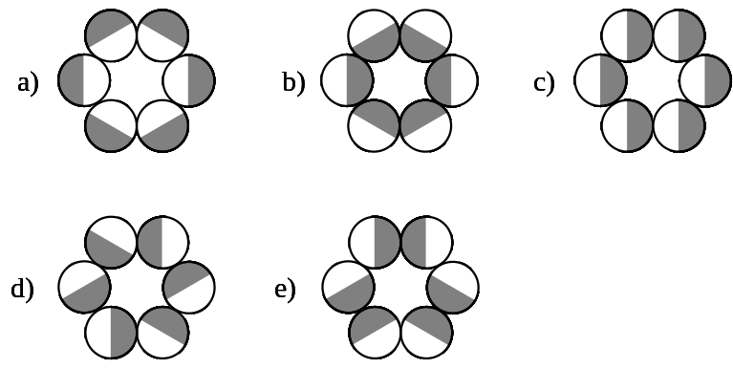
8-2. Which of the 20-amino acid sequences listed below is the most likely candidate to be the transmembrane segment in a protein that spans the membrane exactly once? (To answer this question, you may have to consult Panel 2-5, p.72-73.)
- I T L I Y F G V M A G V I G T I L L I S
- I T P I Y F G P M A G V I G T P L L I S
- I T E I Y F G R M A G V I G T D L L I S

8-3. Question 11-16 in the textbook (p.386).
Topic 9
Carbohydrates
Readings: p.52-54, p.68-69, p.380-381, 384
Carbohydrates, or sugars, are one of the four main classes of compounds in living cells (Fig 2-15, p.52). Monosaccharides are the simplest sugars and have the molecular formula (CH₂O)_{n}, where n = 3 to 7. A monosaccharide with three carbon atoms is called a triose; with four, a tetrose; with five, a pentose; with six, a hexose; with seven, a heptose.
Monosaccharides are often represented using Fischer projections, which depict the stereochemistry at each carbon atom (p.70, top panel, and structures below). These projections are named after Emil Fischer, who elucidated the structure of glucose. At each carbon atom, the horizontal bonds are meant to come out of the page, toward the viewer, while the vertical bonds go into the page, away from the viewer.
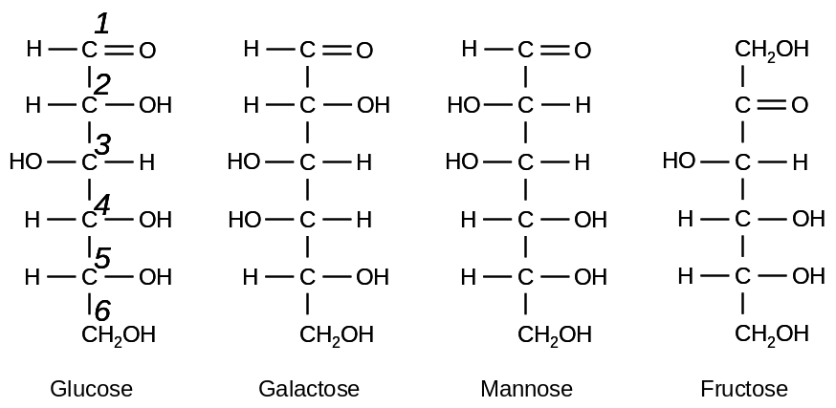
Each monosaccharide has a carbonyl group (an oxygen atom double-bonded to carbon). If this group is at the end of the molecule (i.e., if it is an aldehyde group), the sugar is called an aldose. If the group is not at the end of the molecule (i.e., if it is a ketone group), the sugar is called a ketose. Each carbon in a monosaccharide is numbered, starting from the end closest to the carbonyl group.

Because the position of the carbonyl group and the orientation of the hydroxyl group at interior carbon atoms may vary, many isomers are possible for most monosaccharides. By convention, monosaccharides are called D or L based on the orientation of the hydroxyl group on the chiral carbon furthest from the carbonyl group. Biological sugars are usually D isomers, with the hydroxyl group on the right side in a Fischer projection.
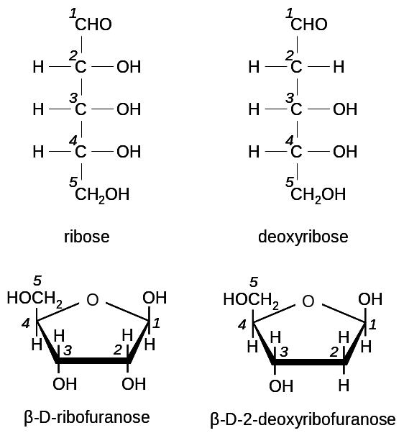
In cells, pentoses and hexoses are predominantly found in ring or cyclic structures (p.68, bottom left panel and structures at right). Cyclic monosaccharides are commonly depicted using Haworth projections, named for Sir W Norman Haworth, an early carbohydrate chemist. To form the ring, a hydroxyl group reacts with the carbon of the carbonyl group; this atom is called the anomeric carbon. Monosaccharide rings are said to be in either the α or β configuration, depending on how the hydroxyl formed at the anomeric carbon is oriented relative to the highest-numbered carbon. The monosaccharide is in the β configuration when these groups are on the same side (p.69, top left panel). When the ring forms, it adopts either the α or β configuration at random. Because the cyclization reaction is reversible, a monosaccharide in solution converts readily between the α and β forms. A monosaccharide that exists as a five-membered ring is called a furanose, while one that forms a six-membered ring is called a pyranose.
Two monosaccharides can join together in a condensation reaction to make a disaccharide (Fig. 2-17, p.53). For example, in lactose, carbon 1 of β-galactose is joined to carbon 4 of glucose; this is a β(1→4) linkage, and the bond is called an O-glycosidic bond. Other monosaccharides can be added to form longer chains called oligosaccharides (“oligo” = “a few”) or polysaccharides (“poly” = “many”). Polysaccharide chains can be branched, depending on which hydroxyl groups react. Anomeric carbons that are not involved in an O-glycosidic linkage are called reducing ends; usually polysaccharides have only one reducing end. An example of a polysaccharide is glycogen, which consists of linear chains of 12-14 glucose monomers in α(1→4) linkage. The linear chains are joined by α(1→6) linkages.
Carbohydrates are:
1) sources of energy (polysaccharides are energy storage molecules, monosaccharides are oxidized to form ATP – see Topics 12-15);
2) used for structural purposes (e.g., cellulose, which is β(1→4)-polyglucose);
3) part of nucleotides (important as energy currency – see Topic 10 – and for DNA and RNA – see Topic 18); and
4) linked to lipids or proteins on the surfaces of cells to protect the cells, make them slippery, and for recognition purposes (e.g., Fig. 11-39, p.384).
Topic 9 Review Questions
9-1. Draw the straight chain and ring structures of glucose, number the carbon atoms and indicate the anomeric carbon in the ring form.

9-2. Maltose is a disaccharide with two glucose molecules in an α(1→4) linkage. Draw the reaction that occurs when two glucose molecules form maltose. Is the maltose molecule you drew α-maltose or β-maltose?

9-3. Glyceraldehyde is the only aldotriose. How many stereoisomers does it have?

Topic 10
Biological forms of energy and reducing power
Readings: p.86-98, p.104-114
Living organisms carry out a diverse set of tasks, such as building and maintaining physical structures, moving, synthesizing macromolecules, maintaining electrochemical gradients, and maintaining a constant body temperature. All of these processes require energy. One fundamental problem living organisms face is how to obtain energy to carry out these tasks.
When considered at their most basic level, all of the processes mentioned above involve chemical reactions. Whether or not a chemical reaction requires energy depends on the change in Gibbs free energy (ΔG) that takes place when the reaction occurs. The ΔG for a given reaction depends in part on the inherent characteristics of the reaction and the molecules involved, and in part on the molecules’ concentrations and environmental factors.
If ΔG for a reaction equals zero, then the reaction is said to be at equilibrium. At equilibrium, the forward and reverse reactions occur to the same extent and no net reaction takes place. If ΔG is negative, (i.e., <0), the forward reaction is more energetically favourable, or spontaneous. If all molecules begin at equal concentration, there will be a net conversion of reactants to products without addition of energy. This will continue until equilibrium is reached, at which time the concentration of products will be higher than that of reactants.
However, if ΔG for a reaction is greater than zero, the forward reaction is energetically unfavourable, and at equilibrium reactants have a higher concentration than products. To take a specific example, the reaction of combining glucose and fructose to make sucrose (p.95, top right panel) has a standard free energy change (ΔG°) of +5.5 kcal/mole. (Note: the small circle in ΔG° indicates that “standard” conditions are assumed, with defined temperature, pressure, and pH. The ΔG° takes into account only the natures of the molecules involved, and not their concentrations. Even though the standard conditions are not normally met in biological systems, they are useful as a point of reference.) If a cell wants to make sucrose in appreciable quantities, it must find some way to overcome the natural tendency of the glucose and fructose molecules to remain apart.
One strategy is to change the concentrations of the reactants and products, such that the ratio of reactants to products is high. This is frequently done in living systems, but is not always practical or desired.
An alternate strategy to drive an unfavourable reaction to completion is to couple that reaction to an energetically favourable reaction (i.e., one with a negative ΔG), such that the total ΔG for both reactions is negative. If the total ΔG is negative, then both reactions will proceed spontaneously. Knowing this, the question becomes: is there a suitable energetically favourable reaction that organisms can couple to many different unfavourable reactions? If so, where do the reactants for the energetically favourable reaction come from?
The vast majority of energy used to sustain life comes ultimately from the sun. Light energy is captured by plants and stored in carbohydrates (this process, photosynthesis, is not covered in this course). Animals obtain energy by eating plants and other animals. This energy comes in the form of molecules such as sugars, fats and proteins. These molecules can be broken down to release energy.
However, the breakdown of (for example) sugar molecules like glucose is not used to directly power chemical reactions in the cell. A major reason for this is that a lot more energy is available in a glucose molecule than is needed to drive individual chemical reactions in the cell. Most of the energy would be wasted as heat. It is more desirable to convert the energy available in glucose into a form that can be used in small amounts, a little at a time, as needed (Fig 13-1, p.426). The universal energy carrier in biological systems is adenosine triphosphate (ATP; Fig 2-23, p.57, and Movie 2.3). ATP is a nucleotide and one of the building blocks for RNA; the general structure of nucleotides is covered in Topic 18.
Hydrolysis of ATP to form ADP and inorganic phosphate (P_{i}) is energetically favourable (ΔG° of -7.3 kcal/mol). Combining the hydrolysis of ATP with unfavourable reactions such as synthesis of sucrose from glucose and fructose can result in an overall reaction that is favourable (p.95). Another example of an energetically unfavourable reaction that is coupled to ATP hydrolysis is the synthesis of glutamine from glutamic acid and ammonia (Fig 3-33, p.107).
ATP is often said to have a "high-energy" phosphoanhydride bond. This is a shorthand way of saying that the ATP to ADP + P_{i} hydrolysis reaction is energetically favourable (p.95). There is nothing special about the particular oxygen-phosphorus bond that is broken in this reaction that makes it "high-energy", except for its surroundings. In this course, I will use the shorthand phrase “high-energy bond” because it is convenient, but remember that it means that an energetically favourable reaction takes place at that bond.
ATP can also be hydrolyzed to AMP and PP_{i} (Fig 3-40, p.113). The PP_{i} ion can be further hydrolyzed to release more energy. Other compounds with “high-energy” bonds exist, some of which release more energy than ATP when hydrolyzed (Fig 13-7, p.435). One example is creatine phosphate, which is used to quickly transfer phosphate groups to ADP during muscle contraction.
Hydrolysis of ATP drives a wide variety of unfavourable cellular reactions. To have enough readily available energy to do work, the cell must continuously regenerate the ATP consumed. The basic metabolic pathways by which cells regenerate ATP are described in Topics 12-17.
In addition to requiring energy, some biochemical processes require molecules to be reduced. Chemically speaking, reduction is the gain of electrons. Oxidation is the opposite of reduction, and happens when a molecule loses electrons. In any red-ox reaction, at least one molecule is oxidized and at least one is reduced; there cannot be oxidation of one molecule without a corresponding reduction of another. So cells require a source of electrons for use when a molecule needs to be reduced.
In organic chemistry a carbon atom is said to become more oxidized as more electronegative atoms (such as oxygen) bond to it (Fig. 3-11, p.88).
Two key biological molecules involved in red-ox reactions are Nicotinamide Adenine Dinucleotide (NAD) and Nicotinamide Adenine Dinucleotide Phosphate (NADP) (Fig 3-34, p.108). These molecules carry electrons on the nicotinamide moiety. In its oxidized form, nicotinamide carries a positive charge, and the molecules are abbreviated NAD⁺ or NADP⁺. Net addition of a hydride ion (H⁻, one proton and two electrons) to nicotinamide neutralizes the charge, and the molecules are abbreviated NADH or NADPH. Similar to the way cells use ATP as an intermediate source of energy, they use NADH and NADPH as sources of reducing power (i.e., reducing agents or electron sources).
Although they are both reducing agents, NADH and NADPH have different roles in metabolism. The reducing power of NADH is primarily used to regenerate ATP from ADP (see Topics 14 and 15), while the reducing power of NADPH is primarily used in the synthesis of biomolecules, notably fatty acids and cholesterol (see Topic 16).

Topic 10 Review Questions
10-1. Question 3-13 in the textbook (p.115).
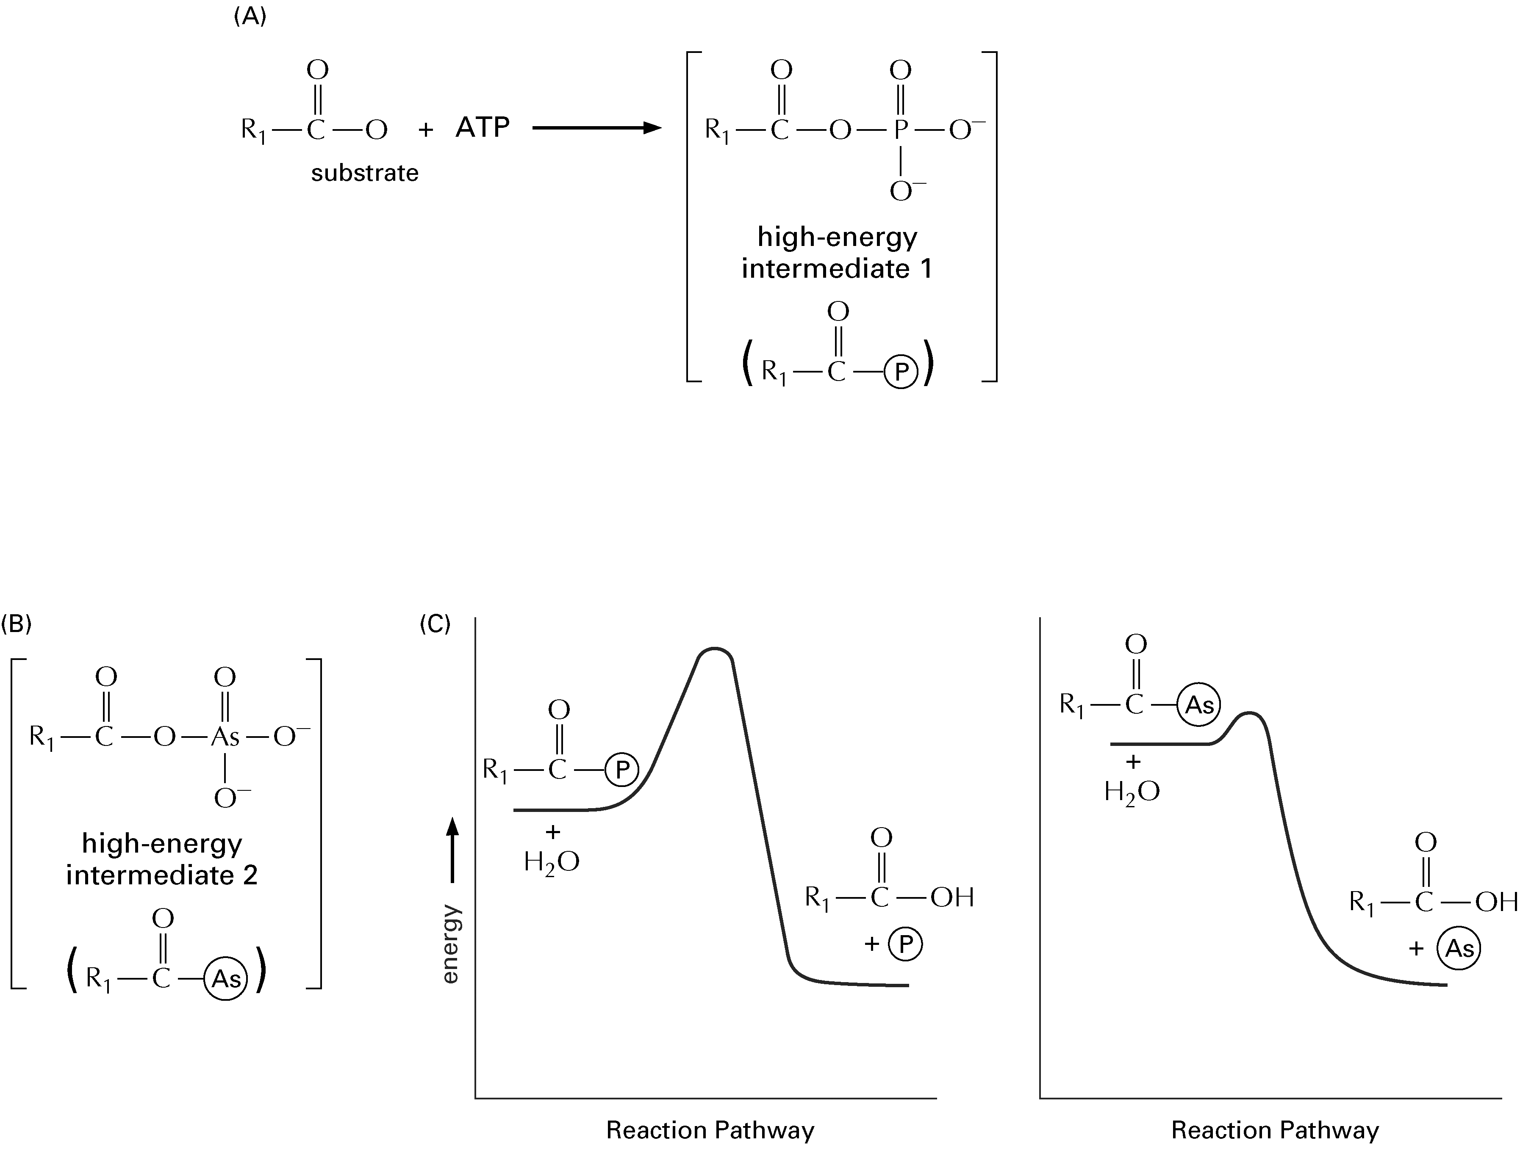
10-2. Many enzyme-catalyzed reactions that use ATP as the energy source involve formation of a “high-energy” intermediate in the form of an anhydride between a carboxylic acid on the enzyme and a phosphate (Figure A). Arsenate can also be incorporated into a similar “high-energy” intermediate in place of the phosphate (Figure B). Figure C shows the reaction profiles for the hydrolysis of these two “high-energy” intermediates.
What is the effect of substituting arsenate for phosphate in this reaction?
a) Arsenate forms a high-energy intermediate of lower energy.
b) Arsenate forms a high-energy intermediate of the same energy.
c) The high-energy arsenate intermediate is more stable.
d) The high-energy arsenate intermediate is less stable.
Follow-up: What consequence is this likely to have for the enzyme-catalyzed reaction?
10-3. Suppose there is a species of fish, the gufu fish, that has a poisonous bite. This fish makes the poison in a specific gland, by converting a harmless metabolite into a highly toxic substance in a single, enzyme-catalyzed reaction. The reaction itself is highly energetically unfavourable, but the enzyme toxosynthase drives it forward by coupling it to ATP hydrolysis:
metabolite + ATP → poison + ADP + P_{i} ΔG = -2.0 kcal/mole
Enzyme: Toxosynthase
Gufu fish is very delicious, but can only be eaten safely if the poisonous gland is removed. Removing the gland properly is very difficult, and chefs must be trained for two years before they are allowed to prepare gufu fish in restaurants.
Part A: Dr. McLachlin has invited all the 2280A students to a party, at which he will be preparing and serving gufu fish. He is not a good cook, and he certainly has not been trained in proper gufu preparation methods. However, he says he has used his biochemical knowledge to develop a mutant gufu fish, in which toxosynthase is unable to use ATP. The enzyme is still able to lower the activation energy for conversion of the metabolite into the poison, but it can’t couple the reaction to ATP hydrolysis. Therefore he claims that the mutant fish is safe to eat, but he admits that he hasn’t had time to try the fish before the party. Would it be safe to eat Dr. McLachlin’s mutant gufu fish?
Part B: Suppose Dr. McLachlin has created a second mutant gufu fish, in which toxosynthase is able to couple the reaction to ATP, but works 100 times more slowly than the normal enzyme. Would it be safe to eat this mutant gufu fish?

Topic 11

Metabolism and enzyme regulation: basic concepts
Readings: p.81-82, p.149-153
Metabolism is the combined sum of the chemical reactions that occur in living organisms to convert raw materials into energy and complex products. Metabolism is traditionally divided into catabolism, or the breaking down of large molecules into smaller ones, and anabolism, or the combining of small molecules to make larger ones (Fig 3-2, p.82). Metabolic pathways are coordinated series of reactions, catalyzed by enzymes and designed to make specific products (Fig 3-1, p.82). As a general rule, catabolic pathways provide energy and reducing power to the cell, while anabolic pathways consume energy and reducing power.
Not every metabolic pathway that occurs in an organism occurs in every cell. Some pathways take place only in specific cellular locations or in specific organs or tissues.
In a living cell, molecules flow through each metabolic pathway at some rate, called the flux. For the cell to function efficiently, it must be able to change the flux of molecules through each pathway. Control of flux is achieved by altering enzymatic activity, and usually several different enzymes contribute to control of the overall flux through a pathway. In addition, flux through a pathway can be influenced by the concentrations of metabolites in that pathway, such as the starting material.
Typical metabolic pathways contain some reactions with ΔG near zero under physiological conditions, and a few reactions that have a very negative value for ΔG. The former reactions are at or near equilibrium. Because enzymes can operate in either direction, relatively small changes in substrate concentration can change the net flow of substrates forward or backward through these reactions. Such reactions are said to be reversible.
Metabolic reactions with large, negative ΔG are said to be irreversible. The ΔG of the reverse reaction is so large and positive that normal fluctuations in metabolite concentration do not make the reverse reaction occur to any substantial degree. In such a reaction, the cellular ratio of reactant to product is much higher than would be seen if the reaction were at equilibrium. The activity of the enzyme catalyzing the reaction is not high enough to bring the reaction to equilibrium. Thermodynamically speaking, irreversible reactions drive metabolic pathways forward.
Because they are far from equilibrium, irreversible reactions are optimal points at which to control the flux through a metabolic pathway. Frequently, the first reaction in a metabolic pathway or after a branch point is irreversible and the enzyme that catalyzes it is a target for metabolic control. Altering enzyme activity occurs by many mechanisms and on time scales ranging from seconds to days. One key longer-term mechanism that I won’t discuss is regulation of the amount of enzyme present in the cell by controlling its synthesis and degradation. However, I will mention two important mechanisms used to rapidly change enzyme activity: allosteric regulation and covalent modification.
Allosteric regulation
Enzymes influenced by allosteric regulation (“allosteric enzymes”) can bind small molecules at sites other than the active site. Binding of these molecules causes conformational changes in the enzyme that increase or decrease its activity. For example, the glycogen phosphorylase found in muscle is an allosteric enzyme. This homodimeric enzyme breaks down glycogen by removing one glucose monomer at a time. In addition to its active site, glycogen phosphorylase has an allosteric site that can bind AMP, ATP, or glucose-6-phosphate (G6P). Binding AMP at the allosteric site favours an enzyme conformation with high activity; binding ATP or G6P favours a conformation with lower enzyme activity. (We will discuss more details of glycogen regulation in Topic 12.) Another example of an allosteric enzyme is aspartate transcarbamoylase, the first enzyme in the pathway of pyrimidine synthesis. This enzyme is inhibited by CTP (Fig. 4-36, p.152). This is an example of feedback inhibition (Fig. 4-35, p.151), in which an end product of a metabolic pathway (usually an anabolic pathway) inhibits an enzyme that functions earlier in the pathway.
Most allosteric enzymes have multiple subunits, and many have separate catalytic and regulatory subunits (i.e., the active site is on one subunit and the allosteric site(s) are on another). Note that allosteric inhibition is different from competitive inhibition, in which a molecule resembling a reactant or product binds to the enzyme’s active site.

Covalent modification
The activity of an enzyme can also be altered using post-translational modification, or the covalent attachment of chemical groups to the enzyme at particular amino acid residues. Adding or removing these chemical groups changes the conformation of the enzyme, affecting activity. For some enzymes, the modified form is the active form, while for others, the unmodified form is more active.
One group that commonly regulates enzyme activity is phosphate (-PO₃²⁻), which, in eucaryotes, is most frequently added to the hydroxyl group of serine, threonine or tyrosine residues. The phosphorylation state of a target enzyme is controlled by the competing activities of a protein kinase, which adds phosphate, and a protein phosphatase, which removes phosphate (Fig. 4-38, p.153). Phosphorylation is frequently used to transmit and amplify signals from outside the cell to the nucleus to control gene expression. Improperly controlled phosphorylation is often implicated in the development of cancer.
Armed with this information about metabolic pathways, we are now in a position to study the major processes by which humans extract energy from biomolecules. We will also briefly look at some important biosynthetic pathways. Topics 12 to 17 are organized around the fates of three metabolites: glucose-6-phosphate, pyruvate, and acetyl-CoA.
Topic 11 Review Questions
11-1. List six mechanisms a cell could use to change the flux through a metabolic pathway.
11-2. Suppose you have discovered a protein in a protozoan (a single-celled eucaryote) that can bind to the base of cilia. When bound, the protein makes the cilia beat faster, causing the protozoan to swim very fast. You have cleverly called this protein Speed. Upon further study, you notice that Speed binds to cilia only when a particular serine residue within Speed is phosphorylated. What do you think would happen if you mutated this serine residue to alanine, an amino acid with no hydroxyl group?
  - The mutant protozoan would be unable to move at all.
  - The mutant protozoan would swim fast all of the time.
  - The mutant protozoan would be unable to swim fast by this mechanism.
  - The mutant protozoan would switch rapidly back and forth between fast and slow swimming.
  - The mutant protozoan would behave no differently than the normal (or “wild type”) protozoan.
11-3. In the scenario from question 11-2, what mutation is most likely to produce a protozoan that would swim fast all of the time?
- Eliminate the gene encoding Speed.
- Eliminate the gene encoding the protein kinase that acts on Speed.
- Force the protozoan to produce twice as much Speed protein as normal.
- Eliminate the gene encoding the protein phosphatase that acts on Speed.
- Force the protozoan to produce twice as much protein phosphatase as normal.

Topic 12

Carbohydrate metabolism
Readings p.425-435, 445-451
Carbohydrates are an important source of energy and reducing power for the cell. In this topic we will consider the fates of glucose, an important monosaccharide, and more particularly its phosphorylated form, glucose-6-phosphate.
Glucose is absorbed from the digestive tract and circulates in the blood, from which it can enter cells via glucose-specific transport proteins. Inside the cell, glucose is converted to glucose 6-phosphate, which can be used in several different ways.
Glycogen synthesis and breakdown
Glucose is oxidized by glycolysis to provide energy to the cell (glycolysis is discussed later in this topic). When the available energy is sufficient to meet an animal’s needs, some glucose is stored as glycogen, a polysaccharide composed of glucose monomers (Fig 13-21, p.448). Glycogen is stored in the liver and striated muscle.
To make glycogen, the cell first converts glucose-6-phosphate to glucose-1-phosphate. Glucose-1-phosphate is added to the glycogen chain in a two-step reaction that involves the net hydrolysis of UTP to UDP and P_{i}. The second step of this two-step reaction is catalyzed by glycogen synthase.
Glycogen (n residues) + G1P + UTP → Glycogen (n + 1 residues) + UDP + 2 P_{i}
Hydrolysis of UTP to UDP and P_{i} is energetically similar to hydrolysis of ATP to ADP and P_{i}. Coupling the reaction to hydrolysis of UTP makes it energetically favourable. UTP can be considered an “ATP equivalent” in this reaction. In fact, NTPs are readily interconverted by the enzyme nucleoside diphosphate kinase:
NTP + ADP <--> NDP + ATP
Any NTP can be considered an ATP equivalent when it is used as a “high-energy” compound.
When energy is low, glucose monomers are removed from glycogen as glucose-1-phosphate by glycogen phosphorylase (Fig 13-21C, p.448). The added phosphate comes from inorganic phosphate dissolved in the cytosol rather than from ATP. A separate enzyme moves the phosphate group to produce glucose-6-phosphate. Under physiological conditions, the ΔG for glycogen breakdown is negative, so no energy input is required.
Note that the glycogen synthesis pathway is not simply the reverse of the glycogen breakdown pathway. In fact, the synthesis pathway cannot just be the breakdown reactions in reverse, because both pathways must be energetically favourable under physiological conditions. Besides being thermodynamically necessary, having distinct synthesis and breakdown pathways allows independent control of each pathway.
Control of glycogen metabolism in both the liver and skeletal muscle is achieved through phosphorylation of glycogen synthase and glycogen phosphorylase. The phosphorylated form of glycogen synthase is less active than the dephosphorylated form. Conversely, the phosphorylated form of glycogen phosphorylase is more active than the dephosphorylated form.
The relative amounts of the phosphorylated and dephosphorylated forms of these enzymes in cells are determined by hormone signals. In liver, insulin, which is released when blood glucose levels are high, causes dephosphorylation of both glycogen synthase and glycogen phosphorylase, thereby stimulating glycogen synthesis. Glucagon, which predominates when blood glucose levels are low, causes phosphorylation of these enzymes in liver, stimulating glycogen breakdown. In skeletal muscle, epinephrine promotes phosphorylation of glycogen synthase and glycogen phosphorylase.
Allosteric effectors also regulate glycogen synthase and glycogen phosphorylase. In skeletal muscle, glycogen synthase is allosterically activated by glucose-6-phosphate, while glycogen phosphorylase is allosterically activated by AMP and inhibited by ATP and glucose-6-phosphate. The liver version of glycogen phosphorylase is allosterically inhibited by glucose.
Glycolysis
Glycolysis (Fig 13-3, p.429; Panel 13-1, p.430-431, Movie 13.1) is an oxidative process that occurs in the cytoplasm. Conversion of glucose to glucose-6-phosphate is usually considered the first step of glycolysis. This step traps the carbohydrate inside the cell, because there is no mechanism for transport of glucose-6-phosphate across the membrane.
The net reaction of the 10 steps of glycolysis is:
glucose + 2 ADP + 2 P_{i} + 2 NAD⁺ ---> 2 pyruvate + 2 NADH + 2 ATP
(Note: for clarity, and to help you focus on the major species involved, H₂O and H⁺ have been omitted from this net reaction and others in my section of these course notes.)
Thus, for every glucose molecule that enters glycolysis, 2 pyruvates, 2 ATP, and 2 NADH are produced. Other monosaccharides, such as fructose, galactose, and mannose, can enter into glycolysis by being converted to either glucose-6-phosphate or fructose-6-phosphate, which are intermediates in the pathway.
Consider the ΔG of the individual reactions of glycolysis under physiological conditions in erythrocytes:
Reaction | Enzyme | ΔG° (kcal/mol) | ΔG (kcal/mol)
1 | Hexokinase | -5.0 | -6.5
2 | Phosphoglucose isomerase | +0.5 | -0.3
3 | Phosphofructokinase | -4.1 | -6.2
4 | Aldolase | +5.4 | -1.4
5 | Triose phosphate isomerase | +1.9 | ~0
6 + 7 | Glyceraldehyde 3-phosphate dehydrogenase + phosphoglycerate kinase | -4.0 | -0.3
8 | Phosphoglycerate mutase | +1.1 | -0.1
9 | Enolase | -0.8 | -0.6
10 | Pyruvate kinase | -5.5 | -3.3
(Source: D Voet, JG Voet, and CW Pratt, Fundamentals of Biochemistry, 3rd ed., John Wiley & Sons, Inc., Hoboken, NJ, 2008, p.511)
Three reactions have a large, negative value for ΔG: reactions 1, 3 and 10. These reactions are considered irreversible. The rest are near equilibrium and are considered reversible. Based on the ΔG values, one would predict that control of flux through glycolysis in erythrocytes is distributed among hexokinase, phosphofructokinase (PFK), and pyruvate kinase.
Hexokinase is present in all tissues and phosphorylates glucose to produce glucose-6-phosphate. Hexokinase is allosterically inhibited by its product, glucose-6-phosphate. This is an example of feedback inhibition. Not only does this inhibition slow the first step of glycolysis, but it slows the transport of glucose into the cell (in many tissues glucose transport is driven by the concentration difference between the outside and the inside of the cell).
The predominant version of hexokinase in the liver is called glucokinase. In contrast to normal hexokinase, glucokinase is not inhibited by glucose-6-phosphate. This allows the liver to continuously import glucose when blood glucose levels are high.
The reaction catalyzed by PFK is:
fructose-6-phosphate + ATP --> fructose-1,6-bisphosphate + ADP
This reaction commits the cell to metabolizing glucose, as opposed to converting it to another sugar or storing it. Control is achieved by influencing the activity of PFK. In addition to binding to the active site of PFK, ATP is an allosteric inhibitor that changes the conformation of the enzyme to reduce its affinity for fructose-6-phosphate. The allosteric activators fructose-2,6-bisphosphate and AMP can reverse inhibition by ATP, promoting glycolysis.
Pyruvate kinase is allosterically regulated by several molecules; in particular, it is activated by fructose-1,6-bisphosphate and inhibited by alanine (see gluconeogenesis below) and ATP. In the liver, pyruvate kinase is also inhibited by phosphorylation, which is favoured when glucagon is high and disfavoured when insulin is high.
Flux through glycolysis is also controlled by the availability of substrate: 1) by the rate of glucose uptake across the cell membrane; and 2) by the rate of glycogen degradation.
Fermentation
Notice that glycolysis does not consume molecular oxygen (O₂), so cells can produce ATP under anaerobic conditions. However, glycolysis does consume NAD⁺. Without regeneration of NAD⁺ from NADH, glycolysis could not proceed, and no ATP would be generated. When oxygen is present, aerobic organisms transfer the electrons from NADH to other electron carriers, and ultimately to oxygen, regenerating NAD⁺ in the process (see Topic 14).
Organisms have devised two main strategies that allow glycolysis to continue in the absence of oxygen (Fig 13-4, p.432). These strategies involve reduction of pyruvate to oxidize NADH to NAD⁺. Pathways that yield energy from a carbon source without changing the net oxidation state of the carbons (such as the glucose to lactate pathway or the glucose to ethanol pathway) are called fermentations.
Formation of lactate
pyruvate + NADH <--> lactate + NAD⁺
This reaction occurs in many microorganisms, and also in higher organisms when little oxygen is available (e.g., in human muscles during intense exercise).
Formation of ethanol
Ethanol is formed from pyruvate in yeast, and several other microorganisms, in a two-step reaction.
pyruvate + H⁺ --> CO₂ + acetaldehyde
acetaldehyde + NADH --> ethanol + NAD⁺
Two end products of these reactions are often used by humans: ethanol for brewing and CO₂ for making bread.
Some fungi and bacteria are called anaerobic because they do not consume O₂ during ATP production. Some anaerobic organisms use only fermentations to produce ATP, while others use a final electron acceptor other than O₂ in the electron transport chain (Topic 14). Anaerobes that cannot tolerate the presence of O₂ are called obligate anaerobes. Other organisms can switch between fermentation and O₂-consuming oxidative phosphorylation (see Topic 14) pathways depending on the availability of O₂; these organisms are called facultative anaerobes. Still other species cannot live on fermentation at all; they are obligate aerobes.
Cells in higher eucaryotes vary in their O₂ requirement. Some, including our muscle cells, are facultative and can switch between fermentation and complete oxidation depending on the O₂ supply. Others, such as brain cells, are strict aerobes and cannot survive unless O₂ is available.

Gluconeogenesis
When blood glucose levels are low and glycogen reserves are depleted, the liver (and, to a lesser extent, the kidney) synthesizes glucose via gluconeogenesis (Fig 13-20, p.447). For simplicity, we will only consider gluconeogenesis using pyruvate as a precursor, but be aware that glycerol, lactate, citric acid cycle intermediates, and many amino acids can also be used as raw materials. In particular, alanine can be readily converted to pyruvate and is a major starting material for gluconeogenesis. 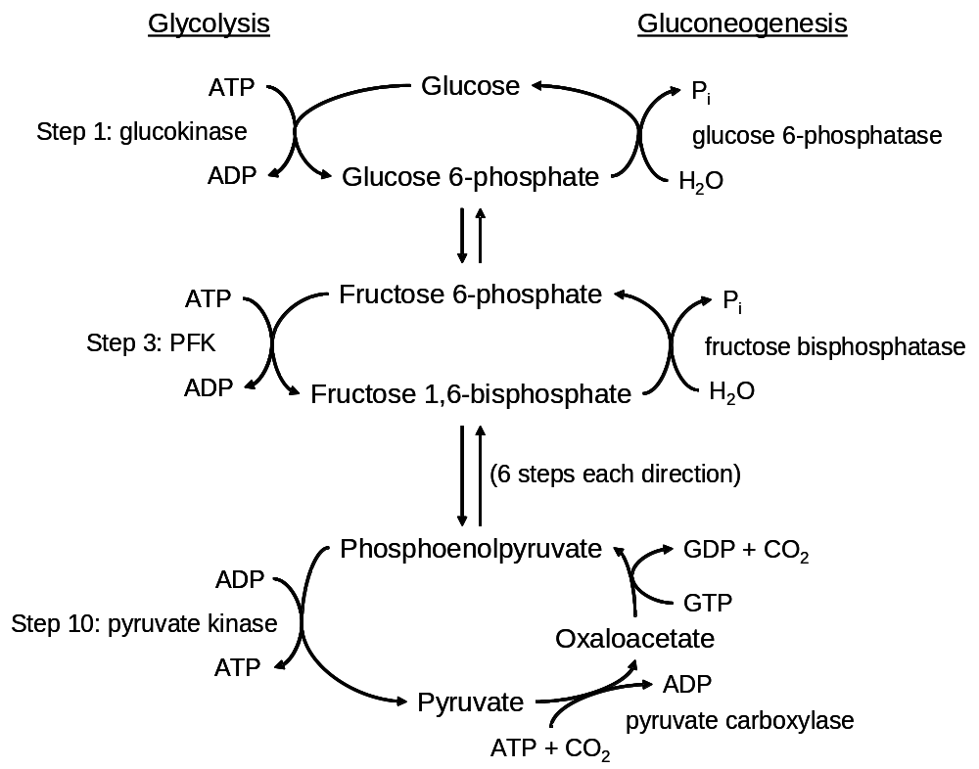
As noted above, most of the reactions of glycolysis have ΔG values near zero under physiological conditions, and thus are reversible. For these reactions, the cell uses the same enzymes during glycolysis and gluconeogenesis, but the enzymes operate in opposite directions, according to substrate availability. However, for the three irreversible glycolysis steps (steps 1, 3 and 10), alternate enzymes must be used (see figure).
To convert pyruvate to phosphoenolpyruvate, the opposite of step 10 of glycolysis, the cell first makes oxaloacetate, consuming one ATP. Then it converts the oxaloacetate to phosphoenolpyruvate, consuming one GTP (an ATP equivalent).
In the glycolysis direction, steps 1 and 3 involve hydrolysis of ATP. In the gluconeogenesis direction, the phosphate groups are simply hydrolyzed from the monosaccharides and released as P_{i}. No ATP is made in the gluconeogenesis direction.
The net reaction of gluconeogenesis, using pyruvate as the starting material, is:
2 pyruvate + 4 ATP + 2 GTP + 2 NADH → glucose + 4 ADP + 2 GDP + 6 P_{i} + 2 NAD⁺
From this it is seen that converting two pyruvates to glucose consumes four more ATP equivalents than are gained by oxidizing glucose to two pyruvates.
Most tissues are unable to perform gluconeogenesis. However, liver cells can perform both gluconeogenesis and glycolysis, and furthermore, both pathways take place in the cytosol. The three energetically key reactions of glycolysis and gluconeogenesis are controlled to avoid the waste that would result if flux through both pathways were high at the same time.
Pyruvate carboxylase, the enzyme that catalyzes the conversion of pyruvate to oxaloacetate, is allosterically activated by acetyl-CoA and ATP. Accumulation of acetyl-CoA and ATP indicates that the liver has sufficient energy from fatty acid oxidation (see Topic 16), resulting in a shift toward gluconeogenesis. Recall that alanine, a key precursor for gluconeogenesis, inhibits pyruvate kinase, the last enzyme in glycolysis.
Furthermore, fructose bisphosphatase, the enzyme that catalyzes the conversion of fructose-1,6-bisphosphate to fructose-6-phosphate (the reverse of step 3 of glycolysis) is inhibited allosterically by AMP and competitively by fructose-2,6-bisphosphate (F2,6P). Recall that F2,6P activates phosphofructokinase, which catalyzes step 3 of glycolysis. High [F2,6P] is promoted by insulin, and stimulates glycolysis. Glucagon promotes low [F2,6P], relieving inhibition of gluconeogenesis and causing the liver to synthesize glucose for export.
Regulation of glucose-6-phosphatase is complex and won’t be considered in this course.
Like glycolysis, gluconeogenesis is stimulated when its starting materials are in abundance.
Pentose phosphate pathway
As mentioned in Topic 10, some anabolic pathways require reducing power, in the form of NADPH. A major way of generating NADPH is to oxidize glucose-6-phosphate in the pentose phosphate pathway. The net reaction for this pathway is:
3 G6P + 6 NADP⁺ →
2 fructose-6-phosphate + glyceraldehyde phosphate + 6 NADPH + 3 CO₂
The carbohydrate products, fructose-6-phosphate and glyceraldehyde phosphate, are intermediates in glycolysis, and can feed into that pathway. Sometimes, however, not all of the monosaccharides are taken completely through the pentose phosphate pathway. One of the intermediates in the pathway is ribose-5-phosphate, which is required for nucleotide synthesis. If nucleotide levels are low, much of the ribose-5-phosphate will be diverted to nucleotide synthesis, instead of being used in glycolysis for energy production. Nucleotides are the building blocks of RNA and DNA, as will be discussed later in the course.
Topic 12 Review Questions
12-1. In most mammalian tissues, hexokinase, the enzyme that catalyzes the phosphorylation of glucose to glucose-6-phosphate, is inhibited by its product. Why is this regulation beneficial to the organism? Why is glucokinase, the isoform of hexokinase in liver cells, not regulated in this way?
12-2. In human muscle cells producing energy anaerobically, would you expect the ratio of pyruvate/lactate to be less than or greater than one? What about in aerobic cells?
12-3. High insulin levels in the blood promote formation of fructose-2,6-bisphosphate. What happens to flux through gluconeogenesis if the concentration of fructose-2,6-bisphosphate increases?
- flux increases
- flux decreases
- there is no change in the flux

Topic 13
Acetyl-CoA part 1: The citric acid cycle
Readings: p.436-439, 440-443, 456-458
Glycolysis takes place in the cytoplasm, producing pyruvate. We have already seen that, under anaerobic conditions, pyruvate can be fermented to lactate or ethanol. Pyruvate can also be used to make glucose when necessary. In this topic we will see a third metabolic fate of pyruvate. Under aerobic conditions, pyruvate produced by glycolysis is transported into mitochondria, where it is oxidized to form CO₂.
Mitochondrial Structure Fig 14-4 p.457, Movie 14.1
The mitochondrion is an organelle with two membranes. The outer membrane has many pores embedded in it, and is freely permeable to most solutes of low molecular weight (up to about 5000 Da). The inner membrane has selective permeability, meaning that ions and charged molecules can only cross it if a special path is made. The inner membrane is folded to form cristae, greatly increasing its surface area.
The space enclosed by the inner membrane is called the matrix. The mitochondrial matrix contains many soluble proteins, as well as extrachromosomal DNA and ribosomes. The mitochondrial genome contains 37 genes, which encode some subunits of the complexes involved in oxidative phosphorylation (see Topics 14 and 15) and RNA molecules required for translation of these subunits. Because mitochondria have their own DNA, have two membranes like many bacteria and reproduce by dividing, it is believed that mitochondria evolved from bacteria that lived symbiotically inside primitive cells.
Mitochondrial respiration
The net result of bioenergetic reactions in mitochondria is to convert pyruvate and O₂ into CO₂ and H₂O. This process is called respiration. This use of the term is distinct from the more common reference to breathing. However, the O₂ we inhale in physiological respiration is used primarily as the final electron acceptor for mitochondrial respiration.
Oxidation of pyruvate to CO₂ in mitochondria
Mitochondrial oxidation of pyruvate occurs in two stages:
I. Decarboxylation of pyruvate and addition of coenzyme A to form acetyl-CoA
II. Oxidation of the acetyl group of acetyl-CoA by the citric acid cycle
Coenzyme A (CoA) is a carrier molecule used to transfer the acetyl group to the citric acid cycle (see structure of acetyl-CoA in Figure 3-36, p.110).
I. Formation of acetyl-CoA from pyruvate
pyruvate + NAD⁺ + CoA → acetyl-CoA + CO₂ + NADH
Enzyme: pyruvate dehydrogenase complex
Oxidation of the carboxylic acid of pyruvate to CO₂ is coupled to reduction of NAD⁺ and formation of a "high-energy" thioester bond between the acetyl group of pyruvate and CoA. This reaction is irreversible and is the only way mammals produce acetyl-CoA from carbohydrates. Therefore the reaction rate is carefully regulated.
The pyruvate dehydrogenase complex is an assembly of three enzymes (Fig 13-8, p.436). It is inhibited by acetyl-CoA and NADH. These products compete with CoA and NAD⁺, respectively, at the enzyme’s active sites. Acetyl-CoA and NADH also promote phosphorylation of a serine residue on the enzyme complex, which inactivates the complex. Pyruvate inhibits this phosphorylation, increasing enzyme activity. Insulin promotes dephosphorylation of the enzyme, also increasing enzyme activity. Thus insulin stimulates production of both glycogen (see Topic 12) and acetyl-CoA.
II. The citric acid cycle (see Movie 13.2)
The citric acid cycle (Panel 13-2, p.442-443) is also called the tricarboxylic acid (TCA) cycle or the Krebs cycle, after Sir Hans Krebs, the scientist who first proposed how the reactions in the cycle fit together (see p.440-441).
The primary purpose of the citric acid cycle in energy metabolism is to oxidize the two carbon atoms carried by acetyl-CoA to make two molecules of CO₂. In three reactions of the cycle, released electrons are transferred to NAD⁺ to produce NADH, which carries the electrons to the electron transport chain (see Topic 14).
In one reaction of the citric acid cycle, electrons are transferred to flavin adenine dinucleotide (FAD; Fig 13-12B, p.439). Like NAD⁺, FAD can accept two electrons, except that the electrons are added to a flavin ring system instead of nicotinamide, and two protons are added instead of one (so the reduced form is abbreviated FADH₂). Unlike NADH, FADH₂ molecules are permanently associated with protein complexes, but because FADH₂ also feeds electrons into the electron transport chain (see Topic 14), for convenience we will treat it as an electron carrier like NADH.
During the citric acid cycle, one GTP is synthesized from GDP and P_{i}. Recall that GTP (Fig. 13-12A, p.439) is equivalent to ATP in energetic terms.
Net reaction of the citric acid cycle
Acetyl-CoA + 3NAD⁺ + FAD + GDP + P_{i} → 2CO₂ + CoA + 3NADH + FADH₂ + GTP
Important things to note:
- Two carbons enter as acetyl-CoA and two (different) carbons leave as CO₂.
- Four reduced electron carriers are generated: three NADH and one FADH₂.
- One "high-energy" phosphate bond is generated, in GTP (= 1 ATP).
- The cycle is unidirectional.
- The cycle is absolutely dependent on oxygen. Transfer of electrons to O₂ via the electron transport chain is the only means available to regenerate the NAD⁺ and FAD required by the cycle.
The citric acid cycle has three irreversible steps, and is largely regulated by 1) the availability of substrates; 2) non-allosteric inhibition by accumulating products; and 3) allosteric feedback inhibition, including inhibition by NADH and ATP.
Pyruvate, acetyl-CoA and the citric acid cycle intermediates have other metabolic roles. Before we discuss these molecules further, we will follow the fate of NADH and FADH₂ to see how these electron carriers are used to generate ATP.
Topic 13 Review Questions
13-1. Question 13-15A in the text (p.452).
13-2. What is a main use of the GTP made in the citric acid cycle?
a) GTP is not used by the cell; it is a waste product that is expelled.
b) It can be converted to GDP to allow synthesis of ATP from ADP.
c) It is hydrolyzed to GDP to drive most of the energetically unfavourable reactions in the cell.
d) It is one of the building blocks of DNA.
e) It is an allosteric activator of enzymes in the citric acid cycle.

Topic 14
Electron Transport
Readings p.388-389, 392-393, 453-461, p.466-467, 470-475
In the citric acid cycle, two carbons are oxidized to CO₂ to reduce the electron carriers NAD⁺ and FAD to NADH and FADH₂, respectively. The electrons carried by NADH and FADH₂ are delivered to O₂ through many intermediates in the electron transport chain, the components of which are embedded in or associated with the inner mitochondrial membrane. The energy released by these oxidation/reduction reactions is used to pump protons (H⁺ ions) out of the matrix and into the intermembrane space. The electrochemical gradient thus established is used to synthesize ATP, by a mechanism described in Topic 15. This process of transferring electrons from one carrier to another to form ATP is called oxidative phosphorylation. We will first consider electron transport in the mitochondrion.
Mitochondrial electron transport system
The mitochondrial electron transport system contains four large protein-based complexes that work in sequence to deliver electrons to oxygen (Fig 14-9, p.461, Movie 14.2). Each complex contains an enzyme that catalyzes electron transfer, and several non-protein cofactors that accept and release electrons. In addition, three of the complexes contain protein subunits that enable movement of protons across the membrane.
There are many electron carriers at work in the electron transport chain. Electrons pass from one carrier to the next in a strictly defined order, from a carrier with relatively low electron affinity to one with higher affinity (Fig 14-20, p.472). A carrier's electron affinity is determined by its chemical structure and by its surrounding environment. The five classes of electron carriers found in the electron transport chain are described below, in approximate order of increasing electron affinity.
1) Flavins Fig 13-12B, p.439
The isoalloxazine (or flavin) ring of riboflavin (the coloured ring structure at the top of Fig 13-12B) can accept two hydrogen atoms (i.e., two protons and two electrons) to become reduced. Compounds containing flavin groups are found associated with protein complexes. A protein that contains a flavin is called a flavoprotein.
2) Iron-sulfur centres
Clusters of iron and sulfur atoms can be covalently linked to proteins via cysteine residues. The number of atoms in an iron-sulfur centre can vary from protein to protein; one common type of iron-sulfur centre contains two irons and two sulfurs, while another type contains four irons and four sulfurs. Each centre can accept one electron directly (without an accompanying proton), reducing Fe³⁺ to Fe²⁺. These are the most numerous electron carriers in mitochondria.
3) Ubiquinone (also called coenzyme Q) Fig 14-19, p.472
Ubiquinone is a lipid with a polyisoprene tail. Ubiquinone is not permanently bound to any protein but can diffuse freely within the hydrophobic phase of the inner mitochondrial membrane. It contains two carbonyl groups that each accept one hydrogen atom (a proton plus an electron) to become hydroxyls. The oxidized form of ubiquinone can be abbreviated simply with the letter Q, and the reduced form is abbreviated QH₂.
4) Cytochromes (e.g., cytochrome c, Fig 14-21, p.473)
Cytochromes are proteins containing the prosthetic group heme (Fig 4-33B, p.149), a tetrapyrrole ring with a coordinated iron ion at the centre. The iron ion can carry one electron at a time, alternating between the Fe²⁺ (ferrous) and Fe³⁺ (ferric) states.
Cytochrome c is the only cytochrome that is a peripheral protein of the inner mitochondrial membrane. The other cytochromes are integral membrane proteins embedded in the membrane as part of larger protein complexes.
5) Copper centres
Proteins can bind copper ions, primarily using histidine residues. In general, copper centres can contain up to three copper ion, and may carry up to one electron per copper ion. The copper alternates between the Cu⁺ (cuprous) and Cu²⁺ (cupric) states.
Flow of electrons through respiratory enzyme complexes
Complex I: NADH dehydrogenase complex
This complex accepts two electrons from matrix-localized NADH, converting it to NAD⁺ that can be used in the citric acid cycle. The electrons are passed to a flavin group, then to a series of iron-sulfur centres, and finally to ubiquinone. As electrons pass from one carrier to another, conformational changes in the protein complex drive proton movement from the mitochondrial matrix to the intermembrane space (Fig. 14-23, p.475).
The net reaction is:
NADH + Q + 5H⁺_{matrix} --> NAD⁺ + QH₂ + 4H⁺_{intermembrane}
The reduced ubiquinone (QH₂) diffuses within the membrane, passing its electrons to Complex III via the Q cycle (see below; we will come to Complex II later).
Complex III: cytochrome b-c₁ complex
This complex contains three heme groups (b_{L}, b_{H}, and c₁) and one Fe₂S₂ centre. Further, there are two ubiquinone binding sites on the complex: Q_{p}, which prefers to bind QH₂, and Q_{n}, which prefers to bind Q.
In the first part of the Q cycle, QH₂ binds to Q_{p}. QH₂ passes one electron to the Fe₂S₂ centre, releasing two protons into the intermembrane space and leaving Q·– (a “semiquinone”) in the Q_{p} site. The electron goes from the Fe₂S₂ site to heme c₁, and from there to cytochrome c. Meanwhile, Q·– gives its remaining electron to heme b_{L}, which passes it to heme b_{H}, which passes it to a molecule of Q bound at the Q_{n} site. Thus at the end of the first part of the Q cycle, Q is bound to the Q_{p} site, Q·– is bound at the Q_{n} site, two protons have entered the intermembrane space, and one cytochrome c has been reduced.
In the second part of the Q cycle, the Q at the Q_{p} site dissociates and is replaced by a second QH₂. It gives up its electrons and protons exactly as the first QH₂ did, releasing two more protons into the intermembrane space and reducing another cytochrome c. The second electron goes, via heme b_{L} and b_{H}, to the Q·– waiting at the Q_{n} site. This ubiquinone picks up two protons from the matrix as the electron arrives, producing QH₂. The Q and QH₂ are released from the cytochrome b-c₁ complex, completing the cycle.
The net reaction is:
QH₂ + 2cyt c (ox) + 2H⁺_{matrix} --> Q + 2 cyt c (red) + 4H⁺_{intermembrane}
Compex IV: cytochrome oxidase complex (Fig 14-25, p.475)
After cytochrome c is reduced, it moves from the cytochrome b-c₁ complex to the cytochrome oxidase complex, bringing one electron with it. Cytochrome oxidase contains three electron-accepting sites. The first contains two copper ions clustered with two cysteine residues. The second is composed of heme a. The third is an unusual site, containing heme a₃ and a copper ion, that can accept two electrons before passing them on to oxygen atoms bound at this site. For each molecule of O₂ that is reduced, four cytochrome c proteins give up their electrons, one at a time. This results in four protons being pumped out of the matrix. As electrons are added to O₂, a total of four matrix protons are also added, to form H₂O. Reduction of O₂ to H₂O by the cytochrome oxidase complex consumes the vast majority of the oxygen we gain by breathing.
The net reaction is:
4cyt c (red) + O₂ + 8H⁺_{matrix} --> 4cyt c (ox) + 2H₂O + 4H⁺_{intermembrane}
Complex II: succinate dehydrogenase complex
In step 6 of the citric acid cycle, succinate is oxidized to fumarate by the succinate dehydrogenase complex, a protein complex embedded in the inner mitochondrial membrane. The electrons from succinate are transferred to FAD (which is a flavin embedded in the complex) to make FADH₂. The electrons then move via iron-sulfur centres to ubiquinone. The reduced ubiquinone diffuses in the membrane to deliver electrons to the cytochrome b-c₁ complex (Complex III). No protons are pumped across the membrane by Complex II. Therefore, oxidation of FADH₂ back to FAD results in pumping of fewer protons than oxidation of matrix-localized NADH to NAD⁺.
The net reaction is:
FADH₂ + Q --> FAD + QH₂
NADH from glycolysis
NADH produced in the cytosol during glycolysis cannot give its electrons to Complex I of the electron transport chain, which requires the NADH to be on the matrix side of the membrane. To obtain ATP from cytosolic NADH, several mechanisms are used. We will consider only the mechanism used in skeletal muscle and brain, where electrons from cytosolic NADH are passed to FAD that is bound to a protein associated with the inner mitochondrial membrane, called flavoprotein dehydrogenase. The resulting FADH₂ gives its electrons to the electron transport chain via coenzyme Q. No protons are pumped during the transfer from NADH to Q.
Net reactions of the electron transport chain:
Matrix NADH: 2NADH + O₂ + 22H⁺_{matrix} --> 2NAD⁺ + 2H₂O + 20H⁺_{intermembrane}
FADH₂: 2FADH₂ + O₂ + 12H⁺_{matrix} --> 2FAD + 2H₂O + 12H⁺_{intermembrane}
Cytosolic NADH: 2NADH + O₂ + 12H⁺_{matrix} --> 2NAD⁺ + 2H₂O + 12H⁺_{intermembrane}
Topic 14 Review Questions
14-1. Question 14-3 in the textbook (p.461).
14-2. Suppose a molecule existed that, after being reduced by a reaction in the citric acid cycle, could transfer electrons directly to cytochrome c. Would the number of ATP molecules generated by re-oxidation of this molecule be more or less than the number generated by oxidation of FADH₂?

Topic 15

ATP synthesis
Readings p.461-465
The electron transport chain pumps protons out of the mitochondrial matrix. As a result, under normal conditions the proton concentration in the intermembrane space is about 10-fold higher than the concentration in the matrix. Furthermore, excess positive charge builds up on the outer surface of the inner mitochondrial membrane, because the protons are not pumped with neutralizing counterions. The proton concentration gradient and the electrical potential combine to produce a protonmotive force that causes protons to flow back into the matrix if they are given the opportunity. This force is used to generate ATP.
Peter Mitchell originally proposed that ATP synthesis was driven by the flow of protons down an electrochemical gradient. Although not initially accepted by biochemists, his proposal, called the chemiosmotic hypothesis, best explained the experimental data (see p.468-469). For example, it was observed that intact membranes are required for ATP synthesis. Also, compounds that make the normally impermeable inner membrane permeable to protons cause ATP synthesis to completely stop.
F₁F₀ ATP synthase (also called F₁F₀-ATPase)
Electron micrographs of inner mitochondrial membranes reveal round particles attached to the inner surface. Efraim Racker isolated these particles and found they were required for ATP synthesis. He called them "coupling factor 1", abbreviated F₁. F₁ is attached to a transmembrane segment called F₀ that allows protons to move across the membrane. Figure 14-12 of the text (p.463) shows the ATP synthase of the bacterium Escherichia coli. It contains eight different subunits; three in F₀ (stoichiometry ab₂c₁₀) and five in F₁ (stoichiometry α₃β₃γδε). The human enzyme is more complex, with at least twice as many distinct subunits.
Mechanism of E. coli ATP synthase (Movie 14.3)
The F₀ section allows protons to move across the membrane, down the electrochemical gradient. Each c subunit binds one proton from the intermembrane space. The proton binds to a particular residue of c partway across the membrane. The ring of c subunits rotates in the membrane, moving protons to a channel, formed with the a subunit, that allows the protons to be released into the matrix. As the ring of c subunits rotates, the γ and ε subunits (the “central stalk”) rotate along with it. Two long, curved α-helices from the γ subunit extend into the α₃β₃ hexamer. As γ rotates, it causes changes in the conformation of the β subunits, each of which contains a catalytic site for ATP synthesis. These conformational changes drive synthesis of ATP from ADP and P_{i}. The α₃β₃ hexamer is prevented from rotating by a “peripheral stalk”, composed of the two b subunits and δ. The long, slender b subunits are anchored to the a subunit in the membrane, and δ helps bind b to α₃β₃. Thus ATP synthase is a tiny rotary motor, with a rotor composed of c₁₀γε, and a stator composed of ab₂α₃β₃δ.
In E. coli ATP synthase, 3⅓ protons move across the inner mitochondrial membrane for every ATP molecule synthesized (10 protons per complete revolution of the c₁₀γε subunit group divided by 3 ATP molecules per revolution). The number of c subunits in ATP synthase from different organisms differs, so the number of protons moved per ATP synthesized may also vary.
3ADP + 3P_{i} + 10H⁺_{intermembrane} --> 3ATP + 3H₂O + 10H⁺_{matrix}
ATP synthase makes ATP in the matrix. To be useful elsewhere in the cell, the ATP must be moved into the cytosol. Furthermore, ADP and P_{i} must be moved into the matrix as substrates for ATP synthesis. Two transporters take care of these tasks (Fig. 14-14, p.464). One exchanges ATP from the matrix for ADP from the cytosol. Because ATP is more negatively charged than ADP, this process is favoured by the electrical potential across the membrane. A second transporter co-transports H₂PO₄⁻ along with a proton into the matrix; here the driving force is the proton concentration gradient across the membrane. Overall, these transporters move one ATP, one ADP and one P_{i} across the membrane using the energy from entry of one proton into the matrix.
Stoichiometry of ATP synthesis Table 14-1 p.465 and Answer 14-5, p.A:39
Oxidative phosphorylation produces most of the ATP made in aerobic cells. How much ATP does oxidative phosphorylation produce?
To simplify the calculation, assume that synthesis of each ATP by ATP synthase is driven by movement of 3 protons across the inner mitochondrial membrane (instead of 3⅓). With this assumption (and remembering the need to move ATP, ADP and P_{i} across the membrane), synthesis and export of one ATP requires movement of 4 protons into the matrix.
In Topic 14 we saw that the electron transport chain exports 10 protons for each NADH made in the matrix. When these protons flow back across the membrane, they provide enough energy for synthesis and export of 2.5 molecules of ATP. A similar calculation shows that from each FADH₂, which causes 6 protons to be exported from the matrix, we obtain about 1.5 molecules of ATP.
As mentioned earlier, electrons from NADH produced in the cytoplasm are transferred to coenzyme Q without causing any proton pumping. Therefore cytosolic NADH, like FADH₂, yields about 1.5 ATP molecules per electron pair.
To summarize, the complete oxidation of a molecule of glucose to CO₂ yields:
2 ATP and 2 NADH from glycolysis in the cytoplasm
2 NADH from pyruvate oxidation to acetyl-CoA in the mitochondrial matrix
2 ATP, 6 NADH and 2 FADH₂ from the citric acid cycle in the matrix.
So complete oxidation of a molecule of glucose gives a net yield of about 30 molecules of ATP:
2 + 3 = 5 from glycolysis
5 from pyuvate oxidation
2 + 15 + 3 = 20 from the citric acid cycle.
Topic 15 Review Questions
15-1. If you isolate intact mitochondria, then place them into low pH buffer, they will begin to synthesize ATP. Why?
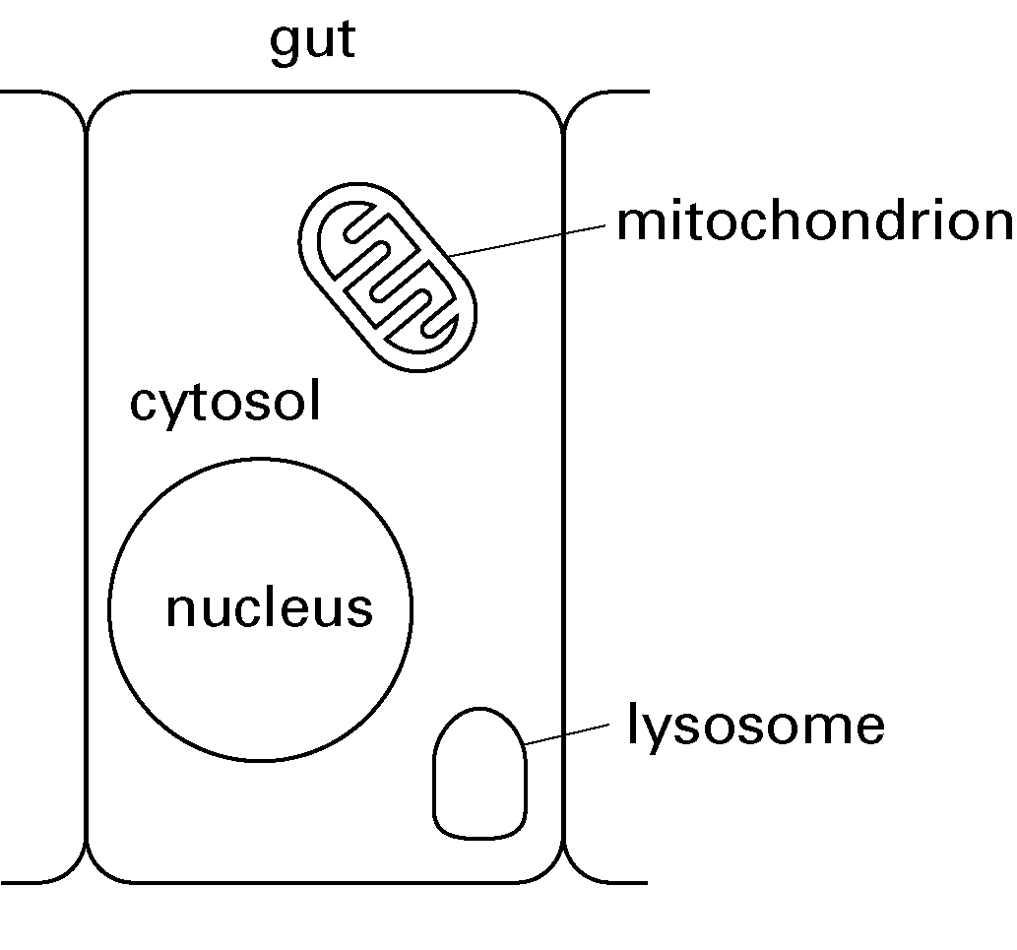
15-2. Question 13-10 in the textbook (p.451).
15-3. Suppose Dr. McLachlin came into class one day and excitedly announced that he had discovered a bacterial species with an unusual mechanism of synthesizing ATP. He says the bacterium uses energy derived from oxidation of a carbon compound to generate a gradient of Na⁺ ions across its cytosolic membrane. ATP synthase uses this sodium ion gradient instead of a proton gradient to synthesize ATP by a rotational mechanism similar to the mechanism of the E. coli ATP synthase.
Do you think this mechanism of ATP synthesis is feasible, or would you think that someone had slipped a hallucinogen into Dr. McLachlin’s coffee?
15-4. The figure at right represents a cell lining the gut. Draw numbered labeled lines to locate exactly where the following processes take place.
Glycolysis
Citric Acid cycle
Conversion of pyruvate to acetyl-CoA
Oxidative phosphorylation
15-5. Rounded to the nearest integer, what percentage of the ATP generated by the complete oxidation of glucose is produced in mitochondria? (This question would not be asked on an exam.)
a) 67% b) 78% c) 83% d) 90% e) 93%

Topic 16
Acetyl-CoA part 2: Fatty acids, ketone bodies, and biosynthesis
Readings: p.436, 439 & 444
Carbohydrates are not the only source of acetyl-CoA for the citric acid cycle. Fatty acids from stored triacylglycerol or from the diet can be degraded and oxidized to acetyl-CoA.
When energy is needed from fat storage, an enzyme called hormone-sensitive lipase degrades triacylglycerol in adipocytes into glycerol and three fatty acids. The released fatty acids enter the bloodstream and are used as fuel in other cells, such as skeletal muscle, heart, and liver. The released glycerol is a substrate for gluconeogenesis.

β-oxidation of fatty acids
In a cell that is using fatty acids for fuel, specific transporters move fatty acid from the blood into the cytosol. Then, the fatty acid is activated with CoA in the cytosol in a reaction that is driven by hydrolysis of ATP to AMP and PP_{i}. The acyl-CoA is then transported into the mitochondrial matrix. There, the acyl-CoA is oxidized in a cycle of four chemical reactions (Fig 13-9, p.437). Each cycle removes two carbons from the fatty acid chain as acetyl-CoA, producing one FADH₂, one NADH, and a fatty acyl-CoA chain that is two carbons shorter than the starting material. The cycle repeats, progressively shortening the fatty acid chain until it is entirely oxidized to acetyl-CoA.
The net β-oxidation reaction for palmitoyl-CoA, the CoA-activated 16-carbon saturated fatty acid, is:
Palmitoyl-CoA + 7 FAD + 7 NAD⁺ + 7 CoA → 8 Acetyl-CoA + 7 FADH₂ + 7 NADH
For simplicity, water and protons have been omitted from this equation.
An acyl-CoA with 2N carbons produces N acetyl-CoA molecules, N-1 FADH₂, and N-1 NADH. Because these reactions occur in the matrix, the acetyl-CoA and NADH produced can be used directly by the citric acid cycle and electron transport chain, respectively. The FADH₂ passes its electrons to coenzyme Q, via a protein other than Complex II.
The fatty acid β-oxidation machinery can accommodate unsaturated fatty acids, but these yield fewer FADH₂ molecules and may require consumption of NADPH (depending on the positions of the double bonds). Fatty acids with odd numbers of carbon atoms produce propionyl-CoA in the final step, which is converted to succinyl-CoA for entry into the citric acid cycle.
Ketone bodies
In addition to using acetyl-CoA to make ATP via the citric acid cycle and oxidative phosphorylation, liver mitochondria can convert acetyl-CoA to ketone bodies. The three main ketone bodies are:
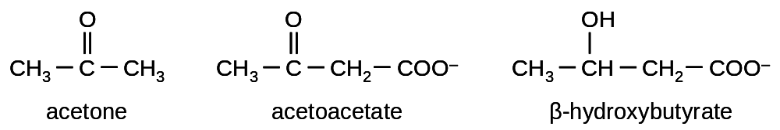
These compounds are exported from the liver and travel through the blood to other tissues, notably brain and muscle, where cells take them up and convert them to acetyl-CoA. Ketone bodies provide a way for the liver to supply other tissues, particularly the brain, with acetyl-CoA for ATP generation.
Fatty acid biosynthesis
When the body’s energy supply is high, acetyl-CoA is stored as fatty acids. Fatty acid biosynthesis occurs in the cytosol, but acetyl-CoA is produced from pyruvate in the mitochondrial matrix. Acetyl-CoA is moved from the matrix to the cytosol by the tricarboxylate transport system, which consumes 2 ATP and 1 NADH but produces 1 NADPH per acetyl-CoA transported.
In the cytosol, the two-carbon units of acetyl-CoA are linked together by fatty acid synthase, a multifunctional enzyme that catalyzes seven different chemical reactions. Most commonly, palmitate, the 16-carbon saturated fatty acid, is produced. The net reaction for this process is:
8 Acetyl-CoA + 14 NADPH + 7 ATP → palmitate + 8 CoA + 14 NADP⁺ + 7 ADP + 7 P_{i}
Fatty acids of other lengths can also be made. Synthesis of a fatty acid with 2N carbons from cytosolic acetyl-CoA consumes 2N-2 NADPH and N-1 ATP. Enzymes exist that can create double bonds in fatty acid chains, if desired. The fatty acids produced can be stored in adipocytes as triacylglycerols, or used to make membrane lipids (see Topic 7).
Control of fatty acid oxidation and biosynthesis occurs via regulatory mechanisms similar to those discussed previously: covalent modification of enzymes based on hormone signals, and allosteric regulation of enzymes. Regulation is also achieved by controlling the amounts of enzymes present. In adipocytes, insulin inhibits hormone-sensitive lipase, preventing release of fatty acids from triacylglycerols, and promotes fatty acid uptake and synthesis of triacylglycerols. Insulin also stimulates fatty acid biosynthesis in the liver. Glucagon activates hormone-sensitive lipase, stimulating release of fatty acids from triacylglycerols.

Biosynthetic pathways leading from glycolysis, acetyl-CoA and the citric acid cycle
Acetyl-CoA and intermediates of glycolysis and the citric acid cycle are used as raw material to make a variety of biological molecules (Fig 13-17, p.444; Fig 13-19, p.446). For example, all carbon atoms of cholesterol are originally derived from acetyl-CoA. Glycolytic intermediates are involved in synthesis of lipids, pyrimidines, and certain amino acids. Intermediates of the citric acid cycle are used to make purines, pyrimidines, certain amino acids, and heme.
These biosynthetic pathways require acetyl-CoA and other molecules to be diverted away from energy metabolism. This is one reason the amount of ATP obtained from glycolysis, the citric acid cycle and fatty acid oxidation is normally lower than the theoretical maximum.
Conversely, amino acids can be degraded to produce pyruvate, acetyl-CoA and citric acid cycle intermediates. Thus proteins are energy storage molecules. However, providing energy is not their major function. During amino acid catabolism, nitrogen atoms are discarded in the form of urea.
Topic 16 Review Questions
16-1. Question 13-6 in the textbook (p.446).
16-2. Indicate where in the cell each process or reaction takes place.
Fatty acid synthesis
Activation of fatty acids with CoA

Fatty acid β-oxidation
16-3. How many net ATP equivalents are produced by the citric acid cycle and oxidative phosphorylation from the complete oxidation of the 18-carbon, saturated fatty acid stearic acid? Assume the stearic acid begins in the cytosol, and that hydrolysis of ATP to AMP and PP_{i} costs 2 ATP equivalents. (This question requires numerical information you don’t need to know for the exam, but should be helpful as a review.)

Topic 17
Energy metabolism: The big picture
Readings: p.445-450
In Topics 12-16 we have looked at the major pathways involved in human energy metabolism. Movement of substrates though these pathways is strictly controlled based on the energy needs of the body.

Fed and unfed states
Just after a meal, energy is readily available from the food just consumed. Blood glucose is high, and insulin is secreted. This stimulates uptake of glucose from the blood by many tissues, including muscle, liver and adipose tissue. Storage of fuel as glycogen and triacylglycerols is favoured, as are protein synthesis and biosynthetic pathways in general. Some glucose-6-phosphate is diverted through the pentose phosphate pathway to make NADPH and ribose 5-phosphate.
As several hours pass since the last meal, blood glucose drops, insulin levels fall and glucagon levels increase. Glucagon inhibits glycolysis and stimulates glycogen breakdown and gluconeogenesis in the liver, which helps replenish the supply of glucose in the blood. Maintaining a certain level of circulating glucose is important because glucose is the brain’s preferred fuel. Muscles break down their own glycogen for energy. After an overnight fast, glycogen breakdown and gluconeogenesis contribute about equally to maintaining blood glucose levels. Glucagon stimulates adipocytes to release fatty acids, and fatty acid oxidation is the major energy source in muscles and liver. Ketone body production is increased but is not a major energy source for the brain. As time passes without food intake, liver glycogen reserves are depleted and most circulating glucose comes from gluconeogenesis. There is net protein degradation, and the released amino acids are the main starting materials for gluconeogenesis.
Gluconeogenesis fueled by amino acids cannot continue indefinitely, because nitrogen becomes depleted, and the body needs proteins to survive. If a human fasts for several days, protein degradation as a source of energy is reduced. Release of fatty acids and glycerol from triacylglycerols continues, and the sustained level of fatty acid in the blood leads to increased ketone body production in the liver. The brain adapts, and ketone bodies become its primary energy source. However, the brain still uses some glucose, and some cell types such as erythrocytes still need glucose for fuel. Glycerol is the main substrate for gluconeogenesis, and oxidation of fatty acids provides the required NADH. Overall, metabolism slows as the body tries to conserve energy.
In the last stages of starvation, when fat reserves are gone, the body is forced to consume protein to provide energy for the brain. Eventually, people do not have enough strength to properly clear air from the lungs while breathing, and they commonly succumb to opportunistic lung infections. Inability to maintain ion gradients across the membranes of brain cells can also cause death, as can impaired liver and heart function caused by a lack of essential proteins.

Diabetes mellitus
Diabetes mellitus (hereafter called just diabetes) is a disease in which the body’s normal response to high blood glucose is impaired. Type 1 diabetes typically arises during childhood and results from auto-immune destruction of pancreatic cells that produce insulin. In untreated Type 1 diabetes, the body behaves as if in a state of perpetual fasting. Cells are not prompted to absorb glucose from the blood, and in fact gluconeogenesis and triacylglycerol degradation are stimulated. Ketone body production is high, increasing the acidity of the blood. Blood glucose levels are high enough that glucose is released in the urine, drawing more water along with it. For this reason excessive urination and thirst are symptoms of diabetes. Extreme buildup of glucose, ketone bodies, and acid in the blood can result in unconsciousness and death. Type I diabetes can be treated with periodic insulin injections to maintain blood glucose within normal limits.
In Type 2 diabetes, the main problem is a lack of normal cellular response to circulating insulin, also called “insulin resistance”. This condition arises over time, typically in overweight, sedentary individuals. The metabolic results are similar to those occurring in Type 1 diabetes. Therapy includes weight loss, increasing fibre and reducing mono- and disaccharides in the diet, drug treatment, and (in some people) insulin injections.

Topic 17 Review Questions
17-1. Which of the following sequences best states the ultimate sources of the brain’s energy during the different stages of starvation?
- Glycogen, then protein, then fatty acids, then protein
- Glycogen, then fatty acids, then protein
- Glycogen, then protein, then fatty acids
- Fatty acids, then glycogen, then protein
- Fatty acids, then protein, then glycogen, then protein

17-2. Based on what we have discussed about energy metabolism, do you think it is possible for people with Type 1 diabetes mellitus to overdose on insulin? If so, why would too much insulin cause a problem?

Topic 18
Introduction to DNA and RNA
Readings p.56-58, 74-75, 171-179, 233
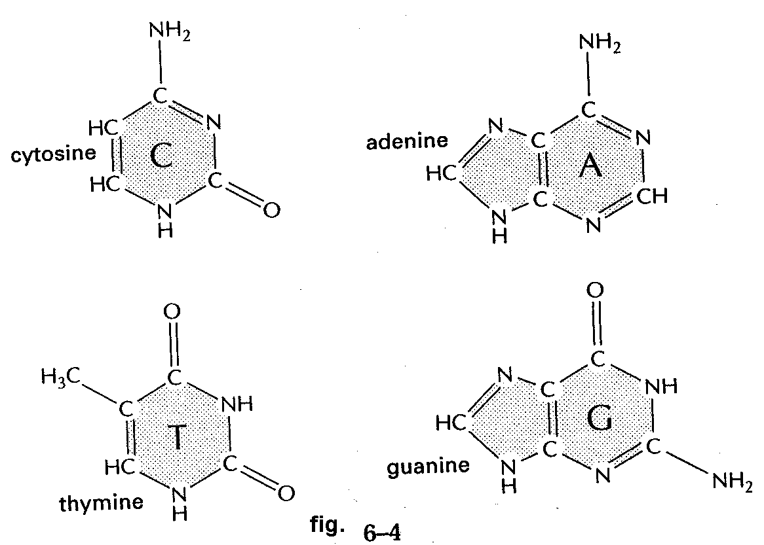
Deoxyribonucleic acid (DNA) is a crucial molecule, because it holds the genetic material, the information passed from parent(s) to offspring that is required to produce an organism. Ribonucleic acid (RNA) has several different functions (Table 7-1, p.236); the most basic ones are (1) acting as the template from which proteins are produced (messenger RNA or mRNA); (2) along with proteins, forming the ribosome and catalyzing protein synthesis (ribosomal RNA or rRNA); and (3) carrying amino acids to the growing peptide chain during protein synthesis (transfer RNA or tRNA).
DNA is a linear polymer composed of deoxyribonucleotide monomers. RNA is a linear polymer composed of ribonucleotide monomers. Each monomer is composed of three parts: a monosaccharide, a nitrogenous base, and a phosphate (see p.74-75).
Monosaccharides
Ribonucleotides contain the pentose ribose. Deoxyribonucleotides contain deoxyribose, which is like ribose, except that C2' bears two hydrogen atoms, instead of one hydrogen and one hydroxyl (p.74).
Nitrogenous bases
There are two types of nitrogenous base: purines and pyrimidines. All purines and pyrimidines are planar and hydrophobic. The two purines found in DNA and RNA are adenine (A) and guanine (G) (p.74 and figure). They join to the hydroxyl on C1' of ribose or deoxyribose via the N9 position.
The three pyrimidines are cytosine (C), which is found in both DNA and RNA, thymine (T), which is found in DNA but not RNA, and uracil (U), which is found in RNA but not DNA (p.74). Uracil is identical to thymine except that uracil lacks the methyl (CH₃-) group. Pyrimidines join to the hydroxyl on C1' of ribose or deoxyribose via the N1 position.
In living systems, the anomeric carbon of ribose or deoxyribose is ordinarily in the β configuration when joined to a nitrogenous base. The sugar and base are joined via an N-glycosidic bond. A sugar joined to a nitrogenous base is called a nucleoside. The five common nucleosides are adenosine, guanosine, cytidine, thymidine, and uridine.
Phosphates
Phosphates are attached to the C5' position of ribose or deoxyribose by a phosphoester linkage. After a phosphate is attached to this position of a nucleoside, a nucleotide is formed (i.e., a nucleotide has all three groups: a sugar, a base, and a phosphate). Phosphate groups are negatively charged at cellular pH.
The names of nucleotides are usually abbreviated using the letter for the nitrogenous base followed by an indication of the number of phosphates present (e.g., ADP for adenosine diphosphate). Sometimes (but not always) the abbreviation for a deoxyribonucleotide will begin with a small d (e.g., dTTP).
DNA and RNA Structure
Mononucleotides are linked together to form an unbranched polynucleotide chain through 3',5' phosphodiester bonds. That is, the phosphate group attached to the 5' carbon of one pentose forms an ester bond to the hydroxyl group at the 3' position of another pentose (see p.75).
The end of a polynucleotide at which the 5' carbon is “free”, or not attached to another monosaccharide, is called the 5' end; likewise at the 3' end the 3' carbon is free. The sequence of the polynucleotide is represented simply by giving the letter for each nucleotide base in order, CAAGTG for example. By convention polynucleotides are written 5' --> 3' left to right, unless otherwise stated. Usually, the context makes it clear whether the polynucleotide is DNA or RNA.
A single strand of DNA is not ordinarily found in the cell. Almost always, two polynucleotide strands are tightly but non-covalently associated with each other. The strands are antiparallel; that is, they have opposite orientation or "polarity". One strand runs in a 5' to 3' direction, and the other runs 3' to 5':
5' ---------------------- > 3'
3' < ---------------------- 5'
The two polynucleotides are wrapped around each other to form a double helix (Fig. 5-2, p.173, CD animation 5.1). The double helix is normally right-handed, meaning that if you look at the helix along its axis, and move your gaze along one strand from a point close to you to a point farther away, the curve is in a clockwise direction. (Can you relate this to the structure of your right hand?) The base pairs lie on the inside and the phosphates are on the outside. This arrangement minimizes charge repulsion between the phosphates, and allows for salt stabilization of the phosphates’ negative charges. Two types of interactions between the bases stabilize the double helix:
1. Base stacking
The bases are planar aromatic rings that are nearly perpendicular to the helical axis. Their flat surfaces allow them to stack on top of each other, stabilized by van der Waals interactions. The atoms in each base pair lie at their optimal van der Waals radius from the adjacent base pair.
Base stacking is not sequence-specific. Any base can stack on top of any other base.
2. Base pairing
Bases also interact by hydrogen bonds between chemical groups on the edges of their ring structures. These interactions are sequence-specific. In normal double-stranded DNA, A and T base pair with each other and no other base; likewise, G and C base pair exclusively with each other. The hydrogen bond donors and acceptors of these pairs are perfectly complementary to each other. The AT pair forms two hydrogen bonds, and the GC pair forms three (Fig 5-6, p.177). These base pairing arrangements are called Watson-Crick base pairing, after James Watson and Francis Crick, the scientists who first proposed the correct structure of DNA. Because A pairs only with T, and G pairs only with C (and vice versa), the sequence on one strand dictates the sequence on the other (i.e., if you know the sequence of one strand, you know the sequence of them both; such strands are said to be complementary strands).
Note that each base pair consists of one purine and one pyrimidine base, giving a uniform base pair size, so that the two sugar-phosphate backbones stay the same distance apart. Also, because water is excluded from the interior of the double-helix, it cannot compete with the bases for hydrogen bonding positions.
DNA can form different types of double helices, with different geometries. In cells, DNA usually adopts a structure called the “B” form. Features of the B-DNA double helix:
it is narrow, about 2 nm (20 Å) wide
it can be very long; human chromosome 1 consists of 245 million base pairs
the distance between consecutive bases is about 0.34 nm (so chromosome 1 would be about 8.3 cm long if it were stretched out in a straight double helix)
because of the positions at which the bases are attached to the sugar-phosphate backbone and the arrangement of hydrogen bonding donors and acceptors, the two grooves between the sugar-phosphate backbones are not equal in size. The wider groove is called the major groove, and the narrower one is the minor groove (Fig 5-7, p.178). Proteins use the chemical groups that project from the bases into the grooves to recognize the sequence of double-stranded DNA.
RNA
Differences between DNA and RNA structure:
1. The sugar in RNA is ribose instead of deoxyribose (Fig 7-3A, p.233). The presence of a hydroxyl group at the 2' position of ribose makes the phosphodiester bond of RNA sensitive to base (OH–). Unlike DNA, RNA is degraded into mononucleotides in basic solution.
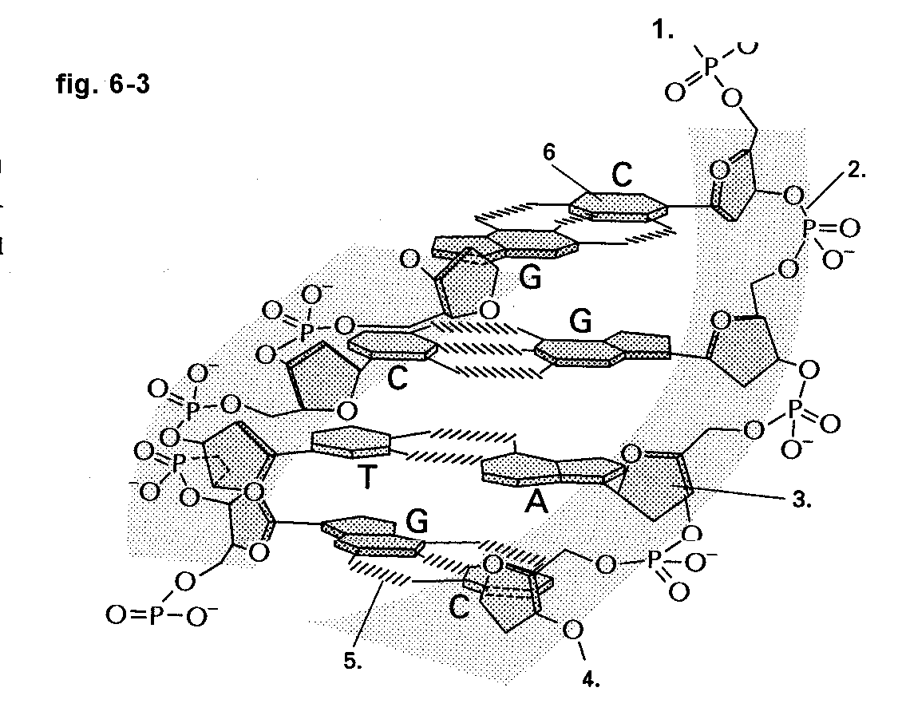
2. RNA contains no thymine, but has uracil instead. These bases are very similar, differing only by a methyl group (Fig 7-3B, p.233). Thus uracil can form a Watson-Crick base pair with adenine, just as thymine can.
3. RNA is usually a single-stranded molecule that is much shorter than DNA (usually no longer than a few thousand nucleotides). RNA molecules fold into unusual shapes that allow the strand to base pair with itself (Fig 7-5, p.234; Fig 7-28, p.250). Sometimes a DNA-like double helix is formed, but other structures also arise, and base-pairing is not always strictly according to the Watson-Crick scheme. Like protein structure, RNA structure is sequence-dependent; this is not true for DNA, in which any sequence forms essentially the same structure.
4. The cell is much more likely to chemically modify nitrogenous bases in RNA than in DNA. Over 100 different types of modified RNA bases have been identified, making up 1-2% of bases in tRNA and less than 1% of bases in rRNA. These modified bases can influence the secondary and tertiary structure of RNA.
Topic 18 Review Questions
18-1. Question 5-6 in the textbook (p.193).
18-2. Question 5-10 in the textbook (p.194).
18-3. On the diagram of a small portion of a DNA molecule below, match the labels to the numbered label lines.
a) Base b) Sugar c) Phosphate d) Hydrogen bond e) 5' end f) 3' end

Topic 19
Chromatin
Readings p.184-190
The DNA of one human cell would be very long if the double helices were extended in a straight line. The cell must arrange the DNA in a compact form so that it will fit within the nucleus. At the same time, the DNA must be available for transcription into RNA. This implies a high degree of organization in DNA packing. DNA is organized with the help of proteins; the complex of DNA and its organizing proteins is called chromatin.
In eucaryotes, DNA is associated with small proteins called histones, each of which has fewer than 200 amino acids. Because histones have many lysine and arginine residues, they are positively charged at physiological pH and ideally suited to interact with the negatively charged phosphate groups of DNA. Histones are highly conserved among eucaryotes, reflecting their important function.
The DNA double-helix helix wraps around a cluster of eight histone proteins: two copies each of histone H2A, histone H2B, histone H3 and histone H4 (Figs 5-22 and 5-23, p.186; Movie 5.2). The DNA makes 1.7 circuits around the histone core, a distance of 147 base pairs. The wrapped DNA and histone core proteins are collectively called a nucleosome core particle. There is a linker region ranging from a few bases to about 80 bases between the core particles. The nucleosome core particle plus the linker is properly called the nucleosome, although sometimes the word nucleosome is used to refer to the nucleosome core particle only. Nucleosomes compact the DNA strand by a factor of about three.
The nucleosomes can pack into a coil called a 30-nm chromatin fibre (Fig 5-25, p.187). The arrangement of nucleosomes in this fibre is still controversial. Some evidence favours a “zig-zag” structure similar to what is shown in Fig 5-25 (p.187). The 30-nm fibre is stabilized by histone H1 (Fig 5-24, p.187). In the 30-nm chromatin fibre, the length of the DNA has been compacted by a factor of ~100.
It is thought that the 30-nm chromatin fibre forms large loops of 30 000 to 200 000 base pairs (30-200 kbp) that are anchored to the chromosomal scaffold, a group of non-histone proteins. The loops are packed together to form the chromosome, which is about 1400 nm thick in its fully condensed form, just before cell division.
Details are still being discovered about how the cell is able to access individual sections of DNA when needed, despite all this packing. Chromosome remodelling complexes exist that use energy from ATP hydrolysis to change the arrangement of nucleosomes (Fig 5-27, p.189). Chemical modification of histones, such as phosphorylation, methylation and acetylation, also seems to have a role, perhaps by influencing the affinity of histones for DNA, the stability of higher order DNA folding, or by recruiting specific proteins to certain regions of DNA (Fig 5-28, p.189).
Topic 19 Review Questions
19-1. Question 5-12B in the textbook (p.194).
19-2. Which statement is false?
- Nucleosomes are present in eucaryotic chromosomes, but not in procaryotic chromosomes.
- Each nucleosome contains two molecules each of histone H2A, H2B, H3, and H4.
- A nucleosome core particle contains a core of histone with DNA wrapped around it approximately 1.7 times.
- Nucleosomes are aided in their formation by the high proportion of acidic amino acids in histone proteins.
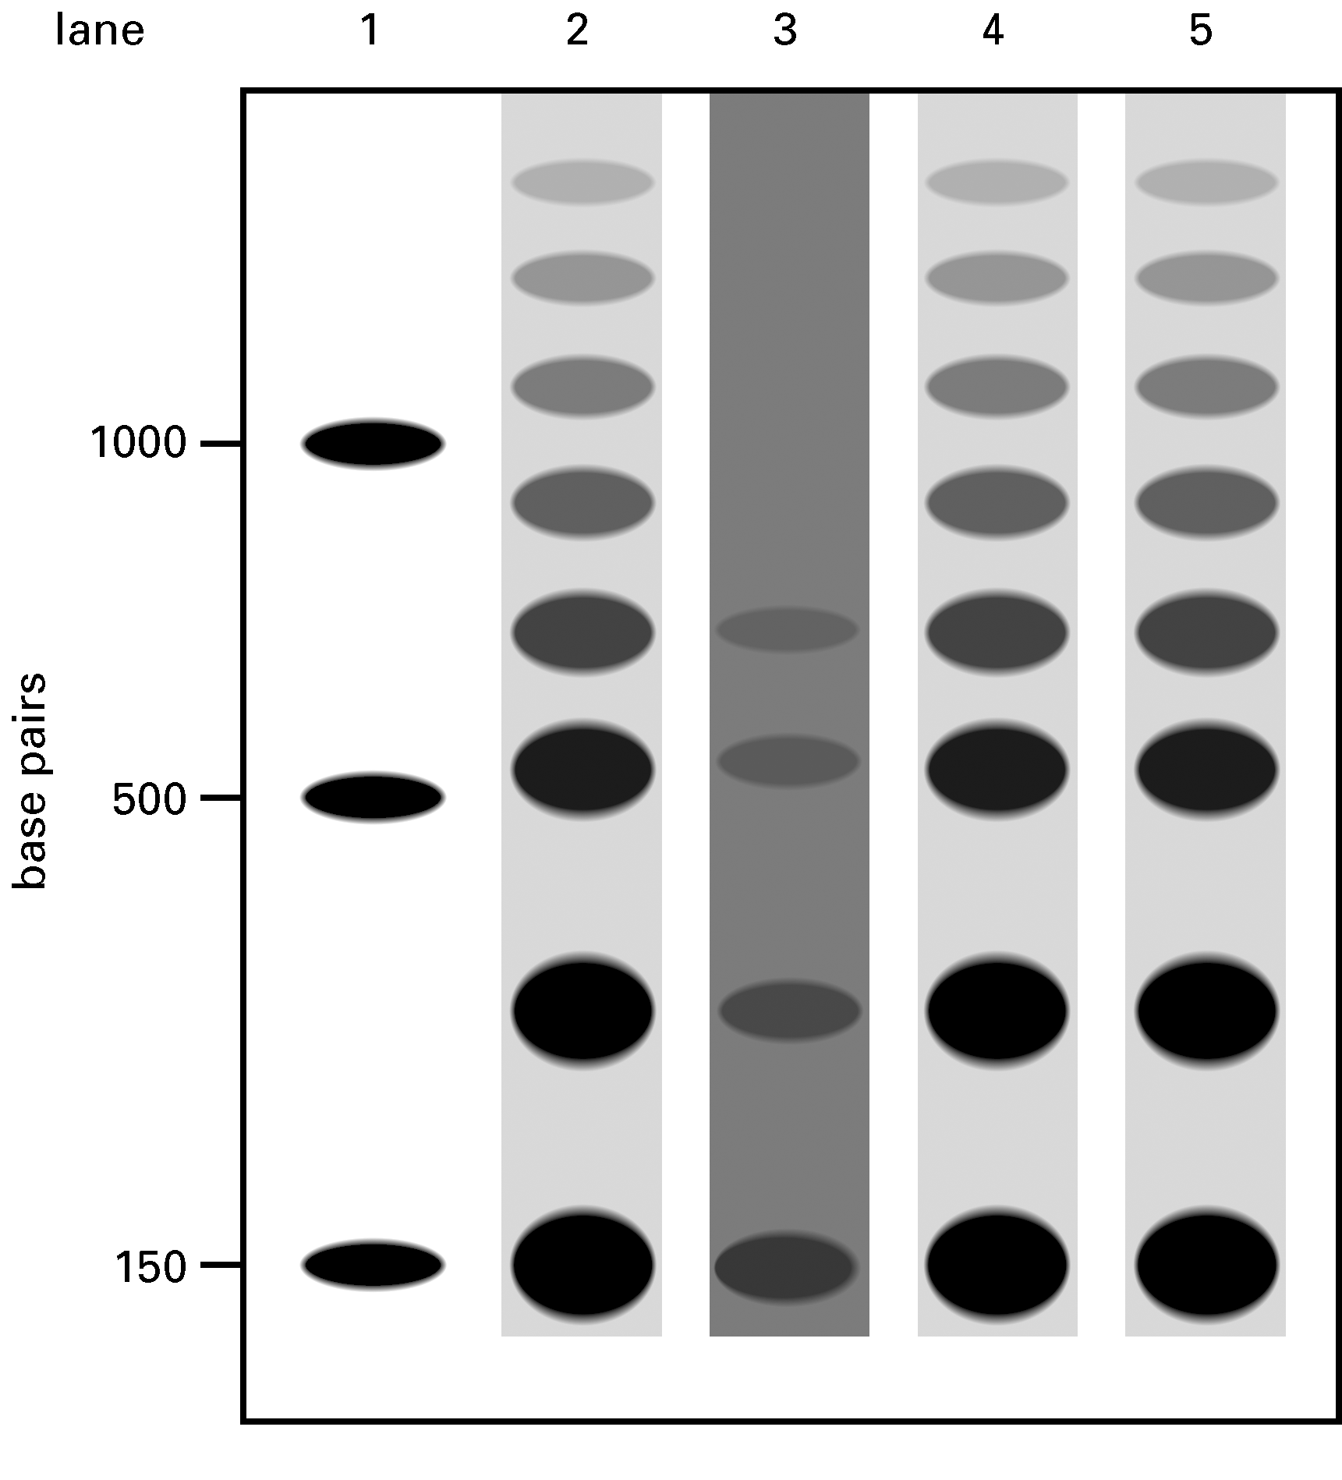
- Nucleosome formation compacts the DNA into approximately one-third of its original length.
19-3. Your friend is working in a lab to study how cells adapt to growth on different carbon sources. He grew half of his cells in the presence of glucose and the other half in the presence of galactose. Then he harvested the cells and isolated their DNA using a gentle procedure that leaves nucleosomes and some higher order chromatin structures intact. He treated the DNA briefly with a low concentration of M-nuclease, a special enzyme that degrades protein-free stretches of DNA. After removing all the proteins, he separated the resulting DNA on the basis of length. Finally, he used a procedure to visualize only those DNA fragments from a region near a particular gene called Sweetie or another gene called Salty. The separated DNA fragments are shown in the figure below. Each vertical column, called a lane, is from a different sample. DNA spots near the top of the figure represent DNA molecules that are longer than those near the bottom. The lanes are as follows:
1. “Marker” containing known DNA fragments of indicated lengths
2. DNA near Sweetie gene from cells grown in glucose
3. DNA near Sweetie gene from cells grown in galactose
4. DNA near Salty gene from cells grown in glucose
5. DNA near Salty gene from cells in grown galactose

A. What do you think the spot closest to the bottom of lane 2 represents?
B. What are the spots with longer lengths? Why is there a ladder of spots?
C. Notice the faint spots and extensive smearing in lane 3, suggesting that, for many copies of the genome, the DNA could be cut almost anywhere near the Sweetie gene after growth of the cells in galactose. This was not observed in the other lanes. Why might the DNA look like this in lane 3?
D. What kinds of proteins might have been at work to cause the difference between lane 2 and lane 3?
- Do you think that gene expression of Sweetie is higher, lower, or the same in galactose compared to glucose? What about Salty?

Topic 20
Replication of DNA
Readings p197-210, CD animations 6.1, 6.4 and 6.5
Starting from a single cell, humans must generate many billions of copies of their DNA throughout their lifetimes. DNA must be copied, or replicated, with great accuracy.
During replication of DNA, each strand of a double helix serves as a template for synthesis of a new DNA strand. The enzyme DNA polymerase (Movie 6.1) makes the new strand complementary to the template, according to the Watson-Crick base pairing rules. For example, when A is on the template strand, T is added to the strand being synthesized (Figs 6-2 and 6-3, p.198). DNA polymerases are often complex multi-subunit enzymes.
Replication of DNA is said to be semi-conservative, meaning that each of the two double helices resulting from replication contains one strand from the original double helix (Fig 6-4, p.199). This was demonstrated in an elegant experiment by Meselson and Stahl, who labeled replicating bacterial cells with ¹⁵N and used centrifugation to “weigh” the bacteria’s double-stranded and single-stranded DNA after various generations had passed (see p.200-202).
Initiation
Replication starts at specialized DNA sequences called replication origins. The procaryote E. coli, which has a relatively small amount of DNA, has a single origin. Eucaryotes have more DNA and have multiple origins. Initiator proteins recognize the sequences of replication origins and pull apart the two strands of DNA at the origins (Fig 6-5, p.199). Replication origins are rich in AT base pairs, which are held together by only two hydrogen bonds and are easier to pull apart than GC base pairs.
After the DNA at the origin has been pulled apart, helicase and other proteins can bind to the DNA. Helicase unwinds the double helix, consuming ATP as it does so (Movie 6.2). Single-strand binding protein associates with unwound regions and prevents them from re-forming base pairs.
Priming
DNA polymerase cannot start synthesizing a DNA strand using only the template strand; it needs something to attach nucleotides to. The enzyme primase gives DNA polymerase something to work with by synthesizing short (~10 nucleotides long) RNA primers on the separated DNA strands in the 5' to 3' direction.
DNA Synthesis
DNA polymerase synthesizes DNA in the 5' to 3' direction, extending the primer from its 3' end (Fig 6-10, p.204). At each position on the single-stranded template DNA, it adds the complementary base from deoxyribonucleoside triphosphates (dNTPs) in the surrounding solution. Mononucleotides are incorporated into the new DNA strand, and pyrophosphate is the by-product.
Synthesis occurs in both directions from the replication origin, at replication forks (Fig 6-9, p.203; 6-12, p.205; Fig 6-17, p.209). Helicase travels at the front of the replication fork, unwinding the DNA. Two DNA polymerase complexes associate with the helicase, each one synthesizing DNA using a different template strand. DNA polymerase stays associated with the template strand with the help of a sliding clamp protein, which forms a doughnut-shaped dimer around the DNA (Movie 6.3).
Double-stranded DNA is anti-parallel. That means that replication on one of the template strands proceeds very naturally: DNA polymerase travels with the replication fork in the 3' to 5' direction, synthesizing complementary DNA in the 5' to 3' direction. This template strand is called the leading strand, and synthesis on this strand is said to be continuous. DNA synthesis on the leading strand can continue for a long distance, usually about 5 x 10⁵ nucleotides, using only one primer.
On the complementary strand, called the lagging strand, DNA synthesis must occur in the direction opposite to that in which the replication fork is moving (Fig. 6-12, p.205). On the lagging strand, synthesis occurs in short bursts to form Okazaki fragments, which are connected later by DNA ligase. In E. coli, Okazaki fragments are 1000-3000 nucleotides long, but in humans they are only one-tenth this length. DNA synthesis on the lagging strand is discontinuous, and needs more primers than synthesis on the leading strand. Replication on the leading and lagging strands occurs concurrently (Fig 6-17 p.209, Movies 6.4 and 6.5).
DNA Ligation
When DNA polymerase completes an Okazaki fragment, it encounters the RNA primer from the previously synthesized fragment (Fig. 6-16, p.208). In eucaryotes, the DNA polymerase synthesizes enough DNA to displace the RNA, forming a flap structure. Then the polymerase dissociates from the double helix. The RNA flap is removed by a separate endonuclease, and then completed fragments of DNA are joined by DNA ligase. Human DNA ligase hydrolyzes ATP to AMP and PP_{i} during this process. Ligase requires the substrate DNA strands to have a 3' hydroxyl and a 5' phosphate.
Proofreading
The error rate of DNA polymerase in humans is about 1 in 10⁵ bases. Errors can take the form of adding an incorrect base (a substitution), adding one or more extra bases (an insertion) or not adding enough bases (a deletion). In addition to its polymerization activity, DNA polymerase has 3' to 5' exonuclease activity, which can remove mononucleotides from the 3' end of a DNA strand. This exonuclease activity is used to proofread the newly synthesized DNA strand and remove erroneously incorporated nucleotides. When DNA polymerase detects an error, it removes the incorrect nucleotide(s) and begins synthesis again from the point of error (Fig 6-13 and 6-14, p.206). Proofreading increases the accuracy of DNA replication 100-fold, to about 1 error every 10⁷ bases in humans.

Telomeres
Telomeres are protein-DNA structures found at the ends of chromosomes. The DNA consists of a 5000-15000 bp double-stranded region containing many repeats of a six-nucleotide sequence (TTAGGG in humans), followed by a 30-200 nucleotide 3' overhang that loops back and displaces an earlier section of the same strand (see figure). Many specific proteins are associated with this DNA structure. Telomeres enable the cell to distinguish between the end of the chromosome and a double-strand break in the middle of the chromosome.
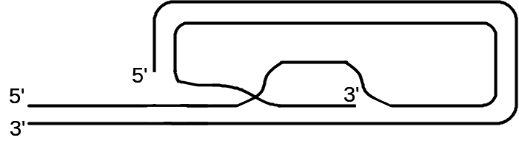
Telomeres also help with another problem, that of replicating the lagging strand at the ends of chromosomes. The cell is unable to synthesize DNA complementary to the very end of the lagging strand, because an RNA primer is needed. Therefore chromosomes get shorter each time the DNA is replicated. Telomeres provide “extra” DNA at the ends of chromosomes, so that coding DNA is not lost during replication. Chromosome shortening is believed to be part of a biological clock that determines the number of generations at which cells stop dividing, and may contribute to the aging process.
Telomeres are synthesized and lengthened by a special DNA polymerase called telomerase (Fig 6-18, p.210 and Movie 6.6). In humans, this enzyme is expressed during embryo development and in germ-line cells, but expression stops in most somatic cells shortly after birth. Abnormal expression of telomerase contributes to making cancer cells immortal.

Antiviral Nucleoside Analogues
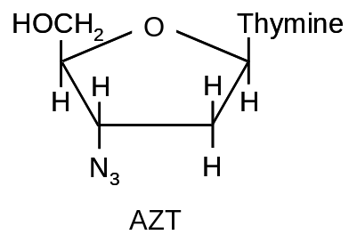
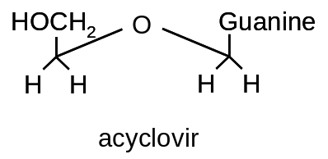
Azido thymidine (AZT), also called zidovudine or Retrovir, is an anti-viral agent used to combat human immunodeficiency virus (HIV). HIV is a retrovirus, a small single-stranded RNA virus. Once in the cell, the virus’ RNA is transcribed to DNA in a process called reverse transcription (the enzyme that does this is called reverse transcriptase). AZT is taken orally and converted to the triphosphate form by the patient’s cells. It can be used as a substrate in place of TTP during DNA synthesis, becoming incorporated into the newly synthesized DNA strand. Because it has azide (N₃) instead of a hydroxyl group at its 3' carbon, the next nucleotide cannot be added to the strand and DNA synthesis stops, preventing formation of new virus particles. AZT triphosphate inhibits reverse transcriptase 100 times more effectively than it inhibits human DNA polymerase, because the viral enzyme, but not the human enzyme, has a higher affinity for AZT than for dTTP.
Acyclovir is a selective inhibitor of the herpes virus DNA polymerase. It also causes chain termination when incorporated into a growing DNA strand.

Topic 20 Review Questions
20-1. In a DNA strand that is being synthesized, which end is growing?
a) the 3' end b) the 5' end c) both ends
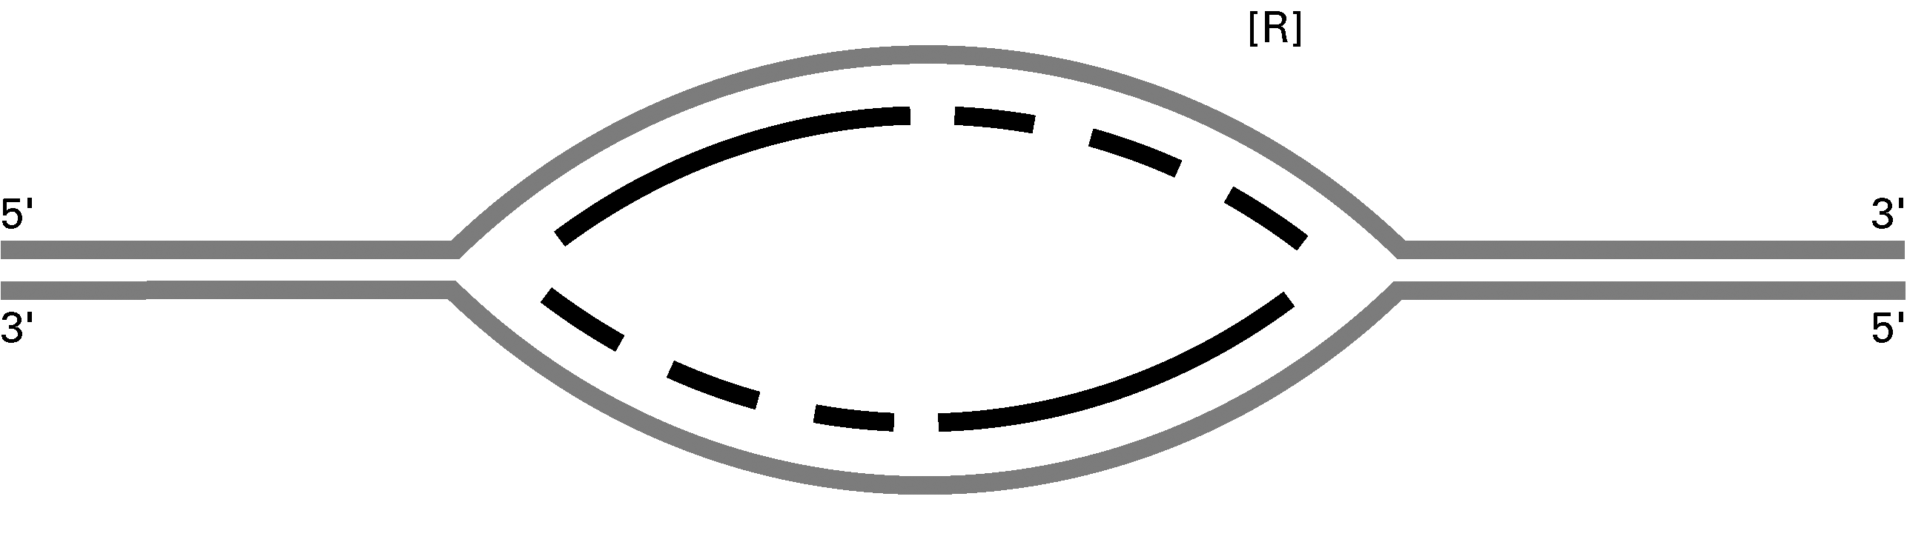
20-2. On the figure of a replication bubble (above):
1. Indicate where the origin of replication was located (use O).
2. Label the leading-strand template and the lagging-strand template of the right-hand fork [R] as X and Y, respectively.
3. Indicate by arrows the direction in which the newly made DNA strands (indicated by dark lines) were synthesized.
4. Number the Okazaki fragments on each strand 1, 2, and 3 in the order in which they were synthesized.
5. Indicate where the most recent DNA synthesis has occurred (use S).
6. Indicate the direction of movement of the replication forks with arrows.

Topic 21
DNA Repair
Readings p.211-220
To preserve genetic information, the cell must guard against unintended changes in the sequence or structure of DNA, which I will refer to as “DNA damage”. The main types of DNA damage are mentioned below.
1. Copying mistakes. Despite the proofreading activity of DNA polymerase, mistakes occur during DNA replication in humans at a rate of about 1 per 10⁷ nucleotides. The result is one or more mismatched base pairs, which would lead to a change in the DNA sequence, or mutation, in one of the daughter double helices after DNA replication (Fig 6-21, p.213).
2. Deamination. The amine group of a nitrogenous base, most commonly cytosine, is changed to a carbonyl (Fig 6-23B, p.214). This occurs spontaneously, and may lead to mutation (Fig 6-25A, p.215). Upon deamination, cytosine is converted to uracil.
3. Depurination. Acid promotes the loss of an entire adenine or guanine base, resulting in an abasic site (Fig 6-23A, p.214). The sugar-phosphate backbone remains intact. Abasic sites block replication by the normal replicative DNA polymerase. When this DNA polymerase stalls, one of several translesion DNA polymerases is recruited to the site. Translesion DNA polymerases are able to synthesize DNA past the site of damage, but because the template has no base, they are likely to either skip that position, or introduce a mutation in the newly synthesized strand (Fig. 6-25B, p.215). After a translesion polymerase has synthesized DNA past the site of damage, the normal replicative DNA polymerase resumes DNA synthesis.
4. Pyrimidine dimers. The double bonds in adjacent pyrimidines, most commonly two thymines, react to form a cyclobutane ring (Fig 6-24, p.214). This reaction is usually caused by ultraviolet radiation. Translesion DNA polymerases are required to replicate DNA past pyrimidine dimers, but are more error-prone than normal replicative DNA polymerases, increasing the risk of mutation.
5. Other base modifications. Ionizing radiation, such as X-rays or gamma-rays, causes a variety of modifications to all four bases. Some chemicals called mutagens react with DNA bases, leading to sequence changes. An example is the superoxide radical, O₂⁻·, the first intermediate formed during reduction of oxygen to water by cytochrome oxidase.
6. Strand breaks. Ionizing radiation or mechanical stress can break the sugar-phosphate backbone, either of one strand (a single-strand break) or of both strands (a double-strand break). Neither the normal replicative DNA polymerase nor translesion polymerases can synthesize DNA past a break in the template. Double strand breaks can cause chromosomal abnormalities or result in cell death.
DNA Repair Systems
A single alteration in a DNA molecule, if left unrepaired, could interfere with the replication process and may cause the death of the cell. DNA damage can also cause mutations, which can alter the sequence of expressed proteins and impair their function. For these reasons, cells have developed a number of DNA repair systems.
1. Proofreading during DNA replication. See Topic 20.
2. Mismatch repair. Mismatch repair enzymes fix mistakes made by DNA polymerase that escaped correction by proofreading, with a success rate of 99% (Table 6-1, p.212). After the repair machinery has detected a site of mismatch, it must determine which strand is the newly synthesized (and hence erroneous) strand. In most procaryotes, it does by this by scanning the DNA in both directions until it finds a methylated base, because most procaryotes add methyl groups to bases within specific sequences some time after replication. Unmethylated strands have not had time to become methylated yet, i.e., the unmethylated strand is the newly synthesized strand. An endonuclease nicks the backbone of the newly synthesized strand, and then an exonuclease removes the bases from the nick to the mismatch site (this can be hundreds of nucleotides away). A DNA polymerase then fills in the gap created by the exonuclease.
In eucaryotes, the method of determining the newly synthesized strand is unclear but may involve searching for intentional nicks (single-strand breaks) in the new strand (Fig. 6-22, p.213). The newly synthesized strand is removed by an exonuclease and resynthesized, as in procaryotes.
3. Base excision repair. Modified bases (including deaminated bases), abasic sites, and single-strand breaks are repaired by base excision repair (BER). There are two types of BER called short-patch and long-patch repair. In both types, an endonuclease cuts the backbone at the site of damage, if necessary. Short-patch BER involves synthesis of only one new nucleotide. Modifications that the short-patch BER proteins can’t fix are handled by long-patch BER, in which 2-10 new nucleotides are synthesized. The undamaged strand serves as the template for new DNA synthesis in each type of BER (Fig 6-26, p.216).
4. Nucleotide excision repair. Pyrimidine dimers and base modifications that distort the helical structure of DNA are repaired by nucleotide excision repair (NER). In this pathway, an endonuclease cuts the backbone of the damaged strand on either side of the site of damage. The distance between the nicks varies from organism to organism (in humans it is 29 bases). The damaged section is removed and new DNA is synthesized to replace it, using the undamaged strand as a template.
People with a defect in NER suffer from xeroderma pigmentosum. In this condition, exposure to UV light causes pyrimidine dimers to accumulate, greatly increasing the risk of skin lesions and skin cancer.
5. Homologous recombination. One of two methods to repair a double-strand break. Proteins bind to the site of damage and recruit DNA (from the other copy of the chromosome) that is complementary to the DNA surrounding the break (Fig 6-29, p.219). The complementary DNA is used as a template to synthesize new DNA to restore the strand to its original condition.
6. Non-homologous end-joining. The second method used to repair a double-strand break. First, the ends are processed with a nuclease or polymerase, as needed (Fig 6-27, p.217). This process does not involve DNA other than the damaged fragments. Then, the ends are ligated together to form a double-helix. Non-homologous end-joining often results in loss of DNA relative to the sequence that existed before damage.
Topic 21 Review Questions
21-1. Question 6-15 in the textbook (p.229).
21-2. Mismatch repair of DNA:
- is carried out solely by the replication DNA polymerase
- requires an undamaged template strand
- preferentially repairs the leading strand to match the lagging strand
- makes replication 100 000 times more accurate
- is defective in people with the condition xeroderma pigmentosum

