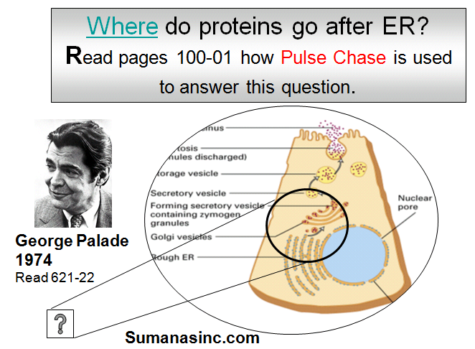
Golgi and pr – Jan 25
***know pulse chase exp and how you would use
It to determine how pr moves in cell
Pulse-chase (pc) experiments are useful for tracking
changes in pr intracellular location or modification
- cell sample exposed to radiolabeled compound
that can be incorporated/attached to pulse,
(molecule of interest) then washed with buffer
- incubate with chase (unlabeled form of compound)
- samples taken periodically are assayed to determine
location/chem. form of radiolabel as function of time
- pc exps (pr detected by autoradiography) are used
to follow synth rate, modification and degradation by
adding radioactive aa precursors during pulse and detecting amts of radioactive pr during the chase
- pc was used to find pathway of secreted prs from ER to cell surface
E.G. cells incubated with 35-S Met (pulse) to label all newly synthesized prs and radioactive aa not incorporated was washed away
- cells were further incubated (chase) for varying times and samples from each time of chase were subjected to immunoprecipitation to isolate a specific pr
- SDSPAGE of immunoprecipitates followed by autoradiography permitted visualization of 1 specific pr, which is initially synthesized as a small precursor (p) and then rapidly modified to a larger mature form (m)
- could measure conversion and/or degradation rate
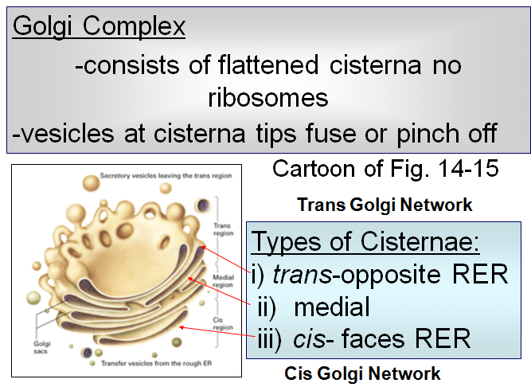
Golgi functions: modify/sort/package
- how do you go from cis -> medial -> trans?
2 explanations:
- vesicles moving up: medial region just an older
cis region
2. entire cisternae moves: goes from cis -> medial ...
***each region has unique functions!
- cis golgi network: vesicles pinching off near base of RER
- trans golgi network: prs not being processed but
getting ready for secretion?

Golgi Function: - “Scurvy” = vit c deficiency
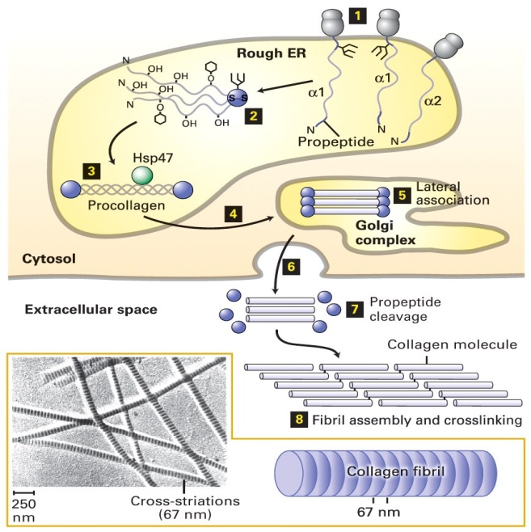
-sugars are trimmed from polypeptide
-hydroxyl groups, added in RER, are used for folding (proline + lysine) Vitamin C
- fact that P and K can be hydroxylated is unique
-final synthesis/packaging for secretion
- collagen most abundant pr
- vitamin C is a cofactor for allowing proline and lysine
to be hydroxylated in RER
- RER is place where glycosylation takes place
- adding sugars to growing polypeptide
- moving from RER to Golgi, sugars trimmed and fine-tuned
- collagen forms triple helix to help with chaperone i.e Hsp 47
- from RER to Golgi, there is some assembly of collagen but only
until it’s released
- at the pt. of release, fibril formed -> if this happened
inside cell, they it would be bombarded and rupture

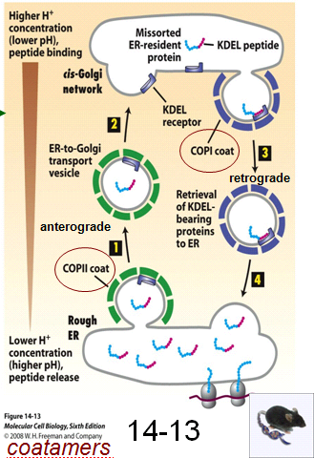
Golgi also reroutes proteins back to RER or lysosomes
How?
-KDEL signal on proteins that should stay in RER lumen
“Retention Signal”
- chaperones are resident ER prs cuz need folding in RER
- coatamers: the type II family recognizes prs moving in anterograde
fashion (moving away from RER towards Golgi)
- receptor binds to pr in low pH -> any pr that has this specific-ordered
sequence KDEL will be recognized by KDEL receptor which causes:
- pr returned to RER, recycling what would be potentially damaging

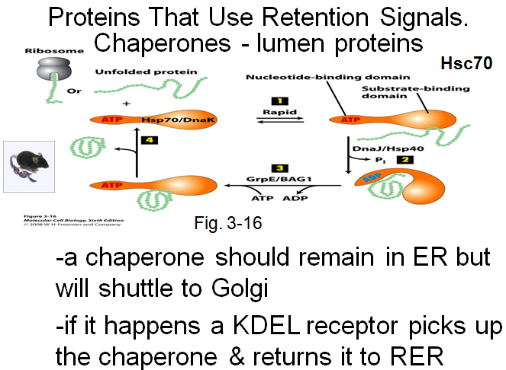

- ATP required for chaperones to work
- chaperones in cytoplasm (not just lumen of RER)
- same prs made in cytoplasm have to be folded
correctly
- region for binding ATP and region for binding pr
- pr binds to chaperone
- give chaperone ATP and ready to release pr and pick
up another one to start procedure again -> recycling aspect

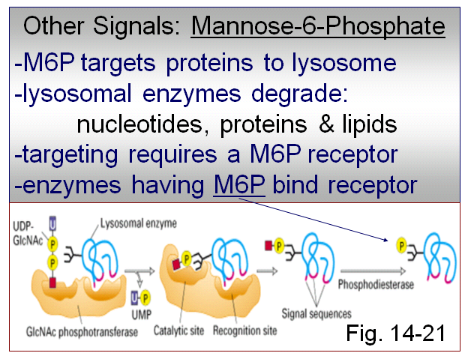
- Tay Sachs: 1 in 25-30 Ash. Jews
- neurons are packed full of lipid that can’t be broken down
- causes blind, deaf, inability to swallow, seizures, muscle
atrophy

- lysosomal hydrolases (hydrolyze prs, lipids, nucleic acids)
-> all have a M6P signal on it
- this occurs in cis-Golgi: addition of P group onto mannose sugar
- sugar phosphotransferase (don’t need to know specific names)
- blue is hydrolase -> how do you tell pr to go to lysosome
- only place where it will work
- take mannose and attach a P residue
- once enzyme has 6P, it will be recognized and sent to lysosome

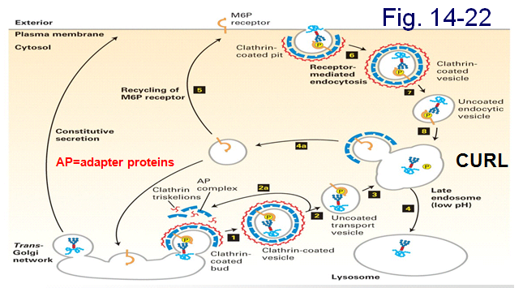

CIS-GOLGI NOT TRANS
- receptor specifically recognizes M6P and hundreds packaged
- adaptor prs ensure receptors stay where they’re supposed to
- vesicle pinches off and clathrin pr (triskelions bind to vesicles, the more vesicle buds off)
- once vesicles are in place, cytoskeleton carries “cargo” to lysosome
- late endosome/CURL: compartment where you have uncoupling of ligand from receptor
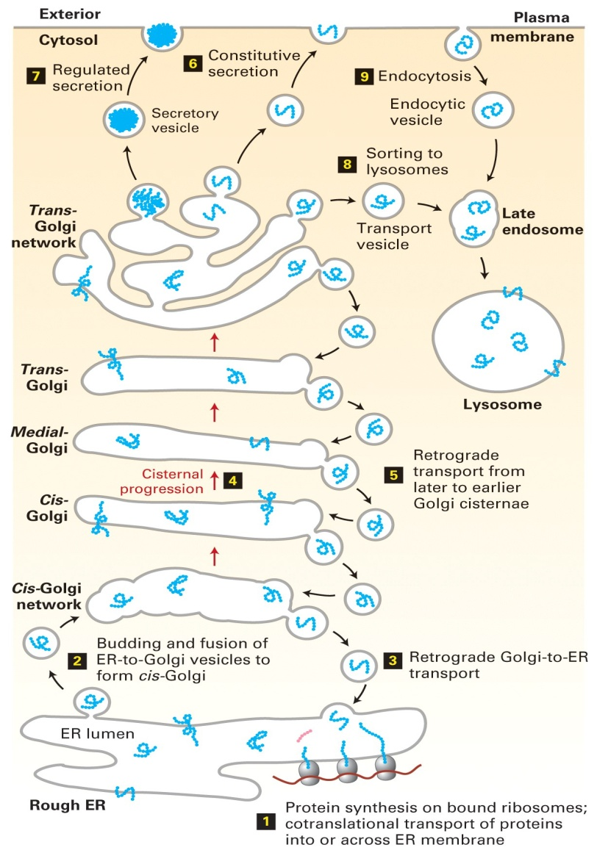
- cells uses receptor and concentrates lysosomal enzymes (works at low pH)

-receptor binding occurs ~ pH 7
-at low pH M6P detaches from receptor
-M6P receptors return to Golgi or to PM
Why receptor on surface? If lysosomal enzyme
secreted out of cell, this is a fail-safe mechanism
to bring it back to cell and send it off to CURL
-> Look at step 6 and 7
EM of just cis, med, trans golgi?
- how would you know pointing to cis?
- what technique? Tag with P using heavy metal
- label pr with antibody:
- purify sugar phosphotransferase
- make antibody
- label antibody with gold particle
- do EM and take antibody and incubate onto
tissue sections?
- EM: everywhere with dots tells Cis

Conceptual Recap
Go over Fig. 14-1 on Protein Secretion

- one cell sends signal to another cell to
Trigger cell div
- signals direct prs to diff destinations
e.g. KDEL on resident ER prs
e.g. M6P signal attached in cis-Golgi instructs
(via M6P receptor) hydrolases to move from trans-
Golgi to lysosome
- M6P attached to enzyme dictats where
It will go
-> pr is NOT secreted, only trafficked to
Where it’s required

Trans-Golgi Network is sorting station
- constitutive v. regulated secretion (i.e waiting
for hormonal or NT signal), also place
Of final proteolytic processing
Vesicles use adapter prs and clathrin to facilitate
Transport – involves cytoskeleton and motor prs
-
-

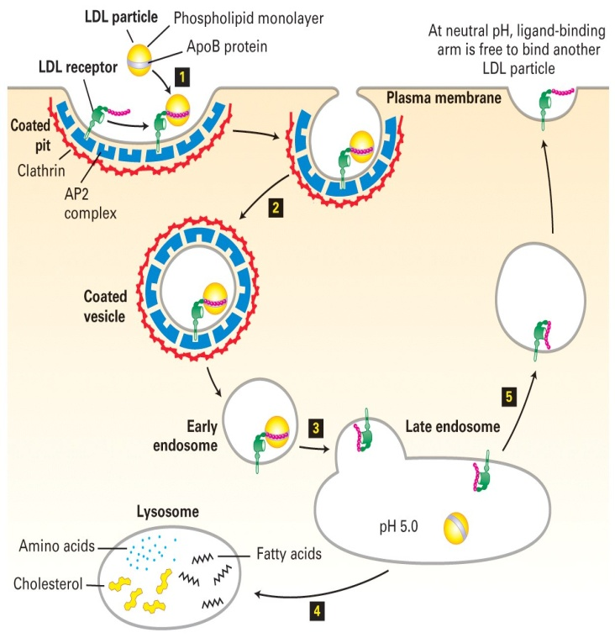
Receptor-Mediated Endocytosis
The Concept: What is it?
A method of selective internalization
- pino: “cell sipping”
- phagocytes: for large particles
- RME: receptor is specific to ligand
i.e. LDL particle => cholesterol
- there are many LDL receptors for efficiency
- adapter prs present and form interaction with clathrin
- clathrin facilitates pinching in and coated vesicle forming
- once clathrin has internalized particle, it’s recycled
- late endosome = CURL (uncouple receptor from ligand)
- proton pumps all along compartment (pumping protons
Into CURL) -> M6P hydrolases only work at low pH
- when active, they break it down into components
- cholesterol = building blocks for hormones

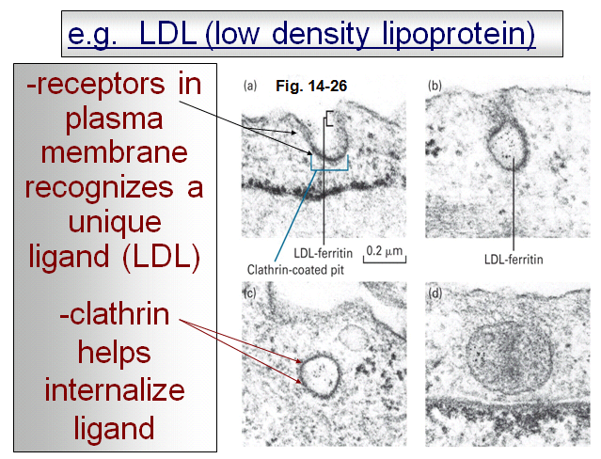

- TEM
- fuzzy coat = clathrin
------------------------------------------------------------------------------------------------------------
Pr is part LDL and part ferretin
- ferretin transports Fe (heavy mental) into cells
- Fe needs to be carried through
- if RME, specific for one ligand, clathrin needed

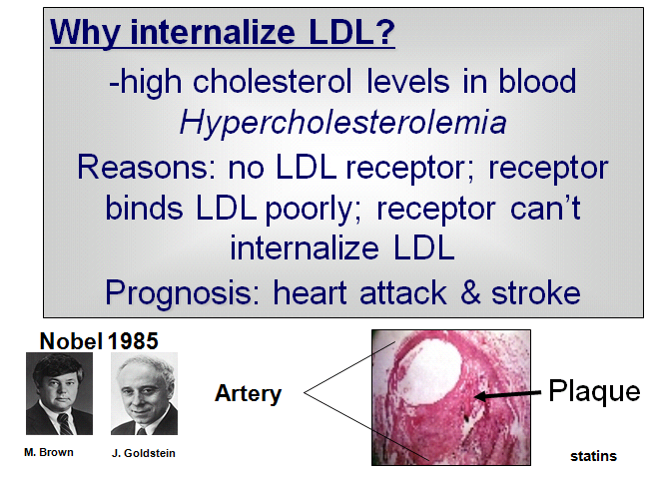

- significant component of hypercholest. is genetic
- foam cells?
- build up occluding coronary artery which leads to heart attack
- binding poorly: 90% of LDL still circulating
- girl given liver transplant: liver stores a huge amt of LDL
And puts it back into bloodstream

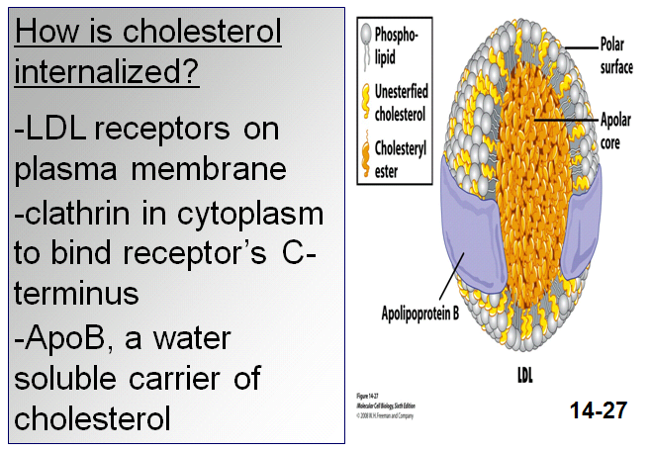

- cholesterol lipid
- ApoB wraps around cholesterol molecules
- if mutated ApoB that couldn’t transport
Cholesterol, you’d prolly still have heart attack
- ApoB is pr recognized by receptor

- extra digits: sonic hedgehog signalling pathway
- need cholesterol for embryonic development
- you’ll have it anyways, but needs to be internalized

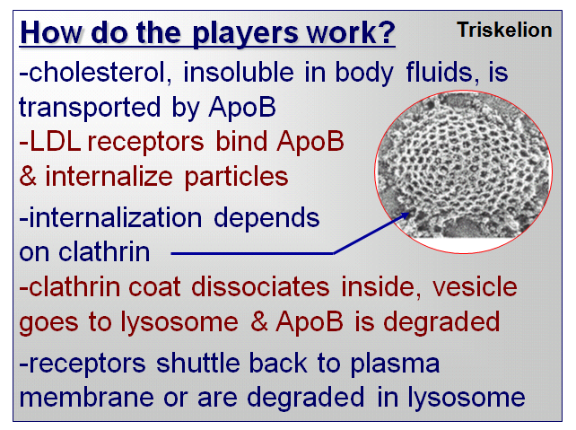

- if you purify clathrin, it’ll self assemble to
Form clathrin basket
- SEM
- lose clathrin, lose trafficking of prs
- once clathrin has internalized vesicles, than
Clath falls off
-

Signal Transduction
- cells respond to signals without having to internalize them
- signals may be secreted growth factors i.e. EGF instructing cells to divide
How does the cell respond? Positively and negatively?

- to transduce signal, you don’t have to internalize it
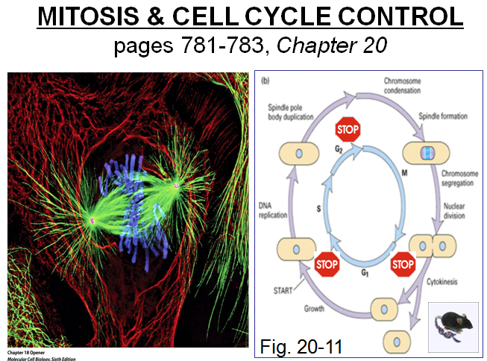
Mitosis
p. 781-783 (nice pic)
- once individual chrs are duplicated in S phase,
they are held together along their length by
prs called cohesins
- mitosis: process where duplicated chrs are
segregated to daughter cells
Prophase
- interphase MTs replaced by asters as duplicated
centrosomes become more active in MT nucleation
- provides 2 sites of assembly of MTs => asters
- 2 asters move and become opposite poles of
mitotic spindle (MT-based structure that separates
chrs)
- pr synth stopped, nucleolus breaks down and chrs
condense
- cohesins are degraded except at centromeric region where 2 sister chromatids remain attached by cohesins
- events coordinated by rapid increase of mitotic cyclin-CDK complex activity: kinase that phosphorylates prs
Prometaphase
- initiated by breakdown of nuclear envelope and pores and disassembly of lamin-based nuclear lamina
- MTs capture chr pairs at specialized structures called kinetochores
- sister chromatids align equidistant from 2 spindle poles => congression
Metaphase is the stage when all chrs are aligned at the metaphase plate
Anaphase
- induced by activation of the anaphase-promoting complex/cyclosome (APC/C)
- activated APC/C leads to destruction of cohesins
- anaphase A: chrs pulled to poles by MTs attached to kinetochore
- anaphase B: mvt of spindle poles farther apart
Telophase is stage where nuclear envelope reforms, chrs decondense, and contractile ring assembly
Cytokinesis happens when cell is pinched into 2 daughter cells by the contractile ring and interphase MT reforms

- green MT
- blue DNA
- red cytoskeleton
- can use fluorescence microscopy in
Live cells
-

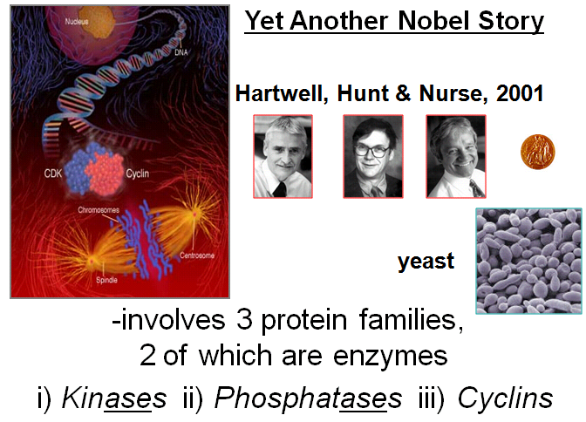

Concept:
-cell proliferation depends on signals
-progression through cell cycle is regulated: G2 -> M checkpoint
-check points ensure things should proceed:

Is all DNA replicated? Important for all
Is cell big enough? Yeast will be able to detect
Is environment favorable? Doesn’t apply for humans
Is DNA damaged? If DNA damaged, repaired or shutdown (apoptosis)
- there is apoptosis in yeast
- micrograph?
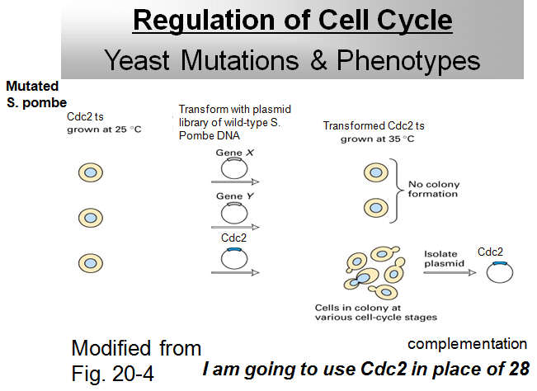
- cyclins used at checkpts
- from yeast 2 hybrid: fixing mutation so
You can make histidine
- fixed it by recreating TF -> complementing
Mutation by introducing a WT gene
- think “gene therapy” for yeast
- 2 genes but in diff strains of yeast
- functional complementation
- start with pool of yeast and mutate genome
- grow yeast at optimal and only temp (25)
- if you raise temp, they won’t grow
- introduce WT genes back into mutated strains
- then raise temp -> temp selection
- no growth
- then introduce another gene and if no growth,
Tells you that WT gene didn’t complement mutation
- they could figure out that original mutation
Would be in cdc2 gene
- if cdc corrects mutation and allows cells to
Undergo mitosis =>
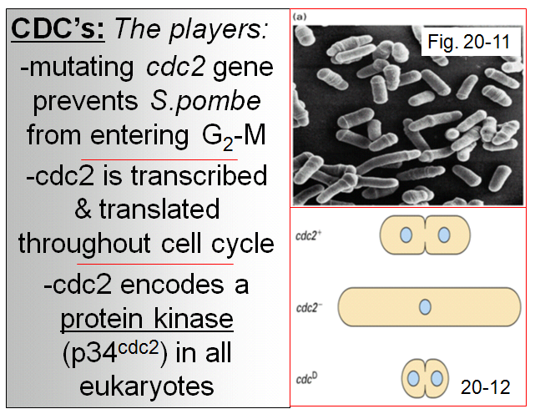

- trying to find which one was mutated in first way
- get around by introducing WT version
- SEM
- cells spend most of time in interphase
- cdc mutated blocks G2-M checkpoint
- how can it behave as a regulator of cell cycle
- kinase phosphorylates
- 34,000 D encoded by cdc2 genes
- if yeast is mutated, incorporate are own cdc2
- cdc2+ = normal
- cdc2- grows until it dies
- cdcD -> constantly being turned on (excessive)
- DNA won’t have time to replicate and this cell
Will die as well
-

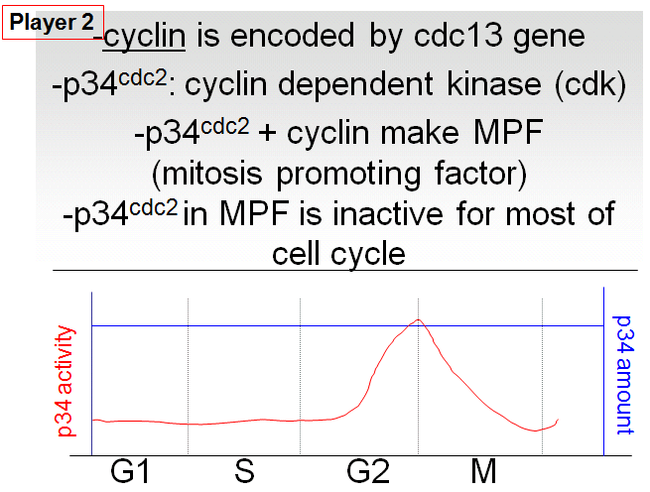

- cyclin regulates cdc2
- no pr works in isolation
- looking at cell cycle: amt of p34 -> increases
In G2-M
- kinase phosphorylates
- pr sitting in cell doing nothing but waiting for signal
- once signal is there, change it’s biological activity
And it becomes active

