Some Concepts to be Covered
- lecture is more for interest, look at big picture!
1) How mitosis is controlled & what happens when these checkpoints are lost or altered.
Wound Healing v. Tumourigenesis
- i.e. apoptosis initiated if body recognizes something wrong
2) How proteins are modified & targeted to intracellular regions or for secretion.
Golgi, RER & Lysosomal Proteins, Collagen, Hormones & Enzymes

3) How & why proteins must be internalized by cells in order to maintain normal physiology.
- sometimes signal transduction tho: many drugs target receptor and ligand interaction
Cholesterol & Heart Disease;
Iron & Anemia; Insulin & Diabetes
But First: Stem Cells, Microscopy, Some Techniques (Pages 8-9, 905-907)
p.8-9 notes
- we begin from a single cell
- development begins with fertilized egg cell dividing into two
- continued cell proliferation and differentiation eventually gives rise to every body tissue
- many cells exhibit distinct functional and/or structural asymmetries -> polarity
- stem cells = cells that can give rise to specific cell types and tissues
- stem cell divisions are a special case of asymmetric division: one of the 2 daughter cells is identical to the parent cell; the other undergoes differentiation, the parent cell is called the stem cell
- cells with potential to develop into any part of animal: embryonic stem cells
- in vitro: extract nuclei from defective sperm and inject nuclei into eggs then implanting fertilized egg into mother
- SCNT: generating specific cell types starting from embryonic or adult stem cells

p.905-907
- germ cells i.e. egg and sperm
- a series of specific cell division patterns akin to a family tree = cell lineage
- cell lineages controlled by internal and external factors
- cell lineages begin with stem cells and highly specialized cells often cannot divide
- intermediate cells known as precursor/progenitor cells or if they are rapidly dividing transient amplifying cells
- once new precursor cell type is created, it often produces TFs characteristic of its fate
- stem cells give rise to both stem cells and differentiating cells and can exhibit several patterns of cell division i.e. divide to increase differentiating cells
- zygote is the ultimately totipotent cell because it has the capability to generate all cell types
- a pluripotent stem cell has the capability of generating a number of diff cell types but NOT all
- stem cells are unique because they are self-renewing and can divide asymmetrically
- a precursor dividing asymmetrically would result in two distinct daughter cells which would be diff to parent cell but the stem cell that is produced is the same as parent
- cell fates are progressively restricted during development
- early germ line segregation
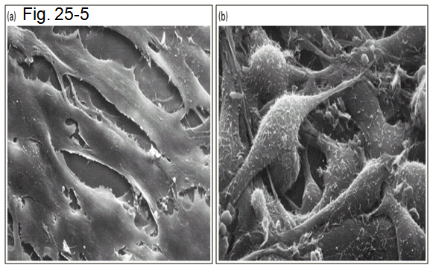
What is a cell?
- functional unit of all living organisms
Panel A -> ordered, spacing
Panel B -> disordered, chaos

How do we study cells?
Hypothesis-Driven Experiments
- needs to be logical
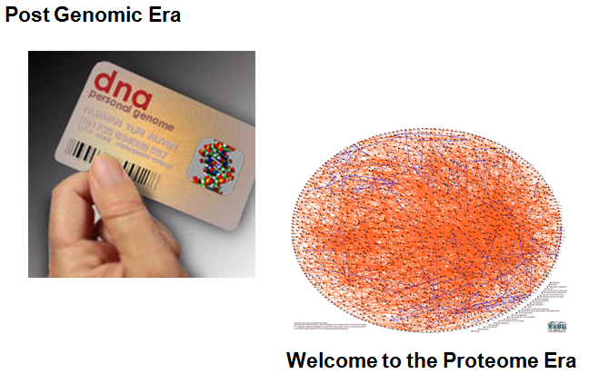
First, you’ll need the tools & methods to isolate and culture cells in vitro, how to view cells and what to look for, how to separate cell organelles and finally, how to identify and study how proteins drive a cell biological process. Once you have the tools, we can start to ask, and more importantly begin to answer, biological questions pertaining to our ~ 75 trillion cells.

Why study cells?
- part of the core in Biology
- lead to Nobel Prize
- fundamental unit of life
- many unanswered concepts
- storehouse for thousands of genes
- determine what is “normal” so we can fix the “abnormal”
Proteome era: how one pr affects the others - Genographic journey
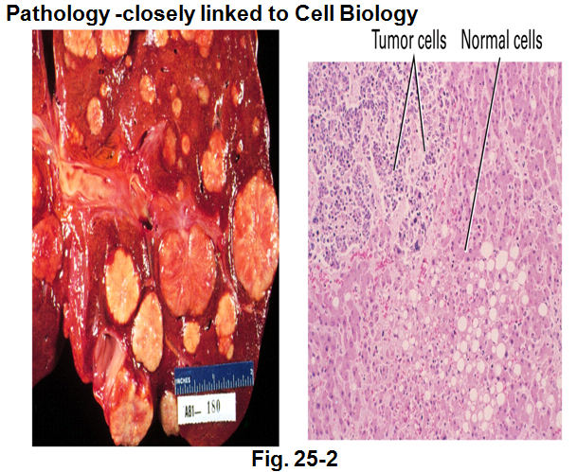
Interactome:
**What is a transcriptome?
Set of all RNA molecules produced in one or a population of cells

Can we rebuild what has been undone?
Stem Cells – what are they, what potential
-> What are IPS cells ?
Induced pluripotent stem cells are a type of pluripotent
stem cell artificially derived from a non-pluripotent cell,
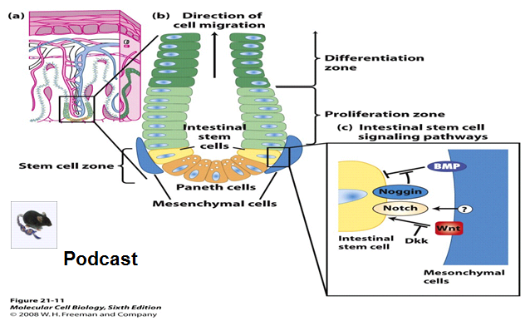
typically an adult somatic cell, by inducing a "forced"
expression of certain genes.

- stem cells exist in small intestine
- buffered area, cells need to be replaced
- don’t need to know figure on the very right
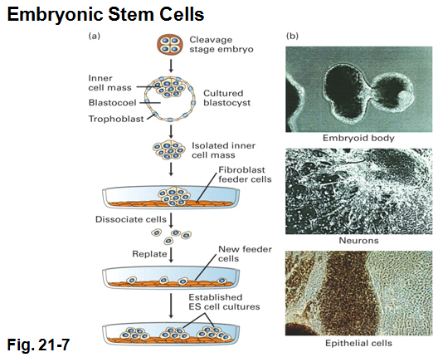

What about earlier and where do they arise?
- cells growing on inner cell mass could give rise to
a whole new embryo (cells will colonize)
- cells grown on another cell type
- cells feed them and they will be able to grow into
little colonies
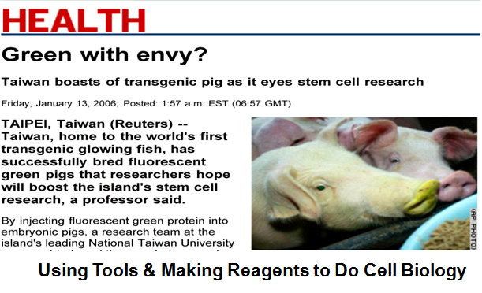
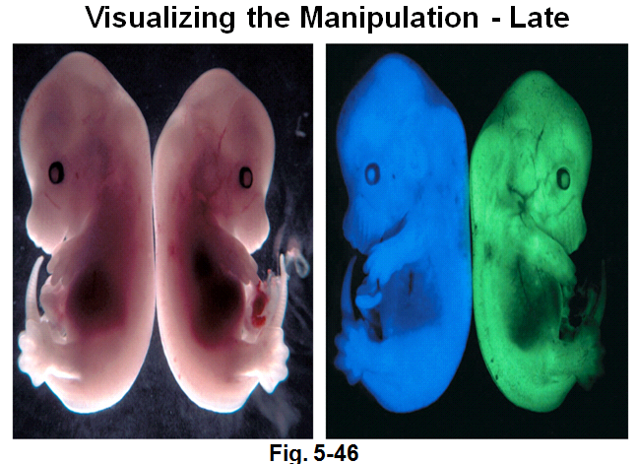
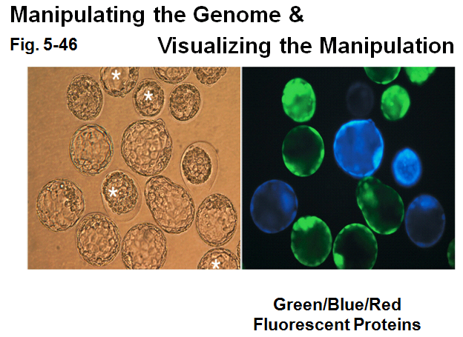

- GFP doesn’t do anything to embryo, need a UV pulse to see fluoresence
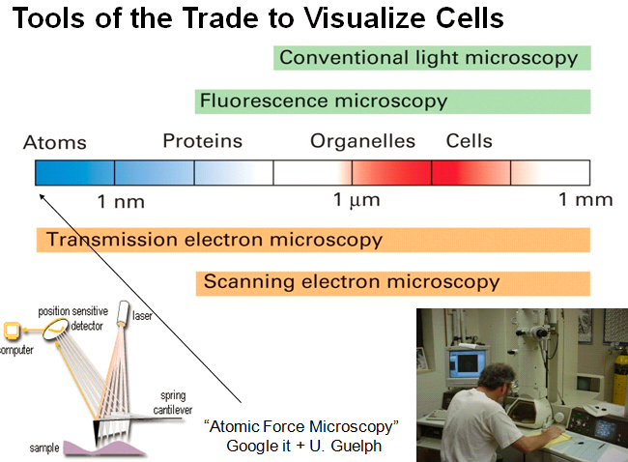
Microscopy
Achromatic microscope: 1826
Wooden Compound microscope, Marzoli: 1811
2 features of microscopy: magnification and resolution
- Anything beyond 1000X is empty magnification
since u can’t resolve anything better
- Resolution is the key for microscopy: resolving 2 distinct pts
Atomic Force Microscopy: very high-resolution type of
scanning probe microscopy, with demonstrated resolution of
fractions of a nanometer, more than 1000 times better than
the optical diffraction limit.
- laser excites cantilever system
- energy that reflects off is detected and you get very
detailed surface topography i.e. seeing at the level of atoms

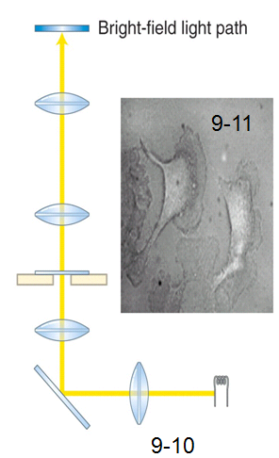
Brightfield Microscope
- light source
- condenser lens to focus light on specimen
- objective lens to collect light after it has passed through specimen
- ocular or eyepiece lens to focus image onto eye
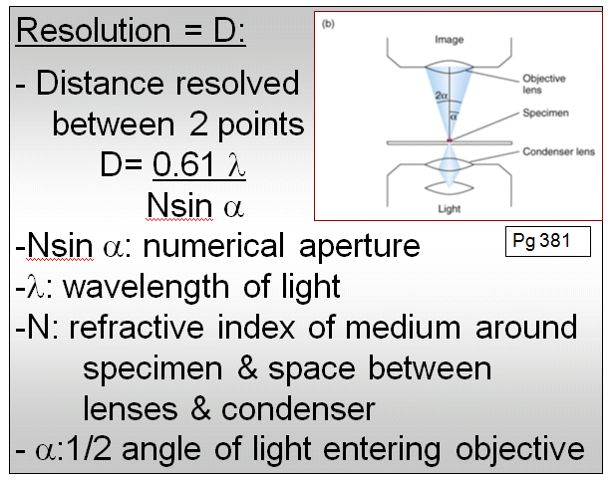

objective lens

condenser

lamp

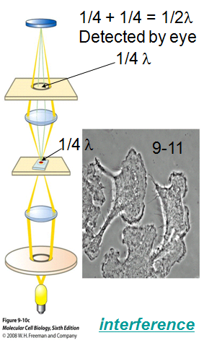

- you want to minimize d! This equation applies to all light microscopes
PHASE CONTRAST Microscopy
- used to examine live “unstained”cells
- small differences in refractive index & thickness within the
cell are converted into contrast visible to the eye
- 2 things introduced into light path: phase annulus
Interference link: http://www.wartburg.edu/biology/fluorescentmicro/phaseanim/phaselightpath.html
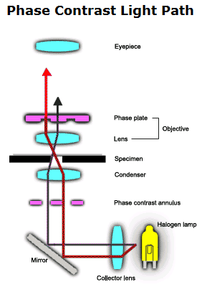
- phase annulus creates cone of light which goes onto specimen
- when light goes thru tissue, amplitude will be slowed down by ¼
- we can’t see a quarter wavelength shift tho
- next section slows the slowed light by a quarter -> this is what we can detect

Q: Wouldn’t it be 0.25 x 0.25?
Light rays passing thru a transparent specimen emerge as either direct rays
or diffracted rays. In phase microscopy, this effect is amplified by using a
microscope equipped with a special annulus (below the stage) and phase
plates (located in the objectives) which accentuate the phase changes
produced by the specimen. Direct rays, unimpeded by the phase plate (red ray)
are of higher intensity, making the background bright and the diffracted rays
(black ray) impeded by the phase plate are of lower intensity, making parts of
the specimen darker. This results in improved contrast differences between
the specimen and the surrounding medium

Differential Interference CONTRAST Microscopy also known as Nomarski imaging examines live unstained cells
- small differences in refractive index & thickness within the cell are converted into contrast visible to the eye
- look thru by focusing on cell thru z coordinate (Fig. 9-11)
9.2 Light Microscopy: Visualizing Cell Structure and Localizing Proteins Within Cells (p. 380-382)
- researchers can use a chimera of any desired pr of interest linked to a naturally fluorescent pr to track location
- resolution of light microscope is about 0.2 μm
- total magnification for bright-field light microscopy: objective x projection
- most important property of microscope is resolution which is equivalent to the min. dist. btwn 2 separate objs

Phase-contrast and differential interference contrast microscopy visualize unstained living cells
- both methods take advantage of differences in refractive index and thickness of cellular materials
- both can be used in time-lapse microscopy where same cell can be photographed at regular intervals for hours
Phase-contrast
- phase-contrast generates an image in which the degree of darkness or brightness of a region depends on the refractive index of that region (light moves more slowly in a medium of higher refractive index)
- beam of light is refracted when passing thru -> part of wave will be out of or in phase -> brighter if in phase
- refracted and unrefracted light are recombined at the image plane to form the image
- useful for examining location and mvt. of larger organelles in live cells and for observing single cells/thin layers

DIC
- based on interference btwn polarized light
- useful for seeing very small details and thick objects
- contrast generated by differences in refractive indexes of object and medium
- in DIC images, objects appear to cast a shadow to one side and is a thin optical “slice” through object
- 3D structure of object can be reconstructed by combining the individual DIC images
