Microscopes and Proteomic Techniques – Jan. 11
Translational science: from bench to bedside

Looking closely and into cells
Phase/DIC -> changing optical path to see more *resolution is extremely important
Techs: Electron Microscopy, Fractionation, Microarrays, Two Hybrid Analysis
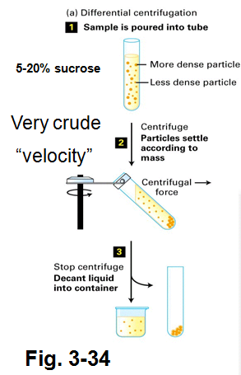
Fractionation
- cell plasma membrane must first be “homogenized” by:
i) sonification: using sound to homogenize cells -> high frequency disrupts
plasma membrane (doesn’t do anything to prs though)
ii) sheared: use stick to shear cells or use serrated glass
iii) pressure: French press -> increased pressure causes cell to explode
iv) detergents: poke little holes in bilayer and contents leak out i.e. Triton X-100
- then the contents are separated by Centrifugation
- once homogenized, often buffer is added as a “cushion” i.e. sucrose

Centrifugation (p.392)
- Differential – crude separation
- spinning homogenate yields pellet and supernatant,
force needed to pellet things to bottom of tube
- increasing centrifugal force (gravity) to isolate organelles
based on mass
- heavy organelles i.e. nuclei pellet at low force of gravity (600 g)
- removing supernatant and a 1.5 x 10⁴ g force to get mc and
lysosomes
- 3 x 10⁵ g needed for ribosomes
- Equilibrium Density-Gradient – finer, analytical separation,
-> need ultracentrifuge
- homogenate is applied to a gradient of sucrose
- separation based on density
- can put supernatant on top of sucrose gradient
- sucrose gradient made by mixing diff concentrations of sucrose
- at high speed, organelles migrate to sucrose layer equal their
own density
- maintain stratified as long as you don’t shake it
- extraction: poke hole, use fraction collector and use spectrometer to know what density of sucrose
Centrifuges
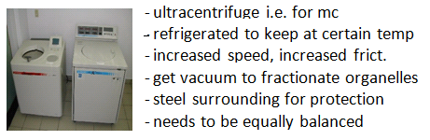
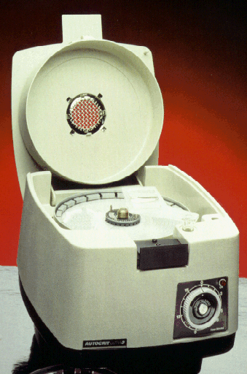
- smalls ones to get crude fractions
i.e. bits of organelles/
plasma membrane

- gel electrophoresis is a good method to separate proteins from organelles but proteins are DENATURED

Biologically-Active Protein Isolation by Column (Liquid) Chromatography used to get pure protein fraction
- uses matrix of special beads; homogeneity = 100% pure
- isolation based on mass (size), charge, or ability to bind to other prs
Detergents and Solubilization
- ionic: SDS disrupts bilayer and attaches itself, disrupts ionic and H bonds -> denaturing pr
- non-ionic -> doesn’t denature protein but disrupts bilayer i.e. Triton X

3 Types: 1. Gel filtration -> isolation based on mass (size); based SOLELY on molecular mass
*** - molecular exclusion beads have pores of specific size
- small prs get trapped in pores while prs larger than pores migrate faster
- wash off (elute) and collect

2. Ion-Exchange -> isolation based on charge
- beads carry a specific charge
- proteins are attracted or repelled by charge (repelled ones come out first)
- elute (w. salt solution) bound proteins by changing charge

3. Affinity -> isolation of proteins that bind to bead-linked antibody
- buy antibody and attach it to bead (1 antibody specific to 1 protein)
- proteins bind regardless of mass or charge
- sample is washed, then proteins eluted by altering pH
- cookie batter disease: hen produces antibacterial called avidin which binds to biotin (vitamin)
- for kids, it will bind to biotin -> Avidin denatured when baked
Further purification of prs
- need purified pr cuz any contamination could kill you (testing for homogeneity)
- denatured -> non-functional
- Native/biologically active -> normal
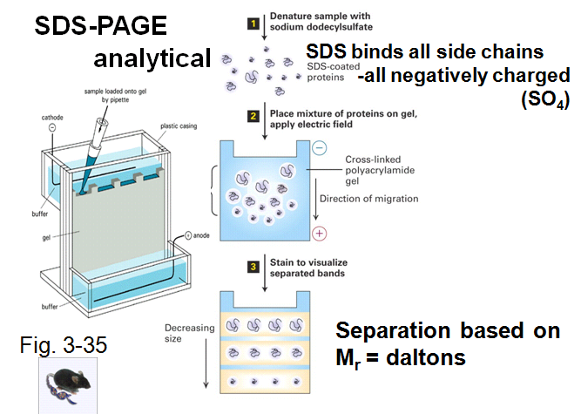
- all polypeptides flooded with
same negative charge
- all negatively charged prs
move from cathode to anode
- separation based solely
on mass!
- compare unknowns
with standards
- all prs in stacking gel then
migrate into separating gel
- can see brom blue running
- once brom blue gets to
bottom, separate glass plates

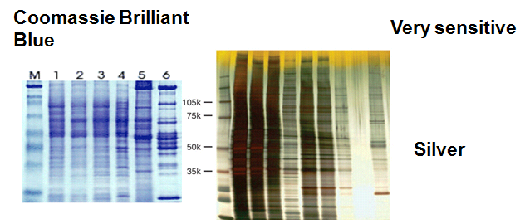
Visualization
- dye physically binds to pr
-need chemical stain/dye to see it
- silver is 10 times more sensitive
- homogeneity would be indicated by a single band
- the prs here are not biologically active

