Covered: light microscopy
Cell fractionation
Organelle and protein purification
Protein detection

Today: a more analytical approach
Antibody (reagent) production
Flurorescence microscopy
Laser scanning confocal microscopy
Electron microscopy

Intro to microarrays
Protein-protein interactions
Protein-DNA interactions

Antibodies and techniques – Jan 13
Know what’s in the figures and read before class***
- proteins with the same mass would show up as a single band... so how do you separate?
- all proteins have amino acids with differing charges
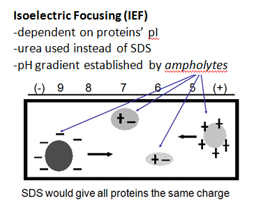
Zwiterrion: is a chemical compound that carries a
total net charge of 0 and is thus electrically neutral,
but carries formal charges on different atoms.
Isoforms: prs that have same name but are different
-> have diff functions
Note: each ampholyte has own pI tube gel
- denature prs (can’t use SDS) using urea
- add in ampholytes to polyacrylamide
- acrylamide cross-links inside gel
- current applied: positive ampholytes migrate thru gel to
negative pole vv
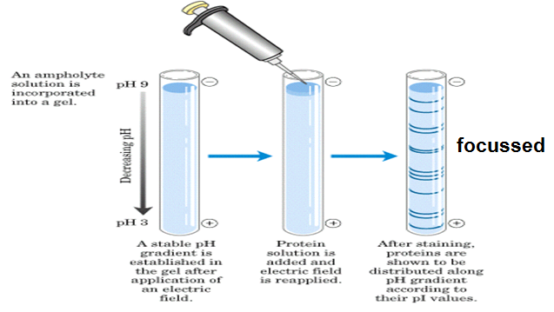
(migrate to environment where it no longer carries charged)
= ampholytes become fixed and gradient created
- proteins that are focussed need to be visualized
(glass pick or mouth pipette)
- stain gel
- Diff positions have diff pI -> touch electrode to tube
And it’ll give you isoelectric point

*if you can see X bands using SDS-PAGE
and Y bands by IEF, then X.Y should
increase your sensitivity

2D PAGE
- IEF followed by SDS-PAGE resulting in higher resolution of samples
- pI, isoelectric focussing (must be done first)
- since SDS can’t be stripped off polypeptide
- differences in charge must be exploited first
- SDS PAGE
- each spot represents a polypeptide
- same molecular mass, pI is almost identical which suggests that these are isoforms of similar prs
-***all aa’s weigh ~ 110 D
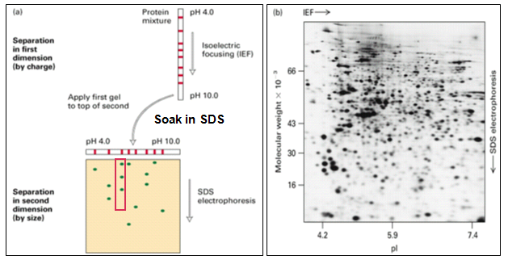
- approx pr ~ 1100 D (if 10 aa)
- change one aa shifts pI and
changes function
- scan polypeptide and finds
prs in database to tell you what
prs you have
- robot finds polypeptide and
then can take sample and
aa’s are compared and looks at
database, makes “signature”
- all have diff in molecule mass ----------------------------
- this technique is a way to get
at unknown and after, make antibody

Why make antibodies? See where prs being expressed and us as therapeutic reagents to fight disease
- Use monoclonal antibodies to create a specific antibody (p.400 – 402)
- http://www.sumanasinc.com/webcontent/animations/content/monoclonalantibodies.html
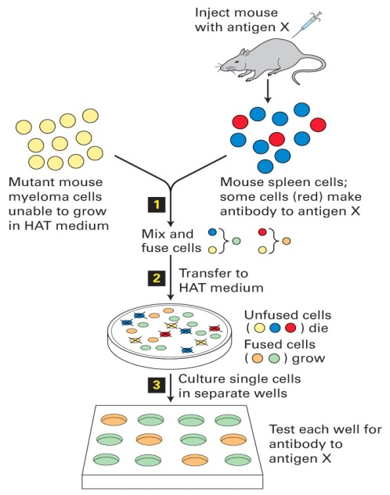
- antibodies that you can inject back into humans to treat disease
- take purified pr and inject
- spleen produces antibodies so spleen taken
- mutants have the immortality trait
- immortal, antibody creating cell -> create hybridoma by fusing
2 diff types of cells
chemical selection: HAT prevents myeloma cells from dividing
by themselves
- cells that don’t survive: myeloma that have not fused
and normal cells
- put one cell into each well, each well only has one antibody being produced
- which clone is producing antibody you need?
-> take a bit of each solution and test it on Western blots (p.98-99)
- remove supernatant and test it against purified antigen
- can use antibodies for immunofluorescence microscopy
- epifluorescence:
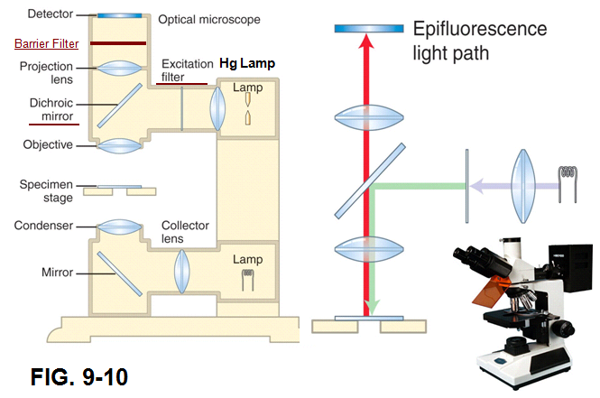

- fluorphore normally has no instrinsic colour until hit with UV light
- dyes or fluorphores absorb E kicking electrons into a higher orbital (unstable) -> UV excites fluorophore (anywhere that antibody is bound to pr)
- instability causes e- to drop into its normal orbital releasing E as visible light “fluorescence”
- visible and UV light travel to ocular but only visible light is seen since barrier filter blocks harmful UV
- signals are bright on a black background (no fluorophores)

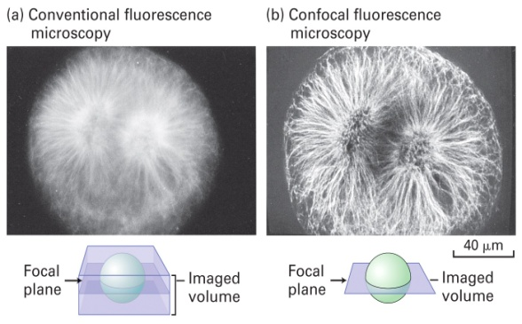
Laser Scanning Confocal Microscope features: exceptional clarity, 3D reconstruction, 4D imaging
- same antibody imaged on 2 diff microscopes -----------
- with confocal, you can tell computer where to fix focal
point so that it can clear out whatever is above and below
plane of interest

Hybrid cells called hybridomas produce abundant monoclonal antibodies
- each normal antibody-producing B lymphocyte in a mammal is capable of producing a single type of antibody that can bind to a specific chemical structure (called a determinant of epitope) on an antigen molecule
- if animal injected with antigen, many B lymphocytes that make antibodies recognize that antigen are stimulated to grow and secrete the antibodies
- each antigen-activated B lymphocyte forms a clone of cells in the spleen or lymph nodes, with each cell of the clone producing the identical antibody
- b.c most natural antigens contain multiple epitopes, exposure of animal to an antigen usually stimulates the formation of multiple diff B-lymphocyte clones, each producing a diff antibody
- resulting mix of antibodies that recognize diff epitopes on the same antigen is polyclonal
- biochemical purification of any one type of monoclonal antibody from blood not feasible: conc of any given antibody is quite low and all antibodies have the same basic molecular architecture
- first step in producing monoclonal antibody: generate immortal, antibody producing cells
Fuse normal B lymphocytes with transformed, immortal lymphocytes called myeloma cells
- during cell fusion, plasma membs of two cells fue together allowing cytosols and organelles to intermingle
- some fused cells undergo division and nuclei eventually coalesce producing hybrid cells
- fusion of myeloma cell with normal antibody-producing cell = hybridoma
- next step: separate hybridoma cells from unfused parent cells and self-fused cells generated by fusion rxn
- selection medium only permits of hybridoma cells (lymphocytes are not immortalized)
- any clone producing that antibody is then grown in large culture
- monoclonal antibodies are commonly employed in affinity chromatography to isolate and purify prs from complex mixtures
- can also be used to label and locate pr using immunofluorescence or immunoblotting
- used in disease treatment: anti-tumour antibodies used widely in cancer therapy

HAT medium is commonly used to isolate hybrid cells
- drugs called antifolates block rxns of tetreahydrofolate, an active form of folic acid
- many cells are resistant to antifolates tho cuz they contain enzymes that can synth. the necessary nucleotides by a diff route from purine and thymidine
- normal cells can grow in HAT medium b.c even tho the aminopterin in the medium blocks de novo synthesis of purines and TMP, the thymidine in the medium is transported and converted in usable purines -> need functional enzymes of the nucleotide salvage pathway to grow on HAT medium

Detecting Proteins in Gels
- 2 general ways to visualize prs: stain prs while they are still within the gel or electrophoretically transfer prs to a membrane made of nitrocellulose and detect them
- prs usually stained with an organic dye or silver-based stain
- western blotting is most common method
Western blotting
- combines resolving power of gel electrophoresis and specificity of antibodies
- used to separate prs and identify a specific pr of interest
- two diff antibodies are used in this method: one specific for desired pr and another that binds to first and is linked to enzyme or other molecule that permits detection of the first antibody
- recombinant DNA methods can incorporate a small peptide epitope into the normal sequence of the pr that can be detected b a commercially available antibody to the epitope
1. SDS PAGE and transfer separated bands from gel to porous membrane where it isn’t readily removed
2. membrane flooded w. sol’n of antibody specific for desired pr and allowed to incubate -> only membrane-bound band containing this pr binds the antibody forming a layer of antibody molecules then membrane is washed to remove unbound antibody
3. membrane incubated with 2nd antibody (which is covalently linked to enzyme or substance that can be detected with great sensitivity) that binds to 1st antibody.
4. location and amount of BOUND antibody 2 is detected permitting electrophoretic motility and mass of desired pr to be determined as well as quantity (based on band intensity)

