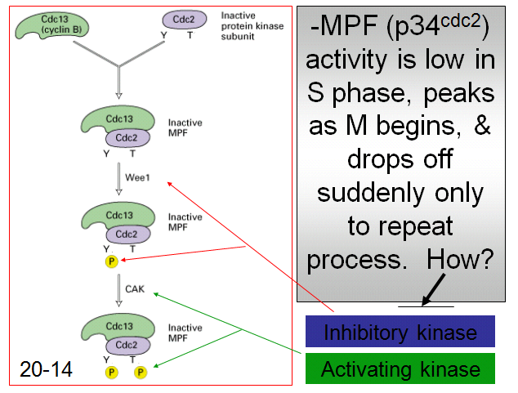
Cell Cycling – Feb 1
- some rote memorization and one liners
- thought questions -> change ingredients
- might not be pr/amt but the activation of pr
CDCs which changes in cell cycle
MPF = heterodimer
- cdc2 is transcribed and translated throughout
cell cycle and encodes a protein kinase
(p34cdc2) in all euks
- kinases phosphorylates Ser, Thr, Tyr
- inactive MPF complex forms and cell is
checking to make sure all conditions met
- repair needs to be done
- Wee1 (kinase) attaches phosphate onto Y (tyrosine)
- mutate Wee1 and phosphorylation event will
not occur -> you get smaller cells
- CAK (activating kinase) attaches phosphate
onto threonine
-> STILL INACTIVE MPF
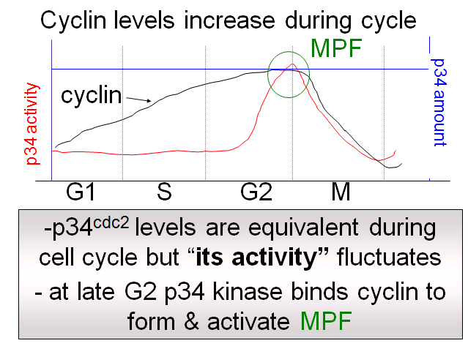
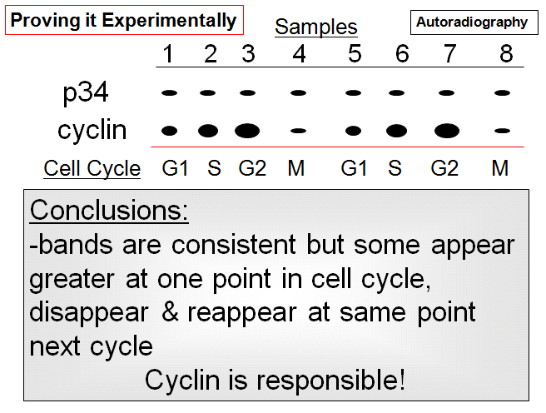

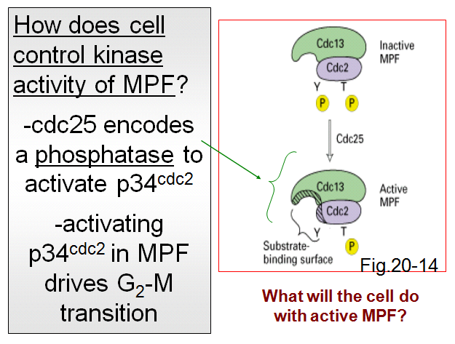
- autoradiography at consistent time pts
- p34 is expressed at equal lvls throughout cell cycle
- cyclin lvls start increasing
- if cyclin lvls go up, it is a good predictor of what
the enzyme p34 will do
-> more cyclin produced which associates with p34
and MPF complex forms
How do you activate MPF? ------------------------------

Q: What happens if you mutate wee1? ***
What happens if mutate CAK? CAK doesn’t do anything
to cyclin!
If CAK mutated, mitosis will be hindered

- mutating wee1, CAK puts on P and premature division

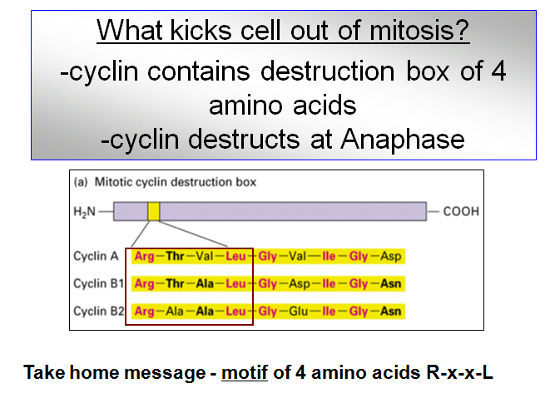
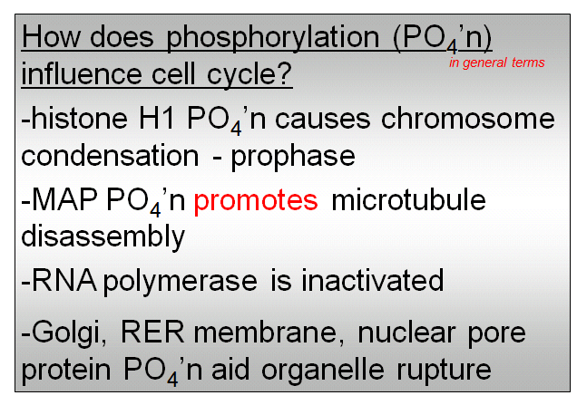

- phosphorylation of H1 causes chrs to condense
- MAP: mt associator pr
- where are mts used in mitosis and why would u
want to promote disassembly?
-> MFP finds MAP and causes mts to fall off
- MFP phosphorylates prs and organelles collapse - cyclin has destruction box; pr binds to another pr and and reassemble in 2 daughter cells degraded
- destruction boxes in cyclins is near amino terminus
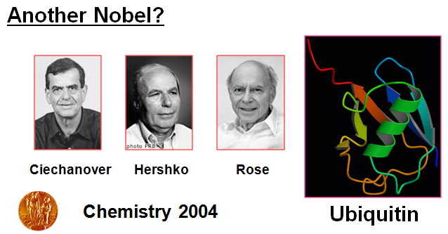
- shut down RNAP (transcription) to conserve E,
stop gene expr, loosen up DNA
- no transcription during mitosis since DNA tightly packed
- phophorylate RNAP (and dephosphorylated after rep)

- in a ribbon diagram what does the barrel denote
How about the arrows

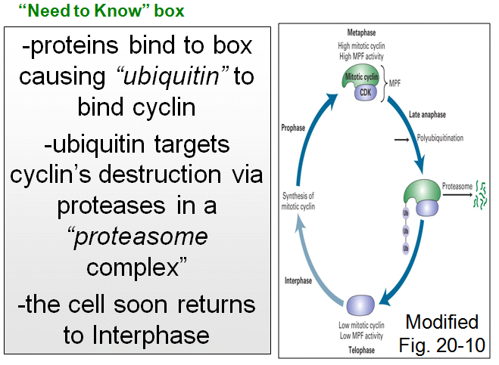

- ubiquitin ligase, pr-pr interaction
recognizes destruction box at amino terminus
and during late anaphase, UL starts
adding ubiquitin to carboxy terminus of cyclin
- UL
- any pr that has ubiquitin moves to
proteasome
recognizes destruction box
- destruction box and ubiquitin go hand in
hand with proteosome
- any pr w. ubiquitin
- 80% of prs enter proteasome and are
Degraded and aa’s reused for next round
of translation

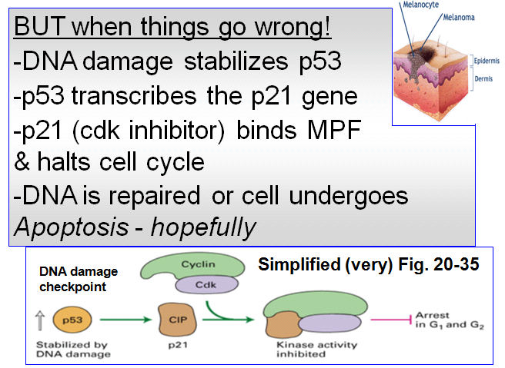
- p53 is a TF (bind unique regions of promoter)
- p53 is a tumour suppressor which ensures
that tumour doesn’t develop
- TF has short half life
- p53’s half life increases: gets stabilized in
cytoplasm and gets into nucleus (after DNA
Damage) and turns on p21 gene
- p21 encodes pr called cdk inhibitor which
binds to MPF -> MPF INACTIVE
- cell undergoes repair mechs or apoptosis
- 2 hallmark features of apoptosis:
1. characteristic fragmentation of DNA (nucleases)
2. blebbing -> bulging in the plasma membrane
caused by cell's cytoskeleton breaking up
-> final checkpoint is p53 action
***KNOW THE NOTES!

