Clathrin and Cyclin – Jan 27
Conceptual Recap
Go over Fig. 14-1 on Protein Secretion
- one cell sends signal to another cell to trigger cell div
- signals direct prs to diff destinations
e.g. KDEL on resident ER prs
e.g. M6P signal attached in cis-Golgi instructs (via M6P receptor) hydrolases to move from trans-golgi to lysosome?
- M6P attached to enzyme dictates where it will go
-> pr is NOT secreted, only trafficked to where it’s required

Trans-Golgi Network is sorting station
- constitutive v. regulated secretion (i.e waiting for hormonal or NT signal), also place of final proteolytic processing
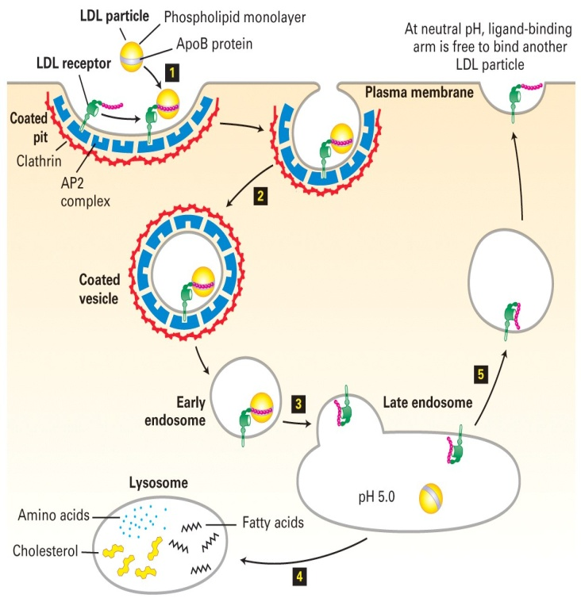
Vesicles use adapter prs and clathrin to facilitate
Transport – involves cytoskeleton and motor prs

Receptor-Mediated Endocytosis
The Concept: What is it?
A method of selective internalization
- pino: “cell sipping”
- phagocytosis: for large particles
- RME: receptor is specific to ligand
i.e. LDL particle => cholesterol
- there are many LDL receptors for efficiency
- adapter prs present and form interaction with clathrin
- clathrin facilitates pinching off of coated pit (coated vesicle formation)
- once clathrin has internalized particle, it’s recycled
- late endosome = CURL (uncouple receptor from ligand)
- proton pumps all along compartment (pumping protons
into CURL) -> b/c in lysosome you have low pH
- M6P hydrolases only work at low pH
- when active, they break LDL down into components
- cholesterol = building blocks for hormones

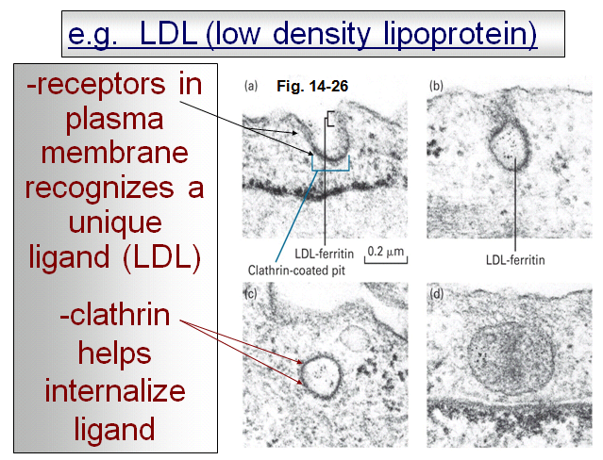
- TEM
- fuzzy coat = clathrin
------------------------------------------------------------------------------------------------------------
Pr is part LDL and part ferretin
- ferretin transports Fe (heavy mental) into cells
- Fe needs to be carried through
- if RME specific for one ligand, clathrin needed

- young girl having heart attacks: maybe no way to internalize

- significant component of hypercholest. is genetic
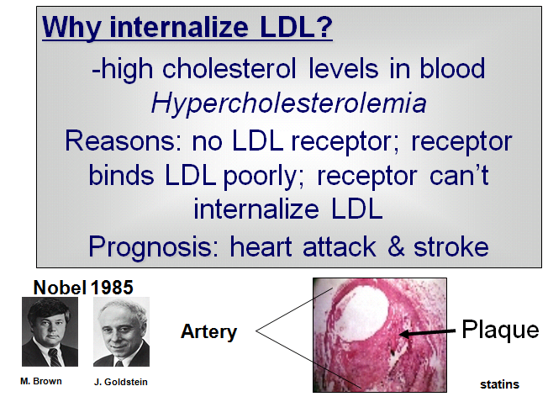
- foam cells
- build up occluding coronary artery which leads to heart attack
- binding poorly: 90% of LDL still circulating
- girl given liver transplant: liver stores a huge amt of LDL
and puts it back into bloodstream

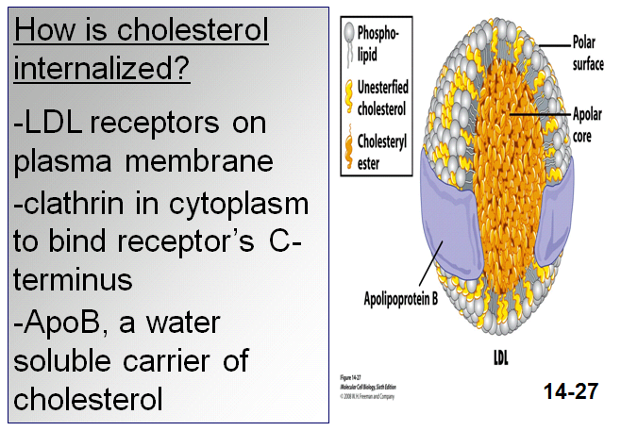
- cholesterol = lipid
- getting it across membrane, you need ApoB pr which
wraps around cholesterol molecules
- if mutated ApoB that couldn’t transport
Cholesterol, you’d prolly still have heart attack
- ApoB is pr recognized by receptor

- extra digits: sonic hedgehog signalling pathway
- need cholesterol for embryonic development
- you’ll have it anyways, but needs to be internalized

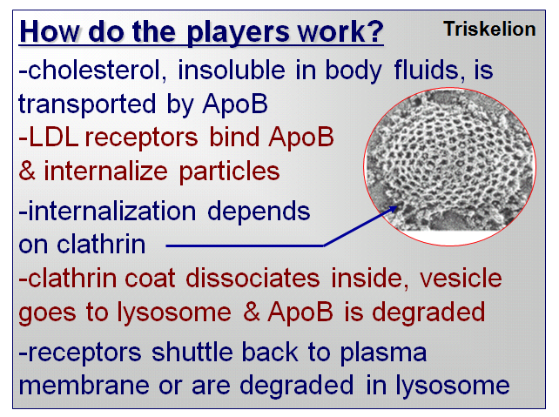
- if you purify clathrin, it’ll self assemble to form clathrin basket
- SEM
- lose clathrin, lose trafficking of prs
- once clathrin has internalized vesicles (carrying all those LDL
particles), then clathrin falls off
- vesicles move thru endosome and e. endosomes come together
- CURL forms and once pH low, goes on to make lysosome

Signal Transduction
- cells respond to signals without having to
internalize them
- signals may be secreted growth factors
i.e. EGF instructing cells to divide
How does the cell respond? Positively and
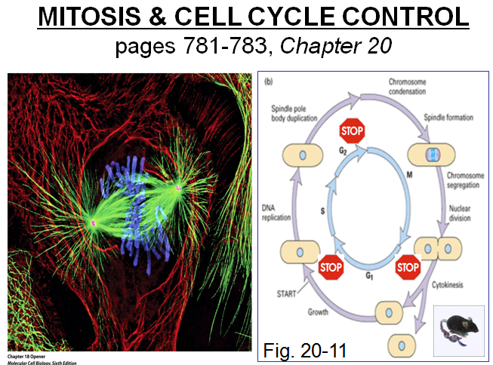
negatively?
- to transduce signal, you don’t have to internalize it
- growth factor just has to bind to receptor
Mitosis
p. 781-783 (nice pic)
- once individual chrs are duplicated in S phase,
they are held together along their length by
prs called cohesins
- mitosis: process where duplicated chrs are
segregated to daughter cells
Prophase
- interphase MTs replaced by asters as duplicated
centrosomes become more active in MT nucleation
- provides 2 sites of assembly of MTs => asters
- 2 asters move and become opposite poles of
mitotic spindle (MT-based structure that separates chrs)
- pr synth stopped, nucleolus breaks down and chrs condense
- cohesins are degraded except at centromeric region where 2 sister chromatids remain attached by cohesins
- events coordinated by rapid increase of mitotic cyclin-CDK complex activity: kinase that phosphorylates prs
Prometaphase
- initiated by breakdown of nuclear envelope and pores and disassembly of lamin-based nuclear lamina
- MTs capture chr pairs at specialized structures called kinetochores
- sister chromatids align equidistant from 2 spindle poles => congression
Metaphase is the stage when all chrs are aligned at the metaphase plate
Anaphase
- induced by activation of the anaphase-promoting complex/cyclosome (APC/C)
- activated APC/C leads to destruction of cohesins
- anaphase A: chrs pulled to poles by MTs attached to kinetochore
- anaphase B: mvt of spindle poles farther apart
Telophase is stage where nuclear envelope reforms, chrs decondense, and contractile ring assembly
Cytokinesis happens when cell is pinched into 2 daughter cells by the contractile ring and interphase MT reforms
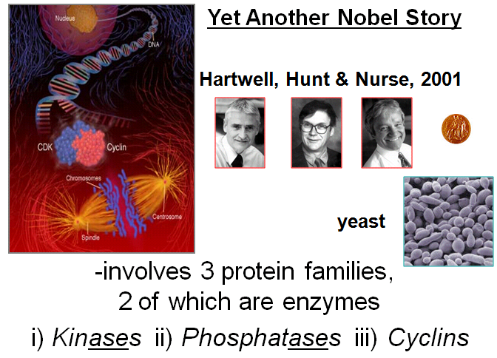
- green MT; blue DNA; red cytoskeleton
- can use fluorescence microscopy in live cells
Concept:
-cell proliferation depends on signals
-progression through cell cycle is regulated: G2 -> M checkpoint
-check points ensure things should proceed:

Is all DNA replicated? Important for all
Is cell big enough? Yeast will be able to detect
Is environment favorable? Doesn’t apply for humans
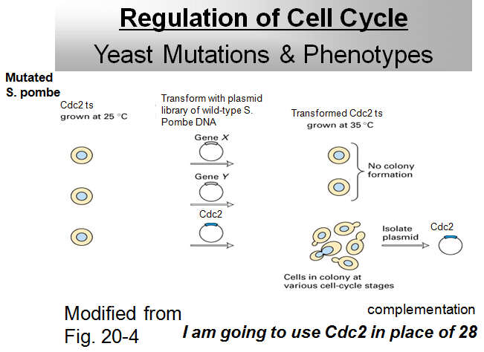
Is DNA damaged? If DNA damaged,
repaired or shutdown (apoptosis)
- there is apoptosis in yeast
- micrograph? SEM
- cyclins used at checkpts
- from yeast 2 hybrid: fixing mutation by recreating
TF so you can make histidine
-> complementing mutation by introducing a WT gene
- think “gene therapy” for yeast
- 2 genes but in diff strains of yeast (cdc2 is easier)
functional complementation:
- start with pool of yeast and mutate genome
- grow yeast at optimal and only temp (25)
- if you raise temp, they won’t grow
- introduce WT genes back into mutated strains
- then raise temp -> temp selection
- no growth; then introduce another gene and if no growth,
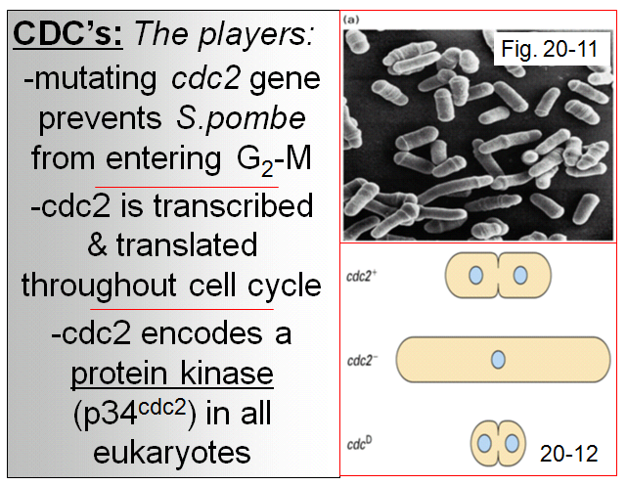
tells you that WT gene didn’t complement mutation
- they could figure out that original mutation would be in cdc2 gene
- if cdc corrects mutation and allows cells to
Undergo mitosis => predict it’s involved with cell cycling

- idea: trying to find which one was mutated in first way
- get around mutation by introducing WT version (SEM)
- expr of WT gene needed to make yeast go from G2 into mitosis
- cells spend most of time in interphase
- cdc mutated blocks G2-M checkpoint
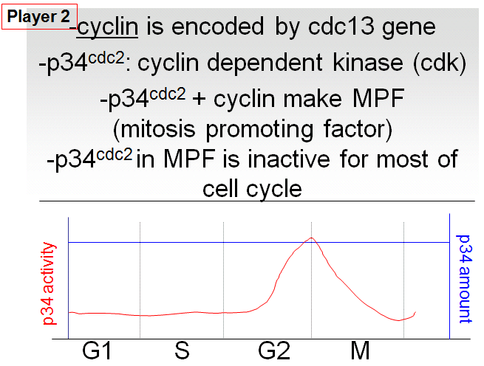
- kinase phosphorylates
- nomenclature: 34,000 D encoded by cdc2 genes
- if yeast is mutated, incorporate are own cdc2; cdc2+ = normal
- cdc2- grows until it dies since cell won’t get out of G2 (unless complement mut)
- cdcD -> constantly being turned on (excessive) -> doesn’t hit checkpt
- DNA won’t have time to replicate and cell will die
Cyclin regulates cdc2
- p34 is a cyclin-dependent kinase; no pr works in isolation
- looking at cell cycle: amt of p34 -> increases in G2-M
- kinase phosphorylates
- pr sitting in cell doing nothing but waiting for signal
- once signal is there, change it’s biological activity and becomes active

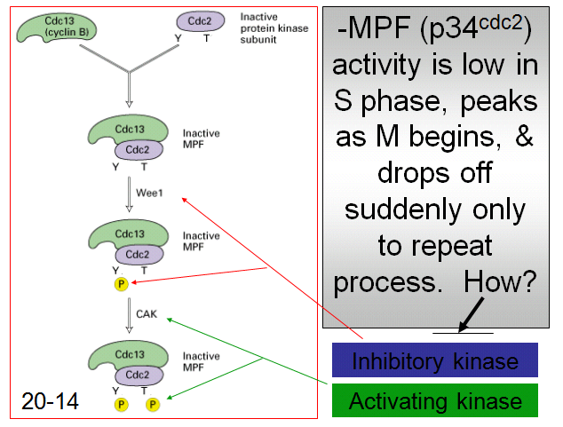
- some rote memorization and one liners
- thought questions -> change ingredients

- might not be pr or amt but the activation of pr
CDCs

- cdc2 is transcribed and translated throughout
cell cycle
- cdc2 encodes a protein kinase
(p34cdc2) in all euks
- kinases phosphorylate Ser, Thr, Tyr
- inactive MPF complex forms and cell is
checking to make sure all conditions met
- repair needs to be done
Mutate Wee1 and phosphorylation event will
Not occur
- 2 stops (where Ps are)
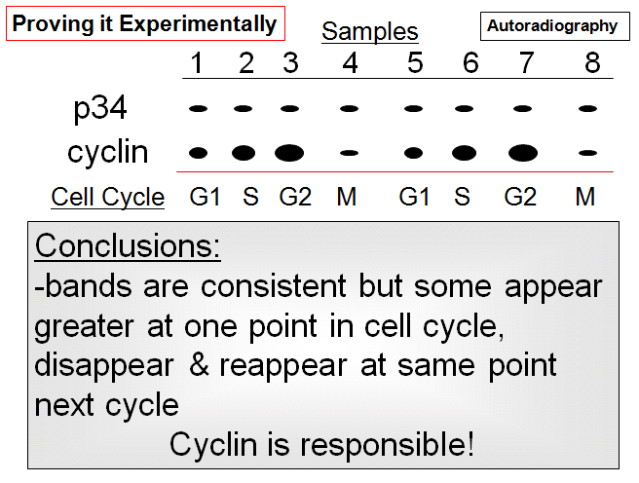

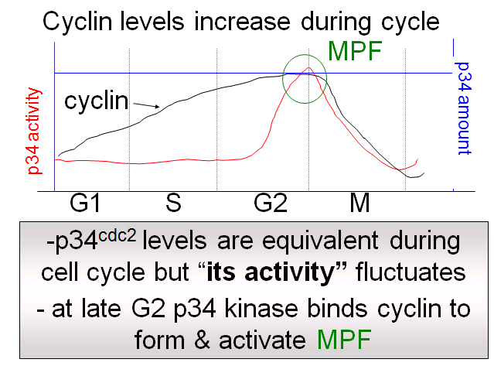

- autoradiography at consistent time pts
- p34 is expressed at equal lvls throughout cell cycle
- cyclin lvls start increasing
- if cyclin lvls go up, it is a good predictor of what
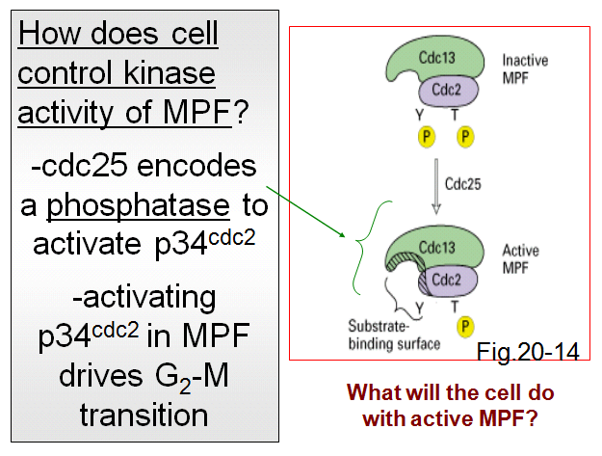
The enzyme p34 will do
-

- wee1 attached to phosphate

Q: What happens if you mutate wee1? ***
What happens if mutate CAK? nothing
If CAK mutated, mitosis will be hindered

- mutating wee1, CAK puts on P

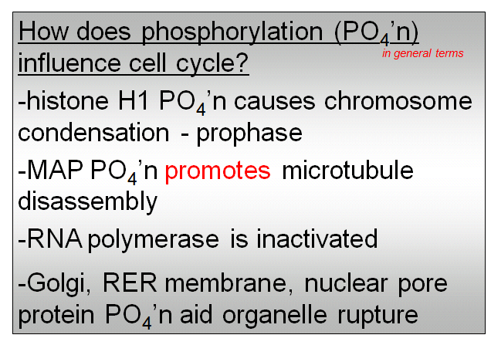
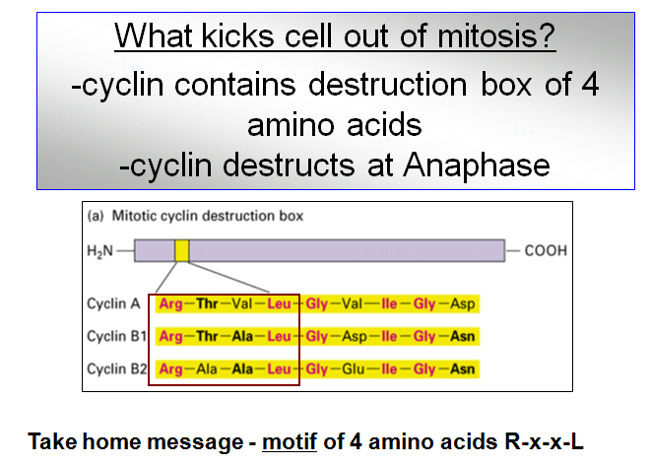

- phosphorylation of H1 causes chrs to condense
- MAP: mt associator pr
- where are mts used and why would u want to
Promote disassembly in mitosis?
- MFP phosphorylates prs and organelles collapse - cyclin has destruction box; pr binds to another pr and degraded
And reassemble in 2 daughter cells - destruction boxes near amino
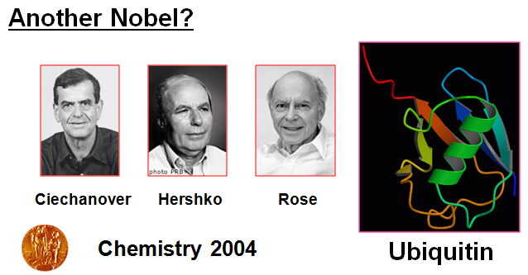
- shut down transcription to conserve E, stop gene
expr, loosen up DNA
- no transcription during mitosis
- clip off phosphate

- in a ribbon diagram what does the barrel denote
How about the arrows

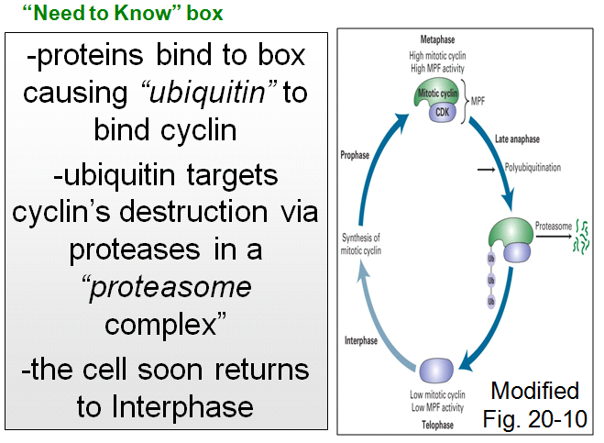

- ubiquitin ligase, pr-pr interaction
Recognizes destruction box and during
Late anaphase, UL starts adding ubiquitin
to and recognizes destruction box
- destruction box and ubiquitin go hand in
Hand with proteosome
- any pr w. ubiquitin
- proteosome, 80% of prs enter and are
Degraded and aa’s reused for next round
Of translation
-

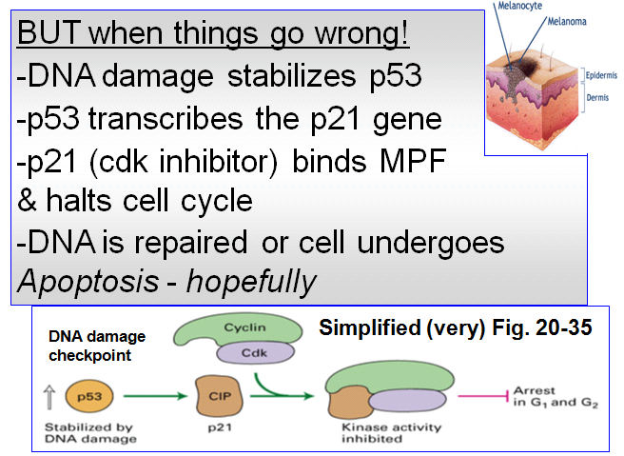
- p53 is a TF (bind unique regions of promoter)
- p53 is a tumour suppressor which ensures
That tumour doesn’t develop
- TF has short half life
- p53’s half life increases: gets stabilized in
Cytoplasm and gets into nucleus (after DNA
Damage)
- TF turns on p21 gene
- p21 binds to MPF and MPF is no longer active
- repair mechs or apoptosis
- programming
- 2 hallmark features of apoptosis:
- characteristic fragmentation of DNA (nucleases)
- blebbing ->
- KNOW THE NOTES!
-

